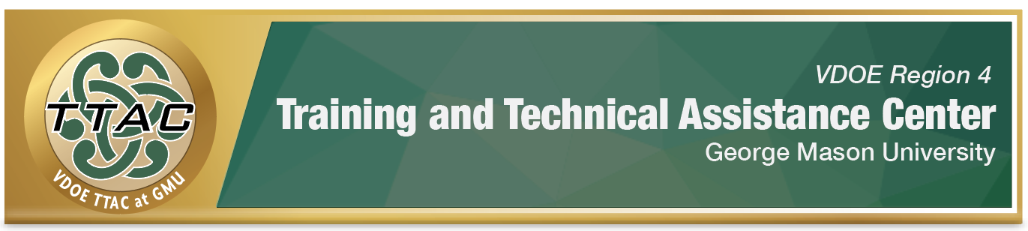
HLP 4 Highlight Tool
HLP 4: Use Multiple Sources of Information to Develop a Comprehensive Understanding of a Student’s Strengths and Needs

Here’s What It Is:
- Utilizing a variety of assessments to build a student learner profile
- Collecting and evaluating student strengths, interests and needs
- Analyzing the learning environment to determine supports/barriers to academic progress

When Do I Use It?
- When making qualification/placement decisions
- When writing goals and objectives
- When determining what changes are needed in instruction/placement
- When deciding on special educational accommodations/modifications

Here’s What It Looks Like:
- 5 Ways to Conduct Formative Assessments Virtually (2:08)
- Distance Learning/ Formative Assessments You Can Implement Remotely (3.40)
- Example of Curriculum-Based Measure (CBM) Screening (2:00)
- Curriculum Based Measurements: General Overview (13.27)
- Self-Determination Tips for Including Students in the Education and Transition Planning (57:08)

Resources to Extend Learning
- Department of Education: What Works Clearinghouse
- University of Missouri: Evidence Based Intervention (EBI) Network
- National Center for Intensive Intervention
- High Leverage Practices and The Iris Center
- I’m Determined

Here Are My Work Plans:
- Examine academic data to determine strengths, needs, etc.; Example of CBM screening (2:00)
- Examine behavioral assessment data to determine strengths, needs, etc.(0:58)
- Collaborate with families to build a comprehensive student profile
- Collect student input (1:47)
- Video: Curriculum Based Measurements: Basic Overview

Suggested Activities:
Visit Intervention Central to discover these activities.
- Use universal screening tools to gain understanding of student progress (check division requirements)
- Use evidence-based practices to select appropriate resources for intervention (What Works Clearinghouse)
- Use on-going progress monitoring tools to guide decision making and data collection
- Use a variety of resources to make informed decisions about academic and behavioral areas of student need

HLP 4 In Action!

Developing a Comprehensive Student Learning Profile
Directions: Review the components of the assessment options below to use as a guideline in developing a comprehensive learner profile as part of a student portfolio collection.

Assessment Option
- Use formal assessments to analyze student academic progress

Guiding References
- Curriculum-Based Assessments to determine academic proficiency in a skill set (see reference below)
- Data from norm-referenced tests (e.g. Woodcock-Johnson Tests of Achievement) to determine eligibility
- Criterion-Referenced Tests (e.g. District-Developed benchmark assessments)
- Diagnostic Assessments (formal and informal) to assess learning needs in a curricular area. (e.g. Core Phonics Survey)

Assessment Option
- Use informal assessments to analyze student academic/behavioral progress

Guiding References
- Curriculum-Based Assessments to determine academic proficiency in a skill set (see reference below)
- Anecdotal records/seating chart
- Observational records (e.g. Daily Scorecard)

Assessment Option
- Include student input & voice

Guiding References
- Student Led IEP Input: Video 18:03-19:24
- Student Involvement in the IEP Process: I’m Determined tools

Assessment Option
- Include parent input & voice

Guiding References
- Beginning of the Year Questionnaire for Families
Adapted from HLP Leadership Guide

References

Hashey, A. I., Kaczorowski, T. L., & DiCesare, D. M. (2020). High-Leverage Practices in
Special Education, Guide 1. Council for Exceptional Children.
Hosp, M. K., Hosp, J. L., & Howell, K. W. (2007). The ABC’s of CBM: A practical guide to
curriculum-based measurement. New York, NY: Guilford Press.
McLeskey, J. (Ed.). (2019). High leverage practices for inclusive classrooms. New York:
Routledge.

Find additional HLP Highlight Tools on TTAC Online.
For information about TTAC Region 4, go to https://ttac.gmu.edu/.

