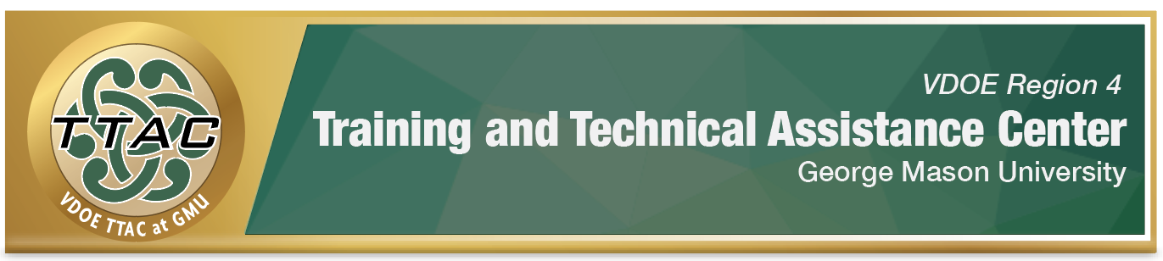HLP Highlight Tool
HLP 19: Use Assistive and Instructional Technologies

Here’s What It Is:
- A tool utilized by students to maintain or increase their functional abilities.
- A part of a student’s IEP and determined on a case-by-case basis
- Addresses the student’s area of identified need
- Supports the goal of instruction and student outcome
- Supports Universal Design of Learning (UDL)- aligned instruction (see Work Plans)
- Tools that can be utilized across content areas or content specific

When Do I Use It?
- When creating IEP goals that require the use of assistive technology
- When a student’s needs require assistive technology to access and benefit from specialized instruction
- When students need require assistive technology to demonstrate understanding of content and/or perform an instructional task

Here’s What It Looks Like:
- What is Assistive Technology? (8:33) Sign in to free TTAC Online Account Required
Resources to Extend Learning
- IRIS Center: High Leverage Practices
- High Leverage Practices
- IRIS Center- Assistive Technology: An Overview
- VDOE K-12 Inclusive Practices Guide
- Assistive Technology Tools in Schools
Here Are My Work Plans:
- Universal Design for Learning (UDL) at a Glance (4:36)
- What is Assistive Technology? video (refer to the parts of the video below)
- Definition of Assistive Technology (AT) Devices and Services (Video 0:22-2:14)
- Explanation of the SETT Framework: (Video 3:50-7:50)

Suggested Activities:
- Plan: determine the purpose, lesson objective/IEP goals to consider
- Consider: Potential technologies and how they can increase/strengthen learning and engagement, evaluate accessibility barriers in instructional technologies
- Implement: test technology from a student’s perspective, consider implementation logistics, train students on the use of technology for learning
- Assess: Evaluate the effectiveness of the technology to support learning outcomes
Adapted from HLP in Special Education laminated guide #6.

HLP 19 In Action!

Sample SETT Framework: It is intended that you use this as a guide. This is to be used in collaboration with a team familiar with student to help create a successful educational environment for student growth and mastery.

Student Name: _______________________________________________________________
Component | Guiding Questions | Comments
Student | - What is the area of instructional concern?  - What is the student’s current strengths?  - What is the student’s current needs?
Environment | - What is the current instructional/physical classroom arrangement?  - What materials/equipment are currently being used by the teacher and student?
Tasks | - What essential tasks will support the student’s IEP goals towards mastery?  - What is the instructional expectation?
Tools | - What high/low tech equipment is currently being used?  - What additional tools does the student need?  - What strategies can be used to support student achievement?

References
Hashey, A. I., Kaczorowski, T. L., & DiCesare, D. M. (2020). High-Leverage Practices in Special Education, Guide 6. Council for Exceptional Children.
McLeskey, J. (Ed.). (2019). High leverage practices for inclusive classrooms. New York: Routledge.

Find additional HLP Highlight Tools on TTAC Online.
For additional information about TTAC Region 4, go to https://ttac.gmu.edu/.

