How to Create A Virtual Blending Board in 10 Easy Steps with Flippity
1 Go to Flippity https://www.flippity.net/

2 Click Flippity Randomizer Template button
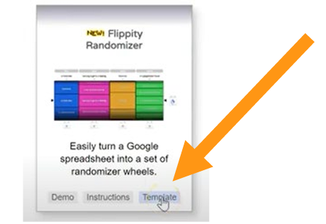

3 Click Make a copy (goes to Google Drive)
- Name your spreadsheet
- Save to a folder where you can find it
- File >move> new folder> name it>check mark>move here

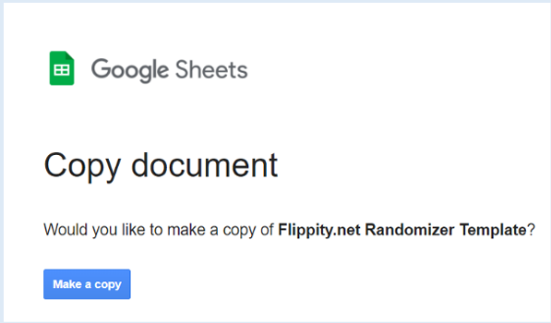
4 Delete the information in the spreadsheet
Don ’t delete /edit anything in blue!

5 Input the phonemes you want
- Make headers in row
- Use only concepts you’ve taught
- Avoid tricky combinations
- Use the beginning, middle end chart
- Test each combination to ensure no unwanted words can be made
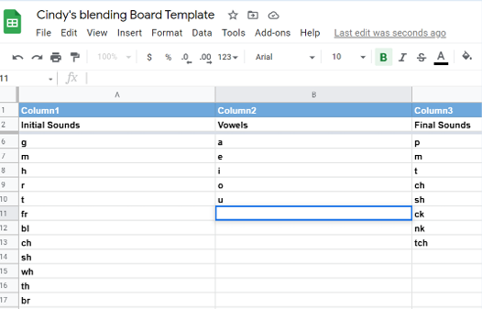

6 Publish
File>Publish to the web>Publish
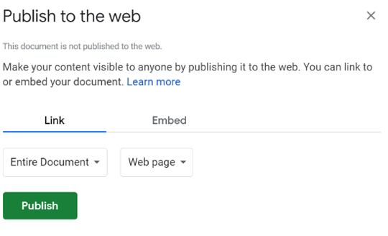

7 Click “Get the Link Here” button at the bottom of the template page
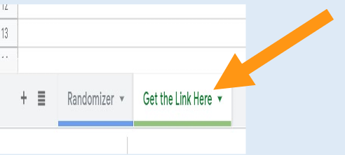
8. Copy the link
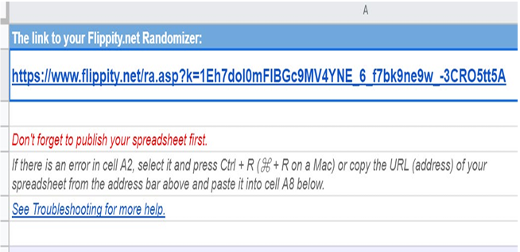

9 Test the randomizer by pasting the link into Google
• Click the magnifying glass to “ zoom in on result
• Experiment with only spinning one column at a time to emphasize phonics concepts”
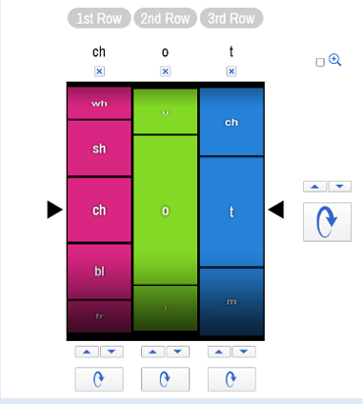
10 Share
Sample Flippity
https://www.flippity.net/ra.asp?k=1Eh7doI0mFIBGc9MV4YNE_6_f7bk9ne9w_-3CRO5tt5A

Note
To edit- go back to template and click the randomizer tab at the bottom. No need to republish or save. When the Flippity is refreshed the changes will be there.

