Final Webinars for the School Year! It’s Free! Register Early!
Certificates of Attendance are available

Assistive technology (AT) changes lives and offers educational solutions that can lead to academic success, increased independence, and greater self-confidence for students with disabilities. This virtual conference highlights evidence-based practices in AT, current trends, and practical AT strategies. It’s also a great way to learn new AT strategies from national presenters and AT colleagues around Virginia. Webinars will be presented in November, February, and April/May. Each webinar will be offered from 12-1 pm and 3-4 pm. Complete webinar descriptions and registration information are available on the conference website, https://vconf.gmu.edu/Conference/TechKnowledgy2016/reg_stat.

April 26, 12-1 pm and 3-4 pm
“Say what you wanna say”
Presenters: Linda Oggel, M.A., CCC-SLP, Speech and Language Pathologist and Mona Pruett, M.S., OT/L, Program Specialist, Virginia Department of Education’s Training and Technical Assistance Center at VCU

When voice output devices are initially introduced, the selection of vocabulary is essential. Limited “real estate” on low-tech communication devices (4, 8, 12 cells) makes vocabulary choice a fundamental and critical goal. Vocabulary selections on dynamic AAC devices are often overwhelming to AAC users and teachers and this session will offer strategies to make that task easier. This session will review the importance of vocabulary selection and how to choose the most meaningful core vocabulary. In addition, resources and strategies will be shared to make language experiences meaningful and fun.

May 2, 12-1 pm and 3-4 pm
Technology Use in Early Childhood Special Education: Teaching The Swipe Generation
Presenter: Beth Poss, M.S., SLP, Montgomery County Public Schools, Maryland

This session, targeted at early childhood educators, examines the current research on the use of technology for children birth to 8 years, and will discuss the implications of technology as an early learning tool for young children with disabilities. Explore developmentally appropriate apps and other technology resources that support the growth of language, play, literacy and early math skills and identify what a Universally Designed for Learning (UDL) early childhood setting looks like.

PLEASE NOTE: These sessions will be archived for later viewing.

Who should attend?
Anyone who is interested in helping students with disabilities advocate for their technology needs, increase independence, and achieve educational success.

Sponsored by
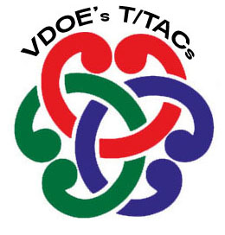
The Virginia Department of Education’s AT Network and the Training and Technical Assistance Centers

