Central Virginia Exceptional Family Fair
September 10, 2016
9:30 a.m. to 12:30 p.m.
Children’s Museum of Richmond (CMoR)
2626 W. Broad Street, Richmond, Virginia 23220
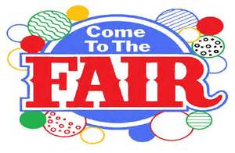  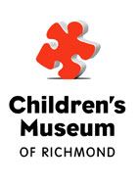  Your registration includes free “all day” admission to the CMoR for a family of up to 6 members. At least one adult must accompany their children at all times. |  | The Virginia Department of Education (VDOE), in collaboration with the Parent Educational Advocacy Training Center (PEATC) and the Center for Family Involvement (CFI), is holding a family fair in the Central Virginia region for parents of students with disabilities.  Why you should attend:  - Come hear keynote speaker Garrett Brumfield from “Overcome Yours.” Garrett, who has cerebral palsy, will share a message of hope, change, and acceptance through sharing his story and the stories of others overcoming great obstacles.  - Two mini “Parent Camp” sessions will give you the opportunity to talk about how we can all work more closely and collaboratively with schools and communities to improve outcomes for our children with disabilities.  - Over 20 vendors (community agencies, service providers, parent resource centers, family organizations, service dogs, and more) will be available to share information and resources for families of children with disabilities.  - Parent networking opportunities.
Space is limited to 200 participants and you must pre-register using the following Web link: https://www.surveymonkey.com/r/vdoefamilyfair or by calling PEATC, at (800) 869-6782.

