Battlefields of Northern Virginia Council of Teachers of Mathematics
Spring 2017 Conference

EQUITY IN MATHEMATICS

Saturday, March 4, 2017
8:00 a.m. – 1:15 p.m.

Benton Middle School
7411 Hoadly Road, Manassas, VA 20112

7:30 | Registration Begins
8:00-8:15 | Continental Breakfast
8:15-8:25 | Welcoming Remarks
8:30 – 9:30 | Keynote
9:45 – 10:45 | Session A
11:00 – 12:00 | Session B
12:15 – 1:15 | Session C

Featured Speaker:
Toya Jones Frank

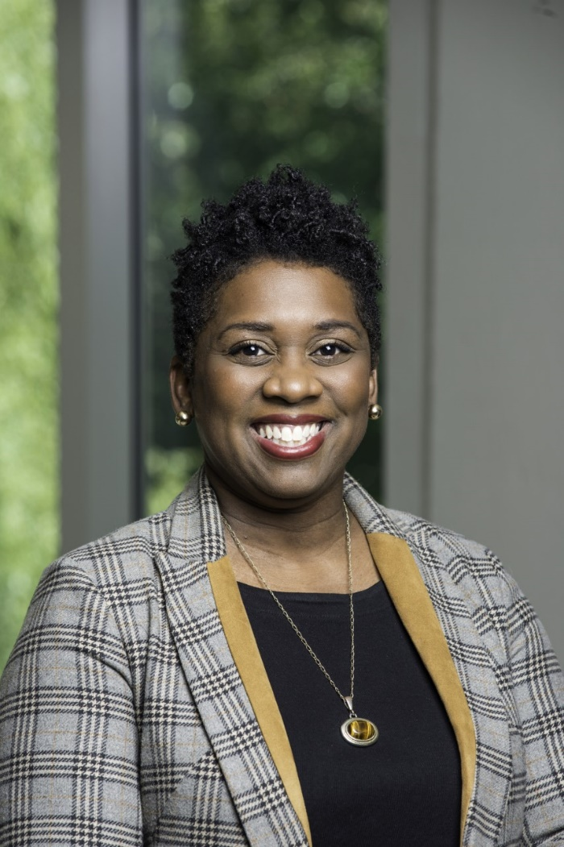

Toya Jones Frank is an assistant professor in the Mathematics Education Leadership (MEL) and Secondary Education programs. She currently teaches the mathematics methods courses for prospective secondary mathematics teachers as well as Ph.D.-level courses in MEL. Frank received a Ph.D. in Curriculum and Instruction with a specialization in Mathematics Education and a M.Ed. in Education Policy and Curriculum Theory from the University of Maryland, College Park. Her current research explores issues of equity and access to advanced mathematics for underrepresented students, secondary mathematics teacher preparation, and diversifying the STEM teacher workforce. Frank is a former high school mathematics teacher and department chair who worked in Maryland and Florida public schools, as well as a former educational consultant for clients including DC Public Schools and ACT, Inc.

BREAKOUT SESSION A 9:45 – 10:45 | Room
Title: Trade Books for all Math Lessons
Presenter: Kelly Wheeler, Title I Math Specialist, Minnieville Elementary, PWCS
Audience: Pre-K – 5th Grade Teachers
Description: Are you always looking for good read aloud books to introduce or reinforce math lessons? Those who attend this session will participate in activities based upon and integrated with trade books. They will also receive a list of good trade books sorted by objective.

*ALSO PRESENTED IN SESSION B & C*

Title: Join Us For A Rounding Round Up!
Presenter: Rosa A. Rosas, Bel Air Elementary, PWCS
Gina Haefele, Bel Air Elementary, PWCS
Jackie Erney, Bel Air Elementary, PWCS

Audience: Pre-K – 5th Grade Teachers
Description: What happens when you deconstruct and reconstruct a color coded 100 chart? Join us to find out how to create a number line that will help students understand/visualize the concept of rounding to the nearest 10 or nearest 100. Come learn techniques for building number sense & rounding skills and make a tool that will help students be successful!

*ALSO PRESENTED IN SESSION B & C*

Title: Supporting SPED Students’ Mathematical Understanding
Presenter: Robin Anderson, Title I Math Specialist, Vaughan ES, PWCS
Asmahan Jackson, Title I Math Specialist, Vaughan ES, PWCS
Caden Palmer, Title I Math Specialist, Bel Air ES, PWCS

Audience: 3rd – 5th Grade Teachers
Description: Teachers will learn the appropriate use of manipulatives and math aids to support SPED students during Tier I instruction and assessments, including the SOLs.

*ALSO PRESENTED IN SESSION B*

BREAKOUT SESSION A 9:45 – 10:45 | Room
Title: Place Value’s Important Place in Understanding Patterns & Estimation
Presenter: Susan Bardenhagen, Teacher, BNVCTM Board Member

Audience: 3rd – 5th Grade Teachers
Description: There are many strategies and activities which strengthen student’s understanding of place value. Applying this knowledge to estimation and rounding by using patterns and similar models will help reinforce these concepts. Presenter will share games, centers, and partner activities while offering ideas for spiraling and integrating language arts with vocabulary.

Title: Tech Tool with Tiers (not Tears)
Presenter: M. Cherise Harrington, Bel Air ES, Title I Math Teacher, PWCS

Audience: 3rd – 8th Grade Teachers
Description: This is an interactive session, designed to start the conversation on how to provide differentiated Tier 2 instruction in classrooms that follow effective Tier 1 instruction during a math block.
We will: 1) Decide on common definitions of “differentiated instruction”, Tier 1 Instruction and Tier 2 Instruction 2) Read an article on Mastery Teaching to support use of tools for differentiation that can lead to mastery 3) Discuss opportunities to meet with struggling students during a math block & 4) Explore online math resources to use in small groups either with students or as independent work.

Title: Learn More and Do More with the C-R-A Model for Instruction
Presenter: Kathy Judge, Middle School Math Coach, Rippon MS, PWCS
Audience: 6th – 8th Grade Teachers
Description: Middle school math teachers…the C-R-A model is for YOU!!! The C-R-A Model for instruction (Concrete-Representational-Abstract) is a highly-effective way to present math topics to all students at all levels. This session will give participants an opportunity to deepen their understanding of this model by looking closer at the components, the benefits of this approach, and how C-R-A can easily be incorporated into instruction. The focus for this session will be on working with the C-R-A Model for all students, with added emphasis on students with learning disabilities. Content will be directed at Math SOLs for grades 6-8.

*ALSO PRESENTED IN SESSION B*

BREAKOUT SESSION A 9:45 – 10:45 | Room
Title: Equity in Math Assessments for ELs
Presenter: Abimbola Akintounde, Algebra Teacher, Harper Park, LCPS
Audience: 6th – 12th Grade Teachers
Description: Our student population today is increasingly diverse, calling for differentiation in our teaching strategies. How do teachers meet the linguistic needs of their English language learners and enhance their success on high stake tests? Can one alter assessments without compromising rigor and content validity? This training seeks to articulate multiple strategies for ensuring ELs have equal access to assessments in the mainstream classroom.

*ALSO PRESENTED IN SESSION B*

Title: Using Desmos in the Algebra 1 Classroom
Presenter: Erica Laich, Math Teacher/Coach, Stonewall Jackson HS, PWCS
Audience: 6th – 12th Grade Teachers
Description: Desmos is a web based graphing calculator that is free for teachers and students. Desmos also created many activities that teachers can use in their classroom. Teachers can also create and share their own activities. In this session, teachers will be introduced to Desmos. At the end of the session, teachers will be able to use the Desmos classroom activities and will have other Algebra 1 activities such as writing the equation of a line that use the graphing capability of Desmos.

*ALSO PRESENTED IN SESSION C*

Title: Lowering the Language Barrier for ELs in the Math Secondary Classroom
Presenter: Janet Graham, Division Math Specialist, MCPS
Rebecca Apple, ESL Math Teacher, Osbourn HS, MCPS

Audience: 6th – 12th Grade Teachers
Description: Help us develop a rubric for best practice by analyzing video clips of two classrooms that employ performance tasks.
Target: Identify best practice in math and in lowering the language barrier of ELs.

*ALSO PRESENTED IN SESSIONS B & C*

BREAKOUT SESSION B 11:00 - 12:00 | Room
Title: Trade Books for all Math Lessons
Presenter: Kelly Wheeler, Title 1 Math Specialist, Minnieville Elementary, PWCS
Audience: Pre-K – 5th Grade Teachers
Description: Are you always looking for good read aloud books to introduce or reinforce math lessons? Those who attend this session will participate in activities based upon and integrated with trade books. They will also receive a list of good trade books sorted by objective.

*ALSO PRESENTED IN SESSION A & C*

Title: Join Us For A Rounding Round Up!
Presenter: Rosa A. Rosas, Bel Air Elementary, PWCS
Gina Haefele, Bel Air Elementary, PWCS
Jackie Erney, Bel Air Elementary, PWCS

Audience: Pre-K – 5th Grade Teachers
Description: What happens when you deconstruct and reconstruct a color coded 100 chart? Join us to find out how to create a number line that will help students understand/visualize the concept of rounding to the nearest 10 or nearest 100. Come learn techniques for building number sense & rounding skills and make a tool that will help students be successful!

*ALSO PRESENTED IN SESSION A & C*

Title: Supporting SPED Students’ Mathematical Understanding
Presenter: Robin Anderson, Title I Math Specialist, Vaughan ES, PWCS
Asmahan Jackson, Title I Math Specialist, Vaughan ES, PWCS
Caden Palmer, Title I Math Specialist, Bel Air ES, PWCS

Audience: 3rd – 5th Grade Teachers
Description: Teachers will learn the appropriate use of manipulatives and math aids to support SPED students during Tier I instruction and assessments, including the SOLs.

*ALSO PRESENTED IN SESSION A*

BREAKOUT SESSION B 11:00 – 12:00 | Room
Title: Developing Student’s Growth Mindset in the Mathematics Classroom
Presenter: Karen Mirkovich, Sinclair ES, PWCS

Audience: 3rd – 5th Grade Teachers
Description: Teachers work diligently to increase student motivation, focus, and persistence when students struggle and feel defeated. This session provides strategies and tools for teachers to create a classroom where each student can increase their potential using a growth mindset model. Each participant will leave this session with resources to strengthen growth mindsets vs. fixed mindsets. Resources will include current research, rich mathematical tasks, website tools. language frames, effective effort rubrics, formative assessments for tracking student’s mindset, and practical ideas to build a classroom environment that promotes equity for all students to believe they can increase their learning.

*ALSO PRESENTED IN SESSION C*

Title: Pinterventions: Becoming Responsible Consumers of Web-based Lesson Resources
Presenter: Cindy Cooper, Middle School Math Specialist, Office of Student Learning, PWCS

Audience: 6th – 8th Grade Teachers, General Audience
Description: Have you ever seen a teaching tool online and wondered if it would work in your classroom? In this session, we’ll examine some of the critical questions teachers must consider when deciding if and how to use resources from online sources such as Pinterest and Teachers Pay Teachers. Some lessons may look ‘cute’, but do little to support mathematical thinking. Others may need some adjustments to meet your needs. Participants will learn how to review and refine online lesson resources to maximize student learning.

Title: Learn More and Do More with the C-R-A Model for Instruction
Presenter: Kathy Judge, Middle School Math Coach, Rippon MS, PWCS
Audience: 6th – 8th Grade Teachers
Description: Middle school math teachers…the C-R-A model is for YOU!!! The C-R-A Model for instruction (Concrete-Representational-Abstract) is a highly-effective way to present math topics to all students at all levels. This session will give participants an opportunity to deepen their understanding of this model by looking closer at the components, the benefits of this approach, and how C-R-A can easily be incorporated into instruction. The focus for this session will be on working with the C-R-A Model for all students, with added emphasis on students with learning disabilities. Content will be directed at Math SOLs for grades 6-8.

*ALSO PRESENTED IN SESSION A*

BREAKOUT SESSION B 11:00 – 12:00 | Room
Title: Math For All!
Presenter: Nakasha Kirkland, Math Coach, PWCS

Audience: 6th – 8th Grade Teachers
Description: Traditional learning outcomes often focus on what students know, while performance-based learning outcomes focus on how well students can apply what they know. Successful teachers of mathematics continually adjust instruction to finding the right balance between these two approaches. At the end of this session, participants will leave with techniques that will help build math fluency and automaticity, as well as ideas that will aid in the development of problem-solving skills.

*ALSO PRESENTED IN SESSION C*

Title: Lowering the Language Barrier for ELs in the Math Secondary Classroom
Presenter: Janet Graham, Division Math Specialist, MCPS
Rebecca Apple, ESL Math Teacher, Osbourn HS, MCPS

Audience: 6th – 12th Grade Teachers
Description: Help us develop a rubric for best practice by analyzing video clips of two classrooms that employ performance tasks.
Target: Identify best practice in math and in lowering the language barrier of ELs.

*ALSO PRESENTED IN SESSIONS A & C*

Title: Equity in Math Assessments for ELs
Presenter: Abimbola Akintounde, Algebra Teacher, Harper Park, LCPS
Audience: 6th – 12th Grade Teachers
Description: Our student population today is increasingly diverse, calling for differentiation in our teaching strategies. How do teachers meet the linguistic needs of their English language learners and enhance their success on high stake tests? Can one alter assessments without compromising rigor and content validity? This training seeks to articulate multiple strategies for ensuring ELs have equal access to assessments in the mainstream classroom.

*ALSO PRESENTED IN SESSION A*

BREAKOUT SESSION C 12:15 – 1:15 | Room
Title: Designing Science Lessons that Apply Math Skills and Concepts
Presenter: Susan Bardenhagen, Teacher, BNVCTM Board Member
Audience: Pre-K – 2nd Grade Teachers
Description: There is a natural connection between Math and Science – patterns, organizing, problem-solving – to name a few. Measurement skills support science experiments, observation skills can be introduced using comparing and contrasting, fractional concepts of set/whole support beginning classification concepts in life science – all instructional strategies which cross-cut curricular areas. Teachers in grades PK-2 can integrate Math and Science content by planning their year-long pacing in tandem. Presenter will share strategies and model lessons with hands-on activities that can tie in holiday and seasonal fun, too.

Title: Trade Books for all Math Lessons
Presenter: Kelly Wheeler, Title 1 Math Specialist, Minnieville Elementary, PWCS
Audience: Pre-K – 5th Grade Teachers
Description: Are you always looking for good read aloud books to introduce or reinforce math lessons? Those who attend this session will participate in activities based upon and integrated with trade books. They will also receive a list of good trade books sorted by objective.

*ALSO PRESENTED IN SESSION A & B*

Title: Join Us For A Rounding Round Up!
Presenter: Rosa A. Rosas, Bel Air ES, PWCS
Gina Haefele, Bel Air ES, PWCS
Jackie Erney, Bel Air ES, PWCS

Audience: Pre-K – 5th Grade Teachers
Description: What happens when you deconstruct and reconstruct a color coded 100 chart? Join us to find out how to create a number line that will help students understand/visualize the concept of rounding to the nearest 10 or nearest 100. Come learn techniques for building number sense & rounding skills and make a tool that will help students be successful!

*ALSO PRESENTED IN SESSION A & B*

BREAKOUT SESSION C 12:15 – 1:15 | Room
Title: Fun with Fractions
Presenter: Valaina Maher, ITC, Bennett ES, PWCS
Eileen Rakshys, 4th Grade Teacher, Bennett ES, PWCS
Audience: 3rd – 5th Grade Teachers
Description: Teachers will become familiar with how to incorporate technology – Kidspiration 3 and PowerPoint to create fraction cards to model proper fractions, improper fractions, and mixed numbers. Strategies will be discussed how to incorporate illustrated fraction cards into review center activities to reinforce fraction objectives to include comparing and ordering fractions, converting fractions and improper fractions, etc.

Title: Developing Student’s Growth Mindset in the Mathematics Classroom
Presenter: Karen Mirkovich, Sinclair ES, PWCS

Audience: 3rd – 5th Grade Teachers
Description: Teachers work diligently to increase student motivation, focus, and persistence when students struggle and feel defeated. This session provides strategies and tools for teachers to create a classroom where each student can increase their potential using a growth mindset model. Each participant will leave this session with resources to strengthen growth mindsets vs. fixed mindsets. Resources will include current research, rich mathematical tasks, website tools. language frames, effective effort rubrics, formative assessments for tracking student’s mindset, and practical ideas to build a classroom environment that promotes equity for all students to believe they can increase their learning.

*ALSO PRESENTED IN SESSION B*

Title: Pondering Probability
Presenter: M. Cherise Harrington, Bel Air ES, Title I Math Teacher, PWCS

Audience: 6th – 8th Grade Teachers (HS Teachers also invited)
Description: This session is designed for Middle School Math Teachers, but High School Teachers may find this a fun and effective way to review Probability terms and concepts as well. We will learn a great Bingo game that is designed to teach and demonstrate many of the concepts students are expected to know such as Theoretical Vs. Experimental Probability, Dependent Vs. Independent Events, Fraction, Decimal & Percent equivalencies, and proper notation. We will also discuss how this game can be adjusted to address grade level standards in grades 6 – 8. Participants can win prizes for getting Bingos and will walk away with a copy of the game and game board templates.

BREAKOUT SESSION C 12:15 – 1:15 | Room
Title: Math For All!
Presenter: Nakasha Kirkland, Math Coach, PWCS

Audience: 6th – 8th Grade Teachers
Description: Traditional learning outcomes often focus on what students know, while performance-based learning outcomes focus on how well students can apply what they know. Successful teachers of mathematics continually adjust instruction to finding the right balance between these two approaches. At the end of this session, participants will leave with techniques that will help build math fluency and automaticity, as well as ideas that will aid in the development of problem-solving skills.

*ALSO PRESENTED IN SESSION B*

Title: Using Desmos in the Algebra 1 Classroom
Presenter: Erica Laich, Math Teacher/Coach, Stonewall Jackson HS, PWCS
Audience: 6th – 12th Grade Teachers
Description: Desmos is a web based graphing calculator that is free for teachers and students. Desmos also created many activities that teachers can use in their classroom. Teachers can also create and share their own activities. In this session, teachers will be introduced to Desmos. At the end of the session, teachers will be able to use the Desmos classroom activities and will have other Algebra 1 activities such as writing the equation of a line that use the graphing capability of Desmos.

*ALSO PRESENTED IN SESSION A*

Title: Lowering the Language Barrier for ELs in the Math Secondary Classroom
Presenter: Janet Graham, Division Math Specialist, MCPS
Rebecca Apple, ESL Math Teacher, Osbourn HS, MCPS

Audience: 6th – 12th Grade Teachers
Description: Help us develop a rubric for best practice by analyzing video clips of two classrooms that employ performance tasks.
Target: Identify best practice in math and in lowering the language barrier of ELs.

*ALSO PRESENTED IN SESSIONS A & B*

Battlefields of Northern Virginia Council of Teachers of Mathematics

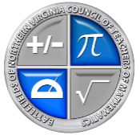

BNVCTM
Katherine Meints President
Kelly Pratte Treasurer
Penny Parker Secretary
Christina Treadwell Conference Program Chair
Amy Hickey Math Supervisor
Kris Gushue Secondary Leadership Rep.
Kathleen Morris Elementary Leadership Rep.
Bethany Lightfield Specialist Representative
Tori Violetta ES Representative
Vacant MS Representative
Vacant HS Representative
Betsey Silva Vendor Liaison
Miller Kehlet NCTM Representative
Christine Gault VCTM Representative
Kathleen Morris Grant Coordinator
Cathy Crocker College Rep
Janet Graham Manassas City Representative
Nicole Sarich Manassas Park Representative
Susan Bardenhagen Board Member

*************************
In Appreciation

The board members of BNVCTM sincerely appreciate the
following people for contributing to the success of this conference:

Denise Huebner, Principal of Benton Middle School
Staff of Benton Middle School for use of their rooms
BNVCTM Spring Conference
March 4, 2017

Name_________________________ School ____________________________
Presentation Title Completed
Session A Title: | Place sticker here
Session B Title: | Place sticker here
Session C Title: | Place sticker here

PWCS Staff: Please return this form to the registration desk at the end of the conference. Your attendance will be marked in the online catalog.
THIS DOCUMENTATION SHEET MUST BE RETURNED
TO RECEIVE PWCS CREDIT
*****************************
Staff from districts other than PWCS, please stop by the registration desk
to receive a certificate before you leave.

