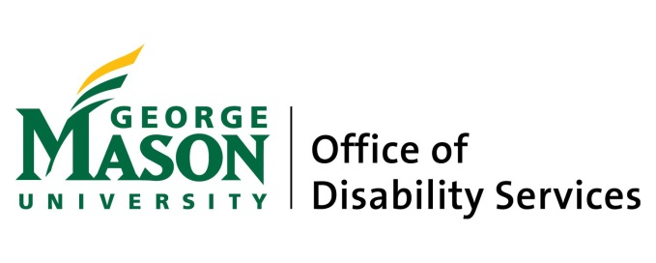

MASON AUTISM SUPPORT INITIATIVE

The Mason Autism Support Initiatve offers individualized, comprehensive social and academic supports to motivated Mason students with autism spectrum disorder in order to guide them through the transition into university life, and assist them in building skills necessary for success in the university environment and beyond. We encourage development of self-advocacy and college-level independent living skills by providing individual and group support within a collaborative model.
Our program is grounded in best practices among institutions of higher education across the nation, and has been shaped by the input of students, staff, faculty, and community members. MASI aims to create opportunities that foster social and academic growth in students, enriching their experience at Mason and preparing them for employment in their selected fields. Our students work together with a staff support team to navigate their Mason experience, and to identify and work toward meeting academic and personal goals. In collaboration with program staff, strategies are developed according to each student’s individual needs in social, communication, academic, and college-level independent living areas.
We also provide awareness training for the university community as a whole, to include individualized and group consultation with faculty and Residence Life staff. MASI Program staff also facilitate occasional social activities, designed around student interests, for the whole cohort.

SERVICES PROVIDED

Learning Coach
Each student will be matched with a Learning Coach, who will meet and correspond with them regularly to provide support and assistance, depending on their individual needs, with many aspects of university life including:
- Implementation of strategies and development of skills in self-advocacy, organization, time management, planning/prioritizing, studying, goal-setting, problem-solving, self-monitoring, decision-making, negotiation, stress management, and self-awareness.
- Effective communication with faculty and staff, classmates, and peers.
- Collaboratively identifying and addressing social needs and navigating challenging situations.
- Accessing and utilizing campus and community resources.
- Transitioning into life as a university student.
- Preparing for transition into the world of work.
Skills Building Seminar
A weekly group meeting that gives students the opportunity to develop social understanding, build college-level social and communication skills, and learn to apply these in various contexts in order to navigate the social world, build and maintain relationships, and become effective self-advocates.
Peer Mentors
Students are paired with a peer mentors who provide another level of support to help them navigate campus socially and academically, practice social skills, create opportunities for social connection, acclimate to university life, and engage in extracurricular clubs and events.
Mason Point of Contact
Each student is assigned a Disability Services staff member who:
- establishes and implements accommodations.
- coordinates and monitors students’ work with their MSSI support team, measuring progress throughout the semester.
- serves as a liaison with faculty and other campus departments providing support to students.

TO APPLY

Applications will be reviewed and accepted on a first-come, first-served basis, as there is limited space in the program. To be considered for program entry, students must be admitted into Mason. Once accepted into the University, students must register with Disability Services (see process and documentation guidelines at ods.gmu.edu). Referral to the MSSI is then facilitated through Disability Services. As the services provided by the MSSI go beyond standard accommodations, in order to provide essential resources and materials, participation in the program includes a fee of $3200 per semester. Fees are subject to change, and payment plans are available. For further information, please contact Amy Duffey, Assistant Director, Disability Services at 703-993-2474, or aduffey@gmu.edu.

