Chalk It Up to Experience!
Tips from Real Co-Teachers of Virginia
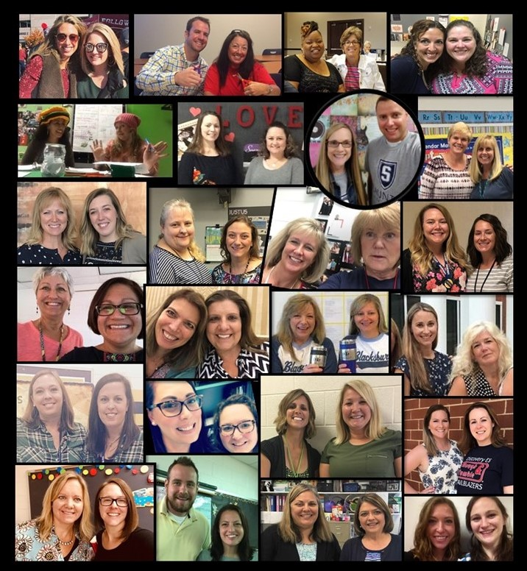
Virginia Department of Education
Excellence in Co-Teaching Initiative
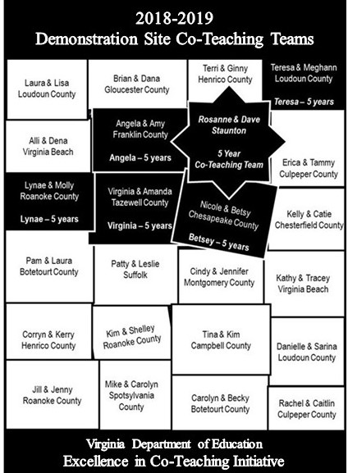
Primary Authors and Reviewers of Chalk It Up to Experience! Pictured on Cover

Table of Contents
Chalk It Up to Experience! 1
Preface 6
Acknowledgements 7
Introduction 8
Classroom Environment and Instructional Routines 10
Elementary 11
Middle 12
High 13
“Real Co-Teachers of Virginia” TTAC Online Resources 14
Co-Teacher Relationships and Shared Responsibilities 15
Elementary 16
Middle 18
High 21
“Real Co-Teachers of Virginia” TTAC Online Resources 22
Co-Planning and Co-Assessing 23
Elementary 24
Middle 26
High 28
“Real Co-Teachers of Virginia” TTAC Online Resources 30
Co-Instructing 31
Models of Co-Teaching 32
Elementary 33
Middle 35
High 37
“Real Co-Teachers of Virginia” TTAC Online Resources 38
Co-Teaching and Project-Based Learning 40
Elementary 41
Middle 41
High 43
Administrative Support 44
Elementary 45
Middle 45
High 46
“Real Co-Teachers of Virginia” TTAC Online Resources 46
Classroom Management 47
Elementary 48
Middle 49
High 49
“Real Co-Teachers of Virginia” TTAC Online Resources 50
Technology and Instructional Resources 51
Elementary 52
Middle 52
High 53
“Real Co-Teachers of Virginia” TTAC Online Resources 54
Parent/Guardian Communication 55
Elementary 56
Middle 57
High 58
“Real Co-Teachers of Virginia” TTAC Online Resources 58
Co-Teaching Benefits to Students 59
Elementary 60
Middle 60
High 61
Final Thoughts about the Excellence in Co-Teaching Initiative 63
Elementary 64
Middle 64
High 64
Appendix 1 66
Primary Authors: 2018-2019 Co-Teaching Teams 66
Appendix 2 68
Training and Technical Assistance Centers (TTAC) 68
Appendix 3 69
Recommended Resources 69
Appendix 4 73
Works Cited in Section Quotations 73

Preface
Federal and state regulations require that students with disabilities are educated with children without disabilities in the least restrictive environment (LRE) to the maximum extent appropriate. This requirement encompasses practices that concentrate on creating meaningful access to instruction for all students across academic, social, and physical environments. According to Virginia’s 2018-2019 Special Education Annual Performance Report to the Public, 68 percent of students with disabilities spend 80 percent or more of the day in the general education classroom. Co-teaching is the most frequently used service delivery model, in which general and special educators share responsibility for assessing student needs in light of curriculum demands, then share planning and delivery of instruction to all students within the general education classroom using a variety of instructional arrangements. Co-teaching has proven to be effective in promoting inclusive education and providing access to the general curriculum for students with disabilities in the LRE.
According to the Individuals with Disabilities Education Improvement Act of 2004 (IDEA 2004), extensive research and experience has demonstrated that the education of children with disabilities can be made more effective by maintaining high expectations for students while ensuring their access to the general education curriculum in the regular classroom as appropriate. For many children with disabilities, this means receiving specially designed instruction and behavioral supports to address their specific learning differences and needs through a co-taught service delivery model. Literature and observational data suggest that co-teaching has yet to reach its full potential as it relates to student achievement and effective implementation.
To inform co-teaching practice in Virginia, the Virginia Department of Education (VDOE) and its Department of Special Education and Student Services developed and supported the Excellence in Co-Teaching Initiative. Initiative teams (refer to Appendix 1) developed this resource to share practical co-teaching tips with teachers and professional developers, and to offer support to school division leaders and parents seeking to improve outcomes for students with disabilities.
Virginia Department of Education
James F. Lane, Ed.D.
Superintendent of Public Instruction
Samantha Hollins, Ph.D.
Assistant Superintendent, Special Education and Student Services
Patricia Abrams, Ed.D.
Director, Special Education Instructional Services
Teresa Lee, Ed.D.
Coordinator, Special Education Instructional Services

Acknowledgements
The Virginia Department of Education (VDOE) wishes to acknowledge all those who provided assistance to the Excellence in Co-Teaching Initiative and the development and review of this instructional resource, including:
Primary Authors and Reviewers
2018-2019 Excellence in Co-Teaching Initiative Demonstration Site Co-Teaching Teams
Training and Technical Assistance Center Demonstration Site Facilitators
Keynote Speakers and Contributors, Annual Real Co-Teachers of Virginia Institutes
Frances Stetson, Ph.D
President, Stetson and Associates, Inc.
Marilyn Friend, Ph.D.
Professor Emerita, University of North Carolina at Greensboro
Jim Knight, Ph.D
Senior Research Associate, University of Kansas Center for Research on Learning
Senior Partner, Instructional Coaching Group
Joyce VanTassel-Baska, Ed.D.
Professor Emerita, College of William and Mary
Lisa Dieker, Ph.D.
Professor, University of Central Florida
Virginia Strategies Intervention Model (SIM) Professional Developers Network
Certified by the University of Kansas Center for Research on Learning

Excellence in Co-Teaching Initiative Consultants
Patricia Parrott, M.Ed.
Educational Consultant

Clare Talbert, M.Ed.
Associate Director of Technology
George Mason University Training and Technical Assistance Center

Introduction
In support of Virginia’s Statewide Inclusion Action Plan and in an effort to promote and improve the implementation of co-teaching throughout Virginia, the Virginia Department of Education (VDOE) began the Excellence in Co-Teaching Initiative in 2014. The initiative sought to establish demonstration sites across the state in which educators can experience co-teaching. Using a competitive process, teams have been identified who are willing to further enhance their current co-teaching practices and to share their knowledge and skills with others. More than 250 teachers and administrators in more than 60 schools in all regions of the state have been involved in the initiative to date. Their efforts are facilitated by staff from the regional Training and Technical Assistance Centers (TTAC) (refer to Appendix 2). These co-teaching teams and administrators have been provided opportunities to enhance their learning by working with leading experts in the fields of co-teaching and instructional strategies. Summer institutes have highlighted various state-of-the art practices, including: schoolwide inclusion, integrating co-teaching models and specially designed instruction with content teaching, strategic instruction, project-based learning, and instructional coaching.
The demonstrations site teams involved in The Excellence in Co-Teaching Initiative share their knowledge of effective co-teaching with others in three specific ways:
- Demonstration Site Observations and Discussions: Co-teaching teams and administrators from other schools/divisions are invited to observe model co-taught lessons in action at the demonstration sites. Time is scheduled for visitors to meet with the co-teaching team and administrator to discuss factors that impact co-teaching success. The educators at both schools are encouraged to continue their discussion and share resources by establishing a distance mentoring relationship.
- Professional Development: Demonstration site teams conduct professional development sessions related to co-teaching and specially designed instruction in their schools/divisions/regions and at professional conferences across the state. They serve as presenters at the content-specific academies and as distance mentors for academy participants who wish to continue contact with experienced co-teaching teams during the following school year.
- Online Training Resource Development: “Real Co-Teachers of Virginia” eWorkshops and webshops have been created within the TTAC Online website to share instructional videos and co-teaching lesson plans developed by the demonstration site teams. Since 2015, these have been among the website’s most popular online trainings, with more than 44,000 unique page-views by teachers across Virginia and the nation. Videos demonstrate co-instructing using various co-teaching models; share tips for effective co-planning, co-assessing, and administrative support; and discuss using High Leverage Practices in co-taught classes. Creation of products by the demonstration site teams is an ongoing process, and new webshops are being planned. Links to the “Real Co-Teachers of Virginia” TTAC Online Resources are provided at the end of many sections of this document. The process for accessing TTAC Online can be found in Appendix 3.
In addition, as part of the Excellence in Co-Teaching Initiative, in collaboration with the VDOE Instructional Offices, Special Education Instructional Services has also sponsored content-specific co-teaching academies to support other co-teaching teams. These academies have focused on improving content understanding, pedagogical strategies, collaboration/co-teaching methods, and networking opportunities. More than 1,200 general and special education teachers have participated in these summer offerings for secondary co-teaching teams of English, mathematics, and science, as well as elementary co-teachers of reading and mathematics.
Finally, this document, Chalk It Up to Experience! Tips from Real Co-Teachers of Virginia, was created by the 2018-2019 demonstration sites co-teachers (Appendix 1). Teams share practical advice for effective co-teaching and practices they consider critical to establishing a strong collaborative relationship. This document will serve as an instructional resource for co-teaching teams and administrators to inform their co-teaching practices.

Classroom Environment and
Instructional Routines
"Student achievement at the end of the year is directly related to the degree to which the teacher establishes good control of classroom procedures in the very first week of the school year."
Harry Wong and Rosemary Wong, 2018
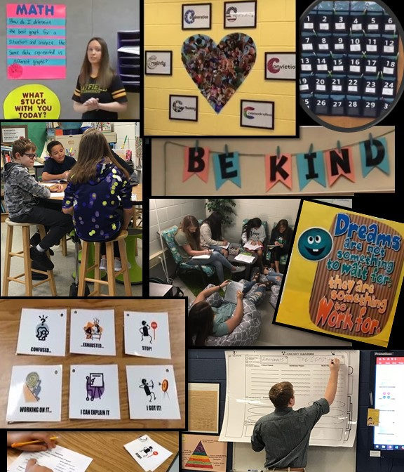

Elementary
“Our classroom has flexible seating for whole group instruction, tables for small group and independent work/stations, exploration stations (blocks, housekeeping, art), room to move (clear pathways), a cool down area, easy access to materials for all students, room dividers to minimize distractions during small group instruction, a Promethean board and laptops to increase student engagement, and a bathroom and a sink for quick transitioning when needed.”
Catie and Kelly
Kindergarten Language Arts and Math
“A typical day begins with [the special educator] doing a Smartboard or other activity to engage the students and set the instruction for the day. [The general educator] spends this time observing student interaction and taking notes regarding understanding, and if needed she will assist any student in need. She then steps in and explains the main activity and lesson for the day. Once the students are engaged in their activity, both teachers then monitor all students for understanding. If needed, [the special educator] will pull a small group of students to a side table to re-teach or offer more academic support while [the general educator] continues to monitor the remainder of the class.”
Tammy and Erica
Grade 1 Math
“In our classroom we use a lot of engaging hands-on activities to hook our students. When you come into our classroom, you will often see students and teachers using technology.”
Corryn and Kerry
Grade 3 Reading and Math
“We nurture the co-teaching relationship with a rhythm that works for us and for the students we serve. Our classrooms are safe, inviting, and have flexible seating giving students voice and choice as to where they want to learn best. Our rooms are lit up with lamps providing a calming environment. The classrooms are set up to provide all day small group learning. All students can learn in both classrooms for small group and/or parallel teaching. We utilize many hands-on engaging activities which provide many opportunities for learning. During the first week of school, we establish rules and routines including organizing their binders, planners, notebooks, and folders. Throughout the school year, both of us are responsible to maintain our instructional routines, provide feedback to students, and support mastery of learning. This provides our students to learn from each other, have social interactions, and increase their respect for one another.”
Alli and Dena
Grade 4 Language Arts, Math and Science

“In our community, classrooms are very diverse and students have a large range of strengths and challenges. We feel that the environment and instructional routines must be adaptable each year. Teachers must be willing to step out of their comfort zone to create an environment and routine that best fit their current students. It is important that we are never afraid to try something new.”
Carolyn and Mike
Grade 5 Math
“We have a third co-teacher who teaches language arts and social studies. We are lucky that we actually have three classrooms between the three of us. The two general education teachers stay in their room. The special education teacher goes into the general education classroom for the lessons, but she then is able to move groups to a different location depending on the type of lessons being taught or if students are distracted. When both teachers are in one classroom, each teacher has an individual space. The spaces are generally on opposite sides of the room as so the groups do not impede each other’s learning. Of course, our spaces change depending on what we have planned for the day. We believe in flexible seating. Although we have student desks, we also have bean bags, pillows, beach chairs, and other non-typical seating for classrooms.
“The students see us as equals and we share all students. They are ‘ours.’ The first item that indicates equal ownership of our class is how we address the class. When we look at the students, it is as a class as a whole.
“Our first thing that we started with was establishing classroom rules that carry over from one class to the switch class. Both classes use the same routine such as where homework belongs, planner activities, where supplies are kept, and the behavior management plan. In each class, the switch teacher along with the special education staff review data daily, weekly, etc. We have entrance tickets, teacher observations, exit tickets, formatives, summatives, and weekly data review, just to name a few.
“The students have a Must Do and a Can Do list. All must dos are turned in and checked. Included in these lists are weekly computer assignments, small group reinforcements, independent work, small group instructions, to name a few. Students are in charge of their own pacing, with the co-teachers checking in several times a week.”
Kathy and Tracey
Grade 5 Math and Science

Middle
“Even before you enter, you will see that the classroom is OURs because both names are located outside the door. This sharing continues upon entering as you quickly notice both teachers ‘live’ in the space. From there, our classroom is far from typical. In order to meet the needs of various students, our classroom offers flexible seating through standing desks with stools, wobble stools, standard chairs, and comfy seats. Our room is illuminated by natural lighting and colorful floor lamps. Around the Promethean board, we have string lights, and we also have a marquee board that greets students with positive points to ponder upon entering. We value our students by acknowledging their birthdays on the marquee as their special day. As well, our room is clean and organized, containing very little clutter, a strategy we share with our students. It has been said our classroom is soothing and welcoming to all who enter – student, colleague, or parent.”
Laura and Pam
English 8
“Our classroom and school population are very diverse, and our classroom style and teaching strategies must constantly change to accommodate our students’ needs. We are consistently adapting our rules, discipline procedures, reinforcement strategies, and even teaching style in order to reach specific groups or individuals.”
Lynae and Molly
Math 6
“The first week we assist students with direct explicit instruction on how to organize their binders to promote their independence. We have an established classroom routine. Students begin each day with recording homework and upcoming assignments in their agenda and they are provided the essential questions for the day’s lesson. Each teacher is equally responsible for ensuring all students are engaged and review the essential questions.”
Brian and Dana
Grade 8 Civics

High
“We work to create a classroom environment where students are comfortable and ready to learn. We have found that flexibility is the key to keeping a well-oiled machine. Our classroom is set up with small groups and partners in mind. As the layout of the room shifts throughout the year, we make sure that students are able to work together and provide peer support for students struggling due to academics or language barriers. While we have purchased a variety of different resources (extra calculators, station whiteboard table, and math manipulatives), we have found that one of our best purchases has been a group of standing desks. We have many students, both general and special education students, who are more comfortable and focus better when given the opportunity to stand during instruction and practice.”
Rachel and Caitlin
Algebra 1

“Real Co-Teachers of Virginia” TTAC Online Resources
Webshop: Real Co-Teachers of Virginia Discuss High Leverage Practices – Elementary
Video: HLP 7 Learning Environment
Webshop: Real Co-Teachers of Virginia Discuss High Leverage Practices – Middle and High
Video: HLP 7 Learning Environment – English
Video: HLP 7 Learning Environment – Math

Co-Teacher Relationships and
Shared Responsibilities
“To be successful, co-teaching relies on two committed educators who care deeply about reaching their students and work diligently to achieve that goal. They problem solve to generate new strategies, resolve differences of opinion, and try alternate solutions if the original one is not successful.”
Marilyn Friend, 2008
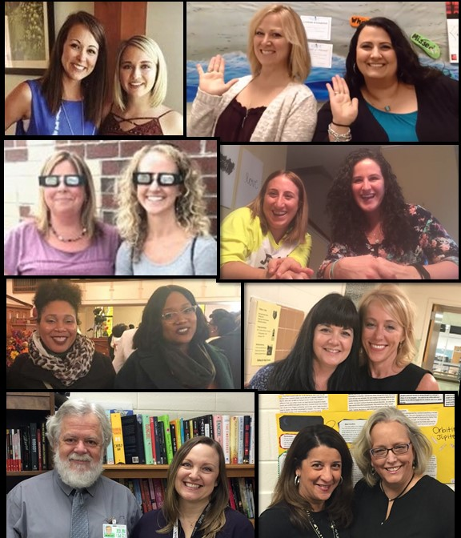

Elementary
“Our Keys to Success: develop co-teaching norms and expectations, believe that all students can be successful and learn, be sure each teacher has a voice that is valued and heard, trust each other, and have fun – two teachers are ALWAYS better than one!”
Catie and Kelly
Kindergarten Language Arts and Math
“To have a successful co-teaching relationship, we believe partners must share a common vision, have clear expectations for one another, and exude honesty. These three characteristics are what we feel will be our foundation.
“All teachers have a vision, and all visions are unique. Therefore, we do not believe that our visions, as co-teachers, must align entirely, but our visions must have similarities. What will our classroom community foster? We believe in risk-taking, collaboration, trust, and acceptance of others and their differences. As teachers, we use the word “expectations” quite frequently. When we do so, we are typically referring to those that we have for our students. What exactly are those expectations - academic, behavior, social, etc.?
“While the expectations we have for our students are undeniably important, we have expectations for one another, as co-teachers, too. What does a “typical” day look like in both of our minds? Who will take care of the miscellaneous classroom duties? Who will be responsible for grading, grouping, etc.? These questions are a few of the many that we found important to discuss prior to beginning our co-teaching journey. Without discussing these questions, we would have undoubtedly run into roadblocks. Although our answers may have not been the same at first, through our common vision, we were able to successfully come to agreements as to how our classroom community will run.
“The last characteristic to a successful co-teaching relationship is honesty. When you co-teach, you share – you share a classroom, a family, and a giant piece of your life. To share your environment, family, and life, you have to feel comfortable with your co-teacher. In order to be comfortable, it is crucial that both co-teachers are honest with one another. No matter how solid the relationship is between co-teachers, there will be moments in which you will disagree or not see “eye to eye.” While this may seem daunting, it is inevitable. To ensure that disagreements will not be a downfall to the co-teaching relationship, both co-teachers must promise to be honest with one another. If an unpleasant or uncomfortable situation presents itself, honesty is key.
“These three characteristics and the support of administration are what we feel is the underlying support of our co-teaching relationship. We can rely not only on one another but on the unwavering support of our administration.”
Lisa and Laura
Grade 2
“Both partners must understand each other’s teaching philosophy, and unite behind the desire to make a difference in the lives of students. If what is best for students is at the heart of every discussion, it’s easier to be reflective, and for feedback not to be taken personally. If challenges arise, teachers must both presume the intentions of the other are positive. It is easier to do that when you can go back to what you have in common – wanting to do what is best for kids. In a new partnership, the general education teacher may have some difficulty releasing some of the control over the classroom. The special educator may be a little overzealous because she is excited to expand her role to working with more students and to be more involved in grade-level curriculum. Flexibility is key! The general educator must be open to new ideas, and must relinquish some of her control in order to allow the specialist to have some ownership of the classroom. The specialist may need to exercise some patience, and to understand that her partner has been the only authority in the classroom up until this point. Both partners must compromise and value the expertise of the other.”
Sarina and Danielle
Grade 3 – All Subjects
“Luckily, our administrative team supports our co-teaching journey. The key to making it work for us is being willing to share responsibilities, embracing all students in the class, flexibility, and the desire to try new strategies to reach all learners.”
Corryn and Kerry
Grade 3 Reading and Math
“The old adage, ‘two is better than one,’ doesn’t only work for scoops of chocolate ice cream! Turns out that it also applies to teaching. We have co-taught for five years and it has been a journey of discovery, learning, and a mutual enjoyment. Throughout this adventure there have been some nuggets of wisdom that we have gained that may help and guide others.
- R-E-S-P-E-C-T. Find out what it means for your co-teacher and do it!
- Share your responsibilities. Two is better than one!
- Know your kids and know your stuff! Understand the IEP and know the grade level standards.
- Be flexible. If at first you don’t succeed, good for you; you found out what doesn’t work. Give it another go! Give and take. You can never limit what you may learn from doing things another way.”
“Co-teaching takes a lot of work and a dual commitment by both members, but once you start, it can be sweeter than two scoops of ice cream!”
Terri and Ginny
Grade 4 Reading and Math
“We know that shared ownership for all students is a non-negotiable. Both co-teachers provide accommodations. We utilize flexible seating in our classrooms. Our communication is open, welcomed, and encouraged by each of us. We collaborate and group children according to the previous year's data, pre-assessments, and formative assessments. Confidential IEP folders are provided to each staff member who works directly with each student. Strategies, instructional activities, and modifications are provided at each collaborative meeting. Communication is open and honest. Accommodations and modifications are provided. All materials are shared. Classroom expectations and routines are jointly developed. Furthermore, we are honest. respecting one another, laugh all day, and accept our ideas and differences. This is what makes our relationship organic and comfortable.”
Alli and Dena
Grade 4 Language Arts, Math and Science

“Our team has participated together in a co-teaching environment for the past three years. During these three years, we have been able to spend time adjusting our teaching styles, layout, and strategies in order to meet the needs within our ever-changing classroom.”
Carolyn and Mike
Grade 5 Math
“The key to making this relationship work is being flexible, shared concern for the students, and realizing that neither one of us knows everything about everything!”
Kim and Tina
Grade 5 Reading and Math
“We understand our roles but realize that some of these roles change daily. The special educator is in charge of the IEP but gains insight from the general educator. The general educator is responsible for the grades but gathers information from the special educator.”
Kathy and Tracey
Grade 5 Math and Science

Middle

“Tips for effective co-teaching:
- Flexibility in planning, classroom management, discipline, teaching style, etc.
- Time management in order to co-plan and brainstorm ideas
- Effective collaboration combining math with accommodations and strategies
- Communication (i.e., what worked and what didn’t work, problem solving, new strategy needed)
- Funny note: dressing alike was never planned but occurred more times than not! Does this mean we are ONE – INTERCHANGEABLE – INDISTINGUISHABLE – CAN FINISH EACH OTHER’S SENTENCES! Yep, just two real co-teachers of Virginia.”
Lynae and Molly
Math 6
“There are several keys to making our relationship work. We have a lot in common in our personal lives. We are also very flexible, understanding, and patient. Academic success is something we both desire for our students to achieve.”
Angela and Amy
English 7
“The day to day operations of our classroom vary. As instructors, we value what each brings to the table in terms of personality and content knowledge.”
Jill and Jenny
Math 7
“Relationship is everything, both between us as educators and with our students. If a positive rapport is not established and maintained, the co-teaching process is negated. Communication is the main way to facilitate a relationship and share duties and responsibilities. Co-teaching isn’t something we do – it’s at the core of our very being. It’s our life, and we love it.”
Laura and Pam
English 8
“Our story together starts not in the classroom, but on volleyball sand courts. That is when we first met over a decade ago. Later, our lives intersected again when we both had our first children at the same time and ended up in the same “mommy” group. Years later, we ended up both teaching in the same school and slowly started to build professional connections.
“We didn’t just jump right into co-teaching. Teresa had experience with the Co-Teaching Initiative with another teacher, and when she found herself moving grade levels, she enlisted Meghann to become her new co-teacher. One of our conditions of joining the Initiative together was formalized administrative support for our efforts.
“Right in the beginning, we met with our administration to advocate for at least two team-taught classes together and common planning time. We reached an agreement after we presented the reasons why this would be beneficial for their students. We feel fortunate to have this support, as our success depends on time to both plan and implement our ideas. (We both have a lot of them!) Without time to talk, including about our kids and husbands, we would struggle to complete the goals we have for ourselves and our students. One of those goals is that the students feel that we genuinely care for each other, and for them, and that takes personal investment.
“We had a very successful first year, not only as a partnership, but also as part of a larger English 8 team. Teresa’s knowledge helps build specialized instruction into all assignment planning. Finding the time to plan, just as a pair, continues to be a challenge. Luckily, we are adept at finding times to talk, including during our lunch times, ‘morning meetings’ over coffee, and occasionally, through text.
“Not only does our team work well together, but we also have a close personal relationship. Because we focus on building rapport, both with each other and with the students, we often receive comments such as ‘I was so impressed with… the ease with which the two teachers interacted with one another and all students.’ (observer)”
Meghann and Teresa
English 8
“It was also important for us to communicate with each other regarding lesson plans, student issues, discipline, classroom procedures prior to starting the school year and then updating regularly as the year progressed. Both of us adapted to each other’s thoughts and ideas.”
Lynae and Molly
Math 6
“We approach our 6th grade math classroom as equal partners and share all the responsibilities associated with teaching. When referring to the students in the classroom, we use ‘our’ students, not ‘yours’ or ‘mine.’ Both individuals are introduced as the teacher during orientation or any meeting. We each are very involved in the function of our classroom. We both share the responsibility of grading, discipline and assessing student performance. We meet with parents as a team when possible. We share in the successes and failures of our classroom as a team. We feel the key to co-teaching is trusting your partner. Allowing your partner equal access to the classroom is critical to your relationship. We feel a successful co-teaching classroom cannot exist without a strong personal relationship. Communication is vital to the existence of your team. We feel both of us need to know what is happening at all times in our room. We need to both know the issues of our students. We also both need to express the same expectations for our room. By implementing all of these key components, our co-teaching partnership is a success.”
Amanda and Virginia
Math 6
“In theory, a collaborative classroom is a beautiful thing. The idea of two certified teachers opens the door for so many variations of teaching through instructional approaches, personalities, and shared responsibilities. All of this is, of course, magnificent in theory. What isn’t always as clear cut and what theory does not tell us is how to effectively develop a relationship as professionals that fosters a dynamic situation in which all students can learn and grow. Just as we expect when we teach our students new content or concepts, establishing an ideal co-teaching situation within a successful co-taught classroom comes with a learning curve.
“First, and foremost, it is imperative that both teachers recognize that you will both bring something to the table and have both received training in your respective areas. For most teams, the general education teacher specializes in the content area (math) and the special education teacher specializes in creating and/or modifying activities for the students. When we began our tenure together, we sat down and discussed general classroom expectations, our ideas relating to educating all ability students, and establishing general ideals for roles within the classroom (grading, parental contact, data collection, etc.).
“Although both of us are capable of performing the ‘clerical’ and ‘administrative’ roles, we found it beneficial to outline who the primary ‘responsible party’ would be for each role. This allowed us to create an environment that offered shared responsibilities catered to our personal strengths. This outline continues to benefit us; however, it is important to note that it is not a ‘my job, her job’ approach, but an understanding for who will initiate or complete various tasks within the classroom on a regular basis. For example, one teacher handles the majority of the grading while the other takes care of most of the rating scales and IEP input request forms. In our opinion, the most effective co-teaching occurs when, as a team, you are able to establish roles and open lines of communication while capitalizing on each individual teachers’ strengths within the classroom. We all have something amazing to bring to the table. The key is learning how to exploit those individual talents within a team environment.”
Jill and Jenny
Math 7
“The students observe us as equal participants in the classroom, often trying as they would with parents to go to the other one of us when they don’t like the response from one of us. We have worked together for four years and can finish each other sentences and know each other’s thoughts. Our roles are very fluid and constantly change within the classroom.”
Leslie and Patty
Math 8 Pre-Algebra
“We feel that the key to our success as co-teachers is based on our belief that all students can and will learn when provided meaningful instruction in a safe environment which focuses on critical thinking, creativity, collaboration, communication conviction and community.”
Becky and Carolyn
Grade 8 Pre-Algebra
“Our co-teaching relationship is based on mutual trust and respect. We acknowledge each other’s busy schedules and are flexible when we plan. We also put tentative dates on our calendar to meet. We build on our strengths and feel we can openly communicate with each other.”
Brian and Dana
Grade 8 Civics

High
“We follow the ‘must, should, could’ mantra, which means that on essentials, we are unified; on non-essentials, diversity; and on all things, charity.”
Rosanne and Dave
English 9, 10 and 11
“Communication is key! In planning, we have honest discussions about strengths and comfort level. Sharing assets that each teacher brings to the classroom (remembering that there are two experts in the room) is an important building block to our success. It is important for us to routinely discuss what is working, what could work better, and what doesn’t seem to be working. Stay positive and try something else if things are not successful on the first try.”
Cindy and Jennifer
English 11
“We have found that the most important step in building a successful co-teaching relationship is to view each other as equal partners and to practice open and honest communication. At the start of our partnership, we spent some time reflecting on and identifying personal strengths and weaknesses and looked for areas that we can support one another with our own special skills.”
Shelley and Kim
World Geography

“Real Co-Teachers of Virginia” TTAC Online Resources
eWorkshop: Real Co-Teachers of Virginia – Middle and High
Webshop #9: Views of Co-Teaching from Multiple Perspectives
Video: Top Ten Ways to Have a Fantastic Co-Teaching Relationship

Co-Planning and Co-Assessing
“One of the major benefits of co-teaching is that teachers bring different areas of expertise. These diverse skills are helpful during the planning stage, as both educators can find ways to use their strengths to ensure that the lesson is appropriately differentiated for a heterogeneous class.”
Wendy Murawski and Lisa Dieker, 2004
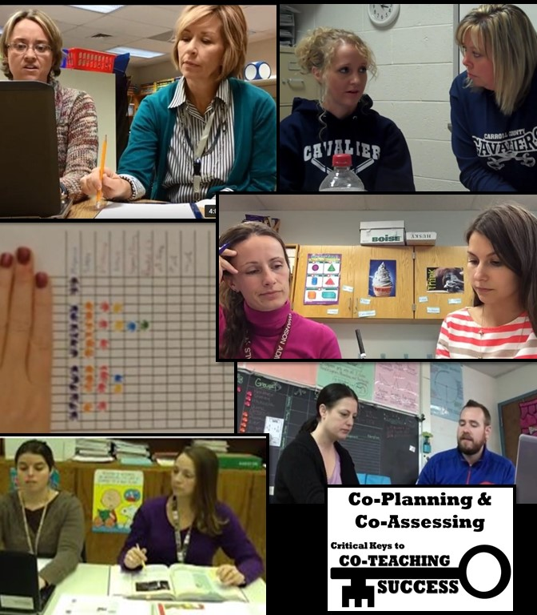

Elementary
“The general education teacher is the curriculum and pacing pro. The special education teacher is the one who knows the learning continuum between the grade levels and seeks to find ways to differentiate based on learning styles and needs. With these powers combined and sufficient time allotted for planning, all students can be successful within the co-taught classroom.”
Catie and Kelly
Kindergarten Language Arts and Math
“We share a planning block and so are able to schedule an hour a week to plan for math. Having the same planning time allows us the flexibility to meet and adjust plans as needed throughout the week. We also meet together for grade team meetings, ensuring that the instruction is in line with the grade level.”
Tammy and Erica
Grade 1 Math
“Unfortunately, we don’t have common co-planning time. However, we always find time to meet. Once a week we formally meet after school to plan for the week ahead. We also find time to communicate each day about lessons or things we need to tweak for the following day. We find communicating daily whether through text, email, or in person, is essential in running a successful co-teaching classroom and being on the same page.”
Corryn and Kerry
Grade 3 Reading and Math
“Time for co-planning needs to be scheduled at least weekly. Teachers cannot be as effective if they do not have an equal understanding of content and how it will be delivered. Plans for new teams might need to be much more detailed than either partner is used to because both should be contributing to lessons. Co-planning for new teams will take a significant amount of time. It is helpful to find a way to streamline the process. The general education teacher might have objectives laid out ahead of time, and may have some resources/activities that have been used in the past. Then, the bulk of planning time can be used to discuss modifications, accommodations, and co-teaching models that would be best for the content and the students. Co-assessing is important for several reasons, especially in the process of reflection. The progress the students are making (or in some cases, are not making) should be a major factor in reflective conversations, and should be considered in the planning of future lessons. Co-assessing also ensures that both teachers have a clear picture of each student’s strengths and areas of need.”
Sarina and Danielle
Grade 3 – All Subjects
“Unfortunately, our planning times did not coincide. We meet on a regular basis at our local Panera Bread Restaurant. This provides us with time to unwind, and have an unhurried planning session where not only our creative juices can flow, but also those great drinks at Panera!”
Terri and Ginny
Grade 4 Reading and Math
“We build a variety of instructional accommodations, or scaffolds, into our lesson planning process to provide natural bridges to learning. Some of our examples are word banks, SIM Framing, technology, visual schedules, and checklists. We utilize a gradual release model when providing instruction for all students. We differentiate instruction for our lesson plans by designing and adjusting on the basis of the results of pre-assessments. We provide remediation based on formative and summative assessments. A variety of instructional and assessment strategies are utilized. Instructional groupings are varied frequently to increase student success and matched with learning styles and interests. Classroom arrangement is compatible with differentiated instruction and allows for easy access to materials and learning stations. We provide accountable talk cards for modeling. Specially designed instruction (SDI) and small group instruction are designed carefully based on the needs of our students.
“We provide flexible grouping based on knowledge of student readiness/ability, interest, learning style, and choice. We utilize a MUST DO/CAN DO format while meeting in groups. The tasks completed during group time are based on partner work and individual student assignments as appropriate.
“We monitor their progress by utilizing anecdotal notes for each student that identify the areas to be monitored, the measurements to be used, the frequency of assessment, and the type of data collection and recording in data assessment folders. We provide opportunities for students to set goals and encourage goal setting as a means of promoting self-responsibility.
“We collaborate on assessments to form groups, reflect on what worked effectively, and identify areas of concern to work on. Students benefit from our collaborative partnership through our observations, data, and verbal conversations with students.”
Alli and Dena
Grade 4 Language Arts, Math and Science
“In addition to the delivery of instruction, co-teaching benefits us in many other ways and eases the many demands of the modern classroom. Having the time to co-plan is extremely beneficial because we are to plan the direction of our instruction and prepare with various perspectives. This allows us to find accommodations or scaffolding that may be needed and plan for possible educational hurdles prior to the lesson delivery. It also gives us the ability to better understand the teaching styles of one another through the planning process. We are able to learn from each other and seek the other’s advice in regards to instructional strategies.
“Co-teaching is beneficial for assessment-driven instruction. We allow the assessments to drive our instruction for the next unit. We can look at data and see what went well and what didn’t. After discussions and reflection, we can adjust our grouping and strategies in order to better meet our students’ needs.”
Carolyn and Mike
Grade 5 Math
“We meet weekly during the special education teacher’s lunch time and during the general education teacher’s recess time. Time is a huge factor so we had to be creative when trying to carve out planning time. We had to develop a plan for flexible grouping so that we could extend the co-teaching time to one hour rather than splitting the time between two classes.”
Kim and Tina
Grade 5 Reading and Math
“We collect data in many different forms. We use entrance tickets, pre-assessments, oral answers, small group instruction, exit tickets, formative and summative assessments. We are constantly changing our groups to meet the needs of the students. This data drives our instruction for the next day of teaching as well as how it will be presented. The data also is used to share information with students about their goals. Usually the special education teacher is responsible for recording the data but the general education teacher has input and insight on how these students are doing. The special education teacher has goal sheets, which are available for review and are discussed weekly with the team.
“We have one planning time a week that is ‘official.’ Plus, we have collaborative planning one time a week with the grade level. Our communications between each other include one formal co-planning time, several informal planning times, numerous emails, text messaging, and phone calls. We use Google tools for numerous activities such as Classroom for sharing items, our share folders, etc. Our documentation is our lesson plans, our collaborative agendas and minutes. We use technology to collect information, show growth, and to plan further lessons.”
Kathy and Tracey
Grade 5 Math and Science

Middle
“We review all IEPs and 504s together and each have copies of the IEPs and 504s. We have a quick reference chart for accommodations/modifications for both classes. In addition, we have a section on that chart to address the IEP goals and collect data for them. We use seating charts based on needs. Prior to any unit, we look at a variety of specifically designed instruction (SDI) techniques that can be incorporated and tweaked for any lesson plan. We are fortunate enough to have common planning. We meet on a weekly basis to plan for upcoming units and to implement SDI. We also use data from various assessments to aid in instructional planning.”
Angela and Amy
English 7
“Our planning is unique because we share common planning times. We are able to collaborate fully in our shared space and time. We often discuss and plan while we both type our lessons into a shared Google Doc. Planning is not limited to a designated time; it often occurs many times a day, and even on weekends and during vacations. While making plans, we make sure we utilize various models of co-teaching. Dependent on the lesson, we make use of the various models of co-teaching: both teach, one teach-one assist, parallel teaching, and station teaching. Using these different models of co-teaching aids in preventing boredom for students as well as for us, while also promoting the idea that our classroom is shared.”
Laura and Pam
English 8
“Because of prior experience with other great co-teaching teams, we had an exceptional first year together in which we had common planning and taught all three blocks of the day with one another. This schedule, however, was not without its challenges due to conflicting duty schedules and grade level and department meetings. Our common planning took many different shapes and forms depending on the week’s activities. When possible, we met with one another during our planning time to discuss content and instructional strategies. Other days, we communicated on the fly before class, in the hallway, through email, or “after hours” through text messages. This was also a year of learning for us, as we became acclimated to a new co-teaching partner and adapted our own prior methods in order to combine our skills and work well as a team.”
Lynae and Molly
Math 6
“Co-planning is essential to the success of our co-teaching team. We share a common planning period. This allows us the opportunity to co-plan on a regular basis. We not only co-plan together; we also co-plan with the entire Math 6 Department. When we co-plan, we allow each other to express our ideas freely. We talk about what has worked and what we need to change. We both have strengths that contribute to the success of our team. When mentoring other teams in our building, we stress the importance of collaborating with each other. The success of the team depends on open communication and sharing ideas/work load.”
Amanda and Virginia
Math 6
“Our team discusses student progress on a daily basis and also makes grading determinations (remediate, offer corrections, etc.) based on student growth. These discussions drive our planning and instructional strategies. It is important to note that our discussions are not centered around our ‘special education students,’ but around any/all students who may be demonstrating a weakness in a particular area. In our classroom, the general education teacher creates a lesson plan ‘shell’ based on our district’s pacing guide. Next, as a team, we discuss the activities available to us, activities we may want to create, and how we will assess student learning. Finally, we discuss the best co-teaching or instructional strategy to utilize for each activity (direct instruction, stations, etc.) and create an outline of the week. Our process comes full circle as we assess, evaluate and adjust our plans during our daily discussions of whole group and individual growth.”
Jill and Jenny
Math 7
“We have been fortunate to have an abundance of administrative support providing an opportunity to share a classroom and a common planning period. This allows us to plan on an ongoing basis and allows us to change strategies throughout the day based on students’ needs and the success of the daily lesson plan. Formative and summative assessments are used daily in our classroom. Warm-ups, class work, exit tickets, formal and informal assessments, projects and teacher observations are used to guide our instruction. Data gathered from assessments provides information needed to implement specialized instruction and inform parents of student progress.”
Becky and Carolyn
Math 8 Pre-Algebra
“Co-planning is an important component of everything that goes on in our classroom. When we group our students, we look at all our data and look at strengths and weaknesses. We also look at personalities, likes and dislikes which change on a daily basis. We have 90 minutes set aside for planning every day. We try to devote at minimum one day every week to planning together. Within the class period we are also planning and adjusting based on what we see occur within the class. We often have different approaches to the same task within a day based on the personalities of the class as a whole. What may work in the morning may not work in the afternoon. The other days are spent in IEP meetings and in pulling in students to help remediate weaknesses and catch up on missed work.”
Leslie and Patty
Math 8 Pre-Algebra
“The general educator functions as the content area specialist and is tasked with drafting the instructional framework and determining the majority of materials that will be used. The special educator functions to specially design instruction, help scaffold lessons and to differentiate materials. In order to ensure student success, we both begin each instructional year defining main units and updating the calendar to reflect the pacing guide. We also co-plan at the beginning of each quarter to make sure we are on target and if needed we adjust the calendar. We are currently in our 4th year of co-teaching this class. The first few years, we required substantial weekly planning as we were creating and developing our lesson plans. Our initial lesson plans were scripted by roles, co taught model(s) being used, and the breakdown of the allotted instructional block time. In year 4, we are now able to co-plan biweekly or at the beginning of each unit of study to modify and/or enhance our lesson plans and materials from previous years to meet the needs of the current students assigned to our class roster. We touch base as needed if concerns arise, schedules need to be changed, to make adjustments and communicate with parents.”
Brian and Dana
Grade 8 Civics

High
“At the beginning of the year, we look at data from previous English SOLs and Scholastic Reading Inventory lexile levels, and previous grades for each student. Utilizing this data enables us to create a game plan for the content, including specially designed instruction, which we will be delivering throughout the course. Assessments guide our instruction. We utilize pre-, mid-, and post-tests frequently to check the growth of our students. These are typically in the form of released SOL benchmarks and other similar tests. We also write persuasive essays 1-2 times per month. We are continuously examining the results of these assessments and adjusting instruction as necessary. Over the years, we have not always had common planning. When we are lucky enough to have it, we look at data, assessments, and student growth during our planning block. Most years, we are flexible with our time in order to meet after school, before school, during lunch, on workdays, and over email.”
Rosanne and Dave
English 9, 10 and 11
“Prior to the start of the school year, we spend time to plan! In addition to curriculum planning, classroom management, teacher roles, and co-teaching models need to be established. Using frequent formative assessment, we share information about all students’ progress. Having two teachers in the room increases the ability to observe if a student is struggling and what methods may help that student. On a daily basis, we adapt plans for the next day based on student need.”
Cindy and Jennifer
English 11
“When we are not teaching, we are reviewing our teaching and planning for the future. It is very important for us to communicate with each other regarding what we saw as the successes and concerns from each lesson as we prepare for the following day. Some days may take more time to review while others are done in five minutes; regardless we have to communicate every day. In addition to direct communication regarding specific lessons, we keep open lines of communication for planning lessons through the use of Google Drive/Docs where we create lesson plans and share ideas for the class as a whole and the needs of specific students.”
Rachel and Caitlin
Algebra 1
“Each teacher brings something unique to the classroom and having a partner to discuss strategies with and plan with can be inspiring and very helpful. Having that collaboration with another teacher can be so beneficial in helping reach those students who might otherwise fall through the cracks. We are a new co-teaching team but have much experience between us. We see co-teaching as a way to provide quality instruction so that all students can access the curriculum. Planning for both of us starts with the general education teacher completing the overall general plan and the sped teacher augmenting instruction. We work toward a more collaborative effort where specialized instruction is implemented on a regular basis. This spring we taught the Algebra IA repeaters, and we have seen great success with these students. Many have said how much better they learn in a smaller group size that gives them more attention and the ability to ask questions in a "safer" environment. Working with smaller class sizes definitely helps those special education students who need more attention in order to be successful and to gain more confidence in their abilities.”
Betsey and Nicole
Algebra 1
“We try to make most decisions about our classroom together. While co-planning is an important and ideal feature of co-teaching, it is not always possible in the high school setting. We found that technology provides a great alternative. Through email and cloud servers such as Google Docs and Office 365, we share lesson plans and ideas even when we are apart.”
Shelley and Kim
World Geography

“Real Co-Teachers of Virginia” TTAC Online Resources
eWorkshop: Real Co-Teachers of Virginia - Elementary
Webshop #3: Co-Assessing in Elementary Classes
Webshop #4: Co-Planning for Elementary Classes
eWorkshop: Real Co-Teachers of Virginia – Middle and High
Webshop #4: Co-Assessing in English Classes
Webshop #5: Co-Assessing in Math Classes
Webshop #6: Co-Planning in English Classes
Webshop #7: Co-Planning in Math Classes
Webshop #8: Co-Teaching in Science and Social Studies Classes
Webshop #9: Views of Co-Teaching from Multiple Perspectives
Video: Co-Planning with a First Year Teacher
Webshop: Real Co-Teachers of Virginia Discuss High Leverage Practices – Elementary
Video: HLP 1 Professional Collaboration
Video: HLP 4 Multiple Sources of Information about Students
Video: HLP 13 Curriculum and Materials Adaptation
Video: HLP 15 Provide Scaffolded Supports
Video: HLP 17 Flexible Grouping
Webshop: Real Co-Teachers of Virginia Discuss High Leverage Practices – Middle and High
Video: HLP 14 Cognitive and Metacognitive Strategies
Video: HLP 17 Flexible Grouping

Co-Instructing
“By beginning with the expectation that the ‘co’ in co-teaching truly means that both teachers should deliver instruction, co-teachers can become creative in how they go about their work. They should blend the approaches, create variations of them, and ultimately, reach the needs of their diverse students.”
Marilyn Friend, 2008
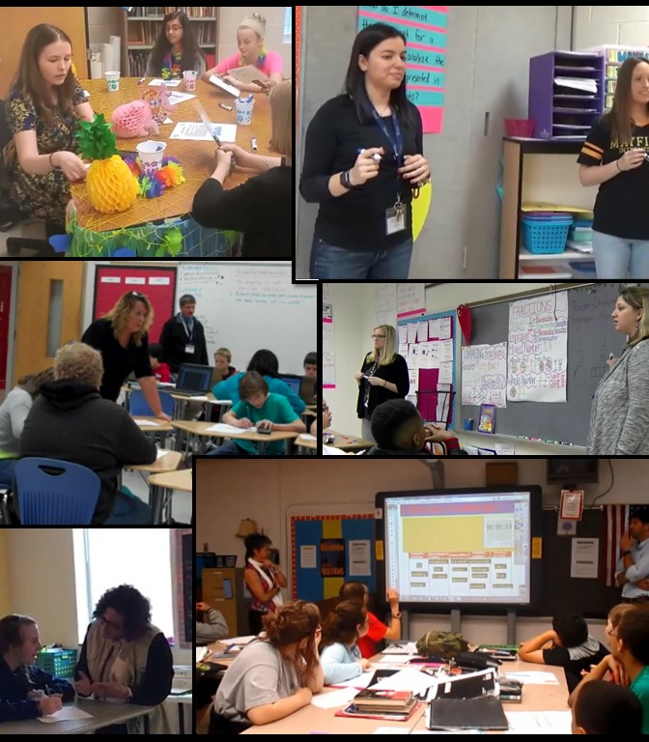

Models of Co-Teaching
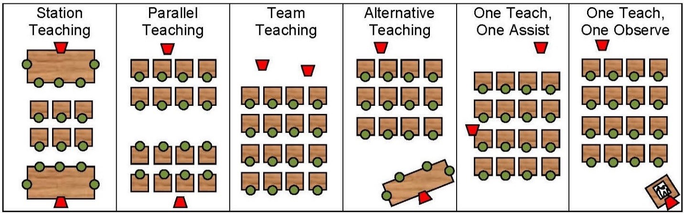
Station Teaching – typically, co-teachers instruct small groups on different parts of the lesson while another group works at a third station independently, with a partner, or with a paraprofessional. Groups rotate to work at each station. “Incomplete” stations can allow three direct instruction sessions for students who need additional or remedial instruction and two independent stations for higher functioning students.
Parallel Teaching – both teach the same information to smaller groups, to better respond to individual needs and encourage student participation.
Team Teaching (Teaming) – both teachers share responsibility for delivering instruction to the whole class.
Alternative Teaching – one teacher provides remediation for struggling learners in a small group, while the other leads enrichment activities for students who have mastered those skills.
One Teach–One Assist – one teacher assumes the primary teaching responsibility while the second provides individual assistance to students as needed.
One Teach–One Observe – one partner teaches and the other observes to generate data to improve instruction or to assess student progress toward IEP goals.

Elementary
“We use team teaching to start or introduce lessons in math and writing. We use station teaching to practice math concepts that have been introduced and to incorporate different ways of using writing strategies. We use parallel teaching when we want to break up into smaller groups to allow students to practice what they have learned with more frequent teacher feedback. We use alternative teaching when students may need the concept taught in a different format or pace.”
Catie and Kelly
Kindergarten Language Arts and Math
“We use station teaching two to three times a week. We have a parent volunteer to assist with groups using our Smart Table and Chromebook stations. As a team, we use differentiated instruction to meet the needs of the tiered groups and we also constantly assess our students to ensure correct placement of the students. If and when needed, we are also able to implement the incomplete station rotation, allowing tier 3 students access to a larger window of intensive academic instruction.”
Tammy and Erica
Grade 1 Math
“After using data to assess student progress, we drive our instructional model to best suit what the class needs for that certain skill. When reviewing, practicing, or extending skills, we like to use station teaching. This helps us pack several activities into one block, and students can get more than one viewpoint on the topic.”
Corryn and Kerry
Grade 3 Reading and Math
“The parallel teaching model plays well with your individual teaching styles and the student’s modalities. We teach the same thing, but the delivery varies according to student learning needs.”
Terri and Ginny
Grade 4 Reading and Math
“We utilize many effective co-teaching models. The models we utilize most are station teaching and parallel teaching. These models provide us the opportunity to be flexible, plan daily using our data, and reflect on students’ strengths and needs. During station teaching, we present targeted instructional content and cooperative learning. During parallel teaching, we decrease student teacher ratio and target students’ instructional needs. In both of our co-teaching models, it shows our strengths and individual teaching practices.”
Alli and Dena
Grade 4 Language Arts, Math and Science
“We use various co-teaching models in our classroom. We have used station teaching, parallel teaching, team teaching, one teach-one assist, and alternative teaching. The type of model we use depends on the skill being taught, behaviors, and how well the students are doing with the concept. This year we have had to try various models to help with the behaviors in the classroom. We are always trying to maximize the effectiveness of having two teachers in the classroom. This year we found ourselves pulling away from station teaching and going more to parallel and team teaching to increase student engagement. Many of the students receive small group testing. Generally, we split the groups and provide some students with an alternative assessment when needed. This accommodation is not only to benefit the student’s with IEPs, but for any student in the classroom who may require this.”
Kim and Tina
Grade 5 Reading and Math
“Having a co-teacher within the classroom allows us the opportunity to expand and provide specific instruction to all our students regardless of need or disability. We are able to use multiple co-teaching models effectively throughout the day. In our classroom, we use a lot of parallel teaching in order to provide our students with instruction at their level. We are able to meet students where they are in their learning journey and provide them with the correct scaffolding in order for them to master content strands. Station teaching in also consistently incorporated into our learning environment. This allows us the ability to continue to push the content strands that are necessary, while still allowing the spiraling of past instruction and remediation of previously taught skills. A team environment allows us to present new material in multiple ways. This allows us the opportunity to model math thinking and acceptable math behaviors so students are able to add these tools to their toolbox. The ability to use these strategies accurately and fluidly allows us to meet our diverse needs of each individual in the class. We feel that each year our co-taught classroom is constantly changing and growing; thus, it never looks the same year-to-year.”
Carolyn and Mike
Grade 5 Math
“During any lesson, several co-teaching approaches are used. Depending on the needs of the students, information being taught, and length of time we have to teach all plays an important part in our teaching. Another important input for us is comfort level of the lesson being taught. A typical day could include starting with one teach-one assist to review a previous lesson, one teacher at the board as the other teacher is walking around working with individual students as needed. Next could be station teaching: one teacher could be introducing a new skill at one area while the second teacher is teaching another skill. During that same time, depending on feedback, one teacher could switch to alternative teaching if we realize some are not ‘getting it,’ then coming back as a teaming approach. The great thing about our co-teaching team is that we are both open to switch our approach mid-stream if something changes or we note something that the students are struggling with.”
Kathy and Tracey
Grade 5 Math and Science

Middle
“Station teaching is used to cover different skills/activities in a variety of ways. It gives the students a chance to move around and use hands-on activities. As we teach, we can reiterate or point them in the right direction for further clarification. Parallel teaching is used because we can provide instruction on the same topic but in a different way. Alternative teaching is used to help students who have missed instruction or to reteach a concept.”
Angela and Amy
English 7
“We have experimented with many co-teaching models, and our personal favorite is station teaching. Maybe because it is our favorite model, our administrators chose to showcase this for multiple visitors throughout the year. Our love for this model was reinforced by receiving positive feedback from observers. Although it isn’t always a good time to plan for this model, we work it in whenever we can.
“A close second of co-teaching models is team teaching. This is the model used most often in our classroom. Teresa’s degree in English gives both teachers authority and ownership over the curriculum in the classroom. We both like to trade off instruction and are not hesitant to interrupt each other or sometimes to even talk over each other! We are both natural storytellers and use that to build rapport in our classroom. We have so much fun together that students just have to respond!
“We also use the alternative teaching model frequently. We work together to identify students that would benefit from re-teaching of specific content, and we use that information to create small groups for intervention. Each time this model is used, the student groups change and they always consist of students with and without disabilities. We both believe that our job is to work with all students, and sometimes we have found that the students who need the most help and intervention are not the special education students.
“One teach-one observe is a reality of every co-taught classroom, but we work hard to mix it up and not always have the same teacher be the one doing the teaching. Because of our mutual comfort level with the content, we are able to decide last minute who would address the whole class. We try to make sure that when one teach-one observe is used, that it is done consciously with both teachers having a purpose. This model can be a great opportunity to take data for IEP goals.”
Meghann and Teresa
English 8
“In the past, we have used several of the co-teaching models including one teach-one assist, station teaching, teaming, and alternative teaching. We have found our most useful models to be station teaching, teaming and alternative teaching. These models allow us to share the responsibility of assuring that all students are comprehending the concept. It also allows us to work with those individual students who need extra help and allows us to meet their needs.”
Amanda and Virginia
Math 6
“Our classroom and school population are very diverse, and our classroom style and teaching strategies must constantly change to accommodate our students’ needs. We are consistently adapting our rules, discipline procedures, reinforcement strategies, and even teaching style in order to reach specific groups or individuals. Because this past school year was our first year as a team, we implemented the co-teaching models of one teach-one assist, parallel teaching, and alternative teaching in most circumstances in order to drive instruction while we got comfortable with one another. As the year progressed, we were able to implement all six co-teaching models interchangeably for various units of study.”
Lynae and Molly
Math 6
“After material has been presented, we utilize station and parallel teaching to offer smaller group instruction for application. Parallel and station teaching provide the best opportunity for differentiation and maximize the effect of a smaller student-teacher ratio.”
Jill and Jenny
Math 7
“We use a variety of co-teaching models. The model that we find most effective is the use of incomplete stations. We are very fortunate in that we are together for a total of 4 classes. This makes it much easier for us to be able to implement new ideas and try to perfect them. We like using incomplete stations because we find that we have students in our classes that are at many different levels. We try to individualize our instruction so that we are reaching all of the students. We want to remediate the lower students and also challenge the higher students. This changes per standard. Students are constantly coming into our classroom not knowing where they will be sitting and whom they will be grouped with. The reason for this is that children may be stronger in one standard and weaker in another. During SOL review and review for tests, we find having two stations to be a good strategy. We split the class in half within the same room and each concentrates on reviewing different concepts (based on our own strengths). It is much easier to remediate weaknesses and catch up on missed work with smaller groups, and students are more comfortable asking and answering questions.”
Leslie and Patty
Math 8 Pre-Algebra
“We use a variety of instructional co-teaching models, but we lean more toward the team teaching model. Visitors in our classroom have often been unable to identify the general educator and the special educator. We recently began incorporating incomplete stations to the delight of our students. This gives struggling students the opportunity to receive extra help while other students can work collaboratively on reinforcing their skills in other areas. This is a great way to use differentiation in the classroom.”
Becky and Carolyn
Math 8 Pre-Algebra
“Our lesson plans show we begin each lesson as a whole group using team teaching or one teach-one assist. When new topics are introduced, the general educator is the content area specialist and leads the class with the special educator assisting and/or team teaching dependent on his/her knowledge base on the topic. After the topic is introduced, we primarily use station teaching and/or parallel teaching or alternative teaching co-teaching models. Flexible grouping based on informal data collection and student need determines how students are placed in groups. Groups change based on student need. Most classes end coming back together as a whole group using the team teaching model for exit.”
Brian and Dana
Grade 8 Civics

High
“We team teach when we are delivering new content or modeling instruction for students. We utilize parallel teaching when students need small group instruction or when behavior issues arise. Alternative teaching helps when we need to re-teach or reinforce ideas with one group while providing enrichment for the other group.”
Rosanne and Dave
English 9, 10 and 11
“For daily routines, we divide teacher roles and determine which co-teaching model we will use. We tend to use team teaching and one teach-one assist the most. When we use one teach-one assist, we are mindful to switch out roles.”
Cindy and Jennifer
English 11
“We have used stations for review prior to a test where each station reviews a different skill and topic from the unit. We have also used stations to practice the same topic but with varied presentations and styles of questions. At each station, students do not always complete the same work or work load depending on their ability level. We focus on quality over quantity. At times, we also abbreviate stations where one group may not finish all of the stations so that they can completely finish the work at one station and demonstrate mastery. The groups that travel through the stations will vary; sometimes groups will be based on ability level and each station will have work that is geared towards each level. Other times we will group students randomly to prompt peer partnership and tutoring. In addition, we have found it effective for teachers to rotate rather than students to help with classroom management and on-task behavior.
“We have found alternative teaching to really benefit our students. We generally have a group of students with attendance challenges and alternative teaching allows us to work with this rotating group of students and catch them up on the missed instruction without distracting the rest of the class. Alternative teaching also helps students who are easily distracted in class or may try to distract their peers to avoid work. By pulling a couple of these students to a quiet, separate, environment, we can help them focus on the work and complete their work in a fraction of the time they would’ve in the classroom and with better quality.”
Rachel and Caitlin
Algebra 1
“Most days we are team teaching. We both are presenting direct instruction together, bouncing off one another, and we both are leading students in activities and supporting students as they work independently or in groups. We use stations when we need to cover a large amount of material. Chunking the information into stations helps to maintain attention, differentiate instruction among the different groups more effectively, and has the added benefit of student movement as they travel from station to station.”
Shelley and Kim
World Geography

“Real Co-Teachers of Virginia” TTAC Online Resources
eWorkshop: Real Co-Teachers of Virginia - Elementary
Webshop # 2: Co-Instructing in Elementary Classrooms
Webshop #5: Co-Teaching Lesson Plans – English and Social Studies
Webshop #6: Co-Teaching Lesson Plans – Math and Science
eWorkshop: Real Co-Teachers of Virginia – Middle and High
Webshop #2: Co-Instructing in English Classes
Webshop #3: Co-Instructing in Math Classes
Webshop #8: Co-Teaching in Science and Social Studies Classes
Webshop #10: Co-Teaching Lesson Plans – English (Middle)
Webshop #11: Co-Teaching Lesson Plans – English (High)
Webshop #12: Co-Teaching Lesson Plans – Math (Middle)
Webshop #13: Co-Teaching Lesson Plans – Math (High)
Webshop #14: Co-Teaching Lesson Plans – Science and Social Studies (High)
Webshop: Real Co-Teachers of Virginia Discuss High Leverage Practices – Elementary
Video: HLP 7 Learning Environment
Video: HLP 8 Positive and Constructive Feedback
Video: HLP 9 Teach a Social Behavior
Video: HLP 13 Curriculum and Materials Adaptation
Video: HLP 15 Provide Scaffolded Supports
Video: HLP 17 Flexible Grouping
Webshop: Real Co-Teachers of Virginia Discuss High Leverage Practices – Middle and High
Video: HLP 8 and 22 Positive and Constructive Feedback
Video: HLP 14 Cognitive and Metacognitive Strategies
Video: HLP 16 Explicit Instruction
Video: HLP 17 Flexible Grouping
Video: HLP 18 Student Engagement

Co-Teaching and Project-Based Learning
“Studies comparing learning outcomes for students taught via project-based learning versus traditional instruction show that when implemented well, PBL increases long-term retention of content, helps students perform as well as or better than traditional learners in high-stakes tests, improves problem-solving and collaboration skills, and improves students’ attitudes toward learning.”
Vega, 2015
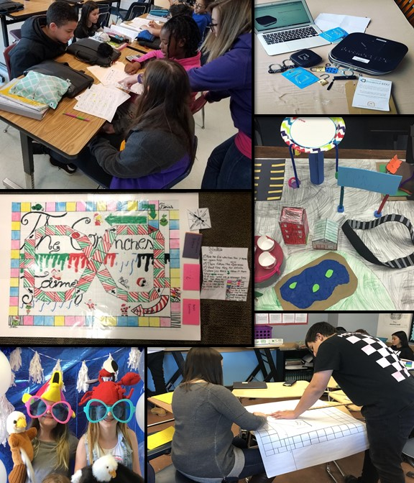

Elementary
“Planning for a PBL is easier for co-teachers. They can bounce ideas off of each other, and they might end up taking the project in a totally different, and better, direction than one would have if planning on his own. Teachers can also divide and conquer with prepping materials, contacting experts, arranging visits, and anything else the PBL requires.

“When a co-taught classroom engages in a PBL experience, the learning is increased dramatically. All of the benefits of PBL are magnified by having two capable teachers working with students. Station teaching with two teachers give students more teacher time, meaning more targeted instruction, and more immediate feedback. We know students will progress through the PBL at different rates. Having two teachers allows for a more organic development of the project by all students. If some students are not ready to take on the next step in the project, one teacher can offer more support to them, while the others can keep moving along. This way, no one is left in the dust, and no one is held back.”
Sarina and Danielle
Grade 3 – All Subjects
“We are very fortunate that our co-teaching teams work closely with their grade level as well as other resources in our building. When planning a project, we begin with a brainstorming activity that involves the teachers, Gifted Resource Teacher, Library Media Specialist, Instructional Tech Specialist, and any outside resources needed.
“As we begin planning for our class, we, as a team, begin to differentiate the project to meet all our learning needs. We include different co-teaching approaches to make sure that all students are learning. This includes team teaching, parallel teaching, station teaching, and one teach-one observe.
“The projects are usually introduced in whole groups and then broken down into steps through different teaching approaches. As 5th grade teachers, we allow the students to self-pace themselves with guidance from us. This helps our students gain confidence as they work through the project. Each step is checked and re-taught as needed. With each step completed, the project is becoming attainable for the student.
“At the conclusion of the project, each student has enjoyed the opportunity to learn from numerous resources as well as themselves taking a leadership role within this project.”
Kathy and Tracey
Grade 5 Math and Science

Middle
“As we were brainstorming, we knew that we wanted the PBL to be based on one of the books that we teach during the year. We quickly realized that we would need to meet several times over the course of a couple of months to create an engaging yet feasible PBL. We wanted to be sure that we could implement a PBL that enhanced our students' learning experience. In addition, we gave the students choice in the type of artifact produced to build their enthusiasm. With having two teachers in the classroom, students had more available sounding boards as well as a second set of eyes to help guide them through the process.”
Angela and Amy
English 7
“We feel that PBL is more approachable with a co-teacher. The old saying "two heads are better than one" is so true. It helps to have someone to collaborate with on projects. Different perspectives on ideas help to formulate a great PBL idea. Projects can be a headache also and having the extra adult in the class helps tremendously. The extra person makes PBLs an option when it may not have been with just one teacher because of the extra work involved.”
Amanda and Virginia
Grade 6 Math
“When conducting our class-wide PBL, we were able to differentiate tasks and activities at various stages of the project. The co-teaching model significantly impacted our ability to do this. We were able to divide students by ability level and scaffold instruction/activities on the fly based on student need. Having two sets of eyes made this much easier. We could also divide students into two separate rooms to specially design lessons based on student need at that specific stage in the process.”
Lynae and Molly
Math 6
“Co-teaching while incorporating PBLs into our instruction allows us to better serve the needs of each student. It provides opportunities to differentiate further than what might be possible within a classroom with a single teacher. We are able to allot one teacher to a specific group (i.e., the lower students/group) for more guidance and scaffolding while the other teacher can roam and help with the remainder of the students as questions arise. During the planning process, knowing we have two teachers in the room, we are better able to account for the lowest functioning students and tailor the project to better meet their needs and level of functioning without compromising the integrity of the project.”
Jill and Jenny
Math 7
“The opportunity to co-teach benefits the students in many ways. The students have access to two experts in the classroom that can share the responsibility of differentiating and meeting their needs. It is during co-planning that we are able to create the PBL activity that most effectively caters to higher-level thinking, growth, and engagement as well as meet the needs of the students that require remediation on a topic. There are also two adults present to provide extra support to those who may require it. In our class, breakout boxes have been used multiple times and students are excited to use them. During Breakout challenges students are answering questions and using problem solving skills they normally would not have done if the activity was just on paper. They are also using communication, collaboration, and advocating skills within their group.”
Leslie and Patty
Math 8 Pre-Algebra

High
“Working with a co-teacher made the PBL process a joy for both the students and the teachers. Because we had different life experiences, we were able to design a project from our varied perspectives that the students connected with, providing them with hope for their own story. We were able to differentiate various aspects of the work, incorporating specially designed instruction in a way that made the project approachable for all students. Our differing skills enabled us to play to our strengths as we planned the project, worked through student questions, and connected with community. In the end, we had full participation from our students, and we found that our co-taught PBL unit was our and our students’ favorite part of the semester.”
Rosanne and Dave
English 9, 10 and 11
“Conducting the PBL with our students was a lot of work and a lot of fun for both teachers and students. This opportunity encouraged students to be creative, collaborate with their peers, and include mathematical concepts learned throughout the year. Our PBL started off as an individual assignment which allowed the teachers to work specifically with students to meet their individual needs, and once they joined a group, peer mentoring was ever present. When we were working on the PBL, students continually expressed their excitement to work on the next step and add the next component for the final project. When students were in groups, the teachers were able to work with each group and celebrate student creativity while also checking for understanding of math content and providing specific support unique to each group.”
Rachel and Caitlin
Algebra 1
“We feel that developing and conducting a PBL for our co-taught classroom really brought out all of the best things about co-teaching and was a natural way for us to co-plan, co-teach, and co-assess. The development of the project enabled us to evaluate and utilize our own strengths and weaknesses and in doing so let us serve as a model for our students to see that they each bring unique ideas and skills to the table.”
Shelley and Kim
World Geography

Administrative Support
“Principals are the individuals who have the power to put into place the conditions that are necessary for co-teaching to have a positive impact on student learning.”
Marilyn Friend, 2008

Elementary
“Our administrators prioritize co-teaching, and are very supportive. They frequently ask us how we are doing and if we need anything from them. They provide substitutes once per quarter to allow us to co-plan for half of a school day, which is extremely helpful.”
Sarina and Danielle
Grade 3 – All Subjects
“Our administrator adores our classroom. It resembles a lounge since we have flexible seating and the students are always on task. It is for this reason that many times when visitors arrive at our school, our classroom is a sure visit. It doesn’t matter how crazy the request (including pens that resemble blood syringes), our principal supports us and finds the needed funds in order for us to engage our students in authentic learning and create greater student outcomes.”
Terri and Ginny
Grade 4 Reading and Math
“Our administrators embrace our co-teaching methods and philosophies. They are extremely supportive and we are very fortunate. Our administration conducts meetings with grade levels during work week. They create the master schedule according to all the co-teaching models in our school. Our administration shares ownership for all students as a non-negotiable standard for our school. They foster a growth mindset with the staff that co-teaching promotes both equity and social justice. Our administration provides us data from the previous year. Furthermore, our administration provides collaboration meetings for both academic and our students’ needs.”
Alli and Dena
Grade 4 Language Arts, Math and Science
“We are very lucky at our school. Our administrators are knowledgeable and supportive of the co-teaching philosophy and implementation. The caseload of the special education teacher and other factors impact how much time there is to schedule planning time. As educators, we do a lot of work after contractual hours. This year, the team also does a lot of planning after hours through meetings, emailing, calls, and texting. We do have one time per week that we do schedule but are always fine-tuning our plans. Our administrator has attended several of our planning times. Our administrators allow us to place the students in classes the year before so we can best place them according to needs. We use the input from previous teachers as well as IEPs, academic performances, etc., to place students.”
Kathy and Tracey
Grade 5 Math and Science

Middle
“We are fortunate to have superb support from our administration. In our county, we have been given ‘permission’ to stray from the confines of rigid teaching. This is a message that started at the ‘top’ with our superintendent and is supported by our building administrators. They value and appreciate our efforts to create a positive, fun learning environment and are willing to do whatever they can to aid and support us. We even get to paint our classroom to enhance our learning environment and classroom atmosphere, though this is not usually allowed.”
Laura and Pam
English 8
“Our school administrators are very supportive of our co-teaching team. They realize the importance of being able to co-plan and create a schedule that allows time for this. They also allow us the opportunity to present professional development to our staff regarding co-teaching. We have had around 12 co-teaching teams in our building in the past in English and Math. We feel we have their total support in our co-teaching team.”
Amanda and Virginia
Math 6
“In my view as an administrator, this program has not only helped other school divisions and schools improve their co-teaching methods, but it has also helped us to improve what we do. I have enjoyed getting ideas from teachers and administrators from other school divisions as well as sharing what we are doing well.”
Tim, Principal
Middle School

High
“Over the years, we have not always had common planning. When we are lucky enough to have it, we look at data, assessments, and student growth during our planning block. Most years, we are flexible with our time in order to meet after school, before school, during lunch, on workdays, and over email. Once our administrator really understood the importance of common pairings, we have had a lot of support in keeping our partnership together, and we are now assigned common planning whenever possible.”
Rosanne and Dave
English 9, 10 and 11

“Real Co-Teachers of Virginia” TTAC Online Resources
eWorkshop: Real Co-Teachers of Virginia – Middle and High
Webshop # 9: Views of Co-Teaching from Multiple Perspectives
Video: Administrative Team Views of Co-Teaching
Video: Principal and Student Interviews about Co-Teaching
Video: Evolution of Co-Teaching at Liberty High School

Classroom Management
“Classroom management is a means of organizing, structuring, and planning events to get things DONE in the classroom that will lead to student learning.
“The solution to behavior problems is right under our noses. It’s not INTERVENTION; it’s PREVENTION.”
Harry Wong and Rosemary Wong, 2013
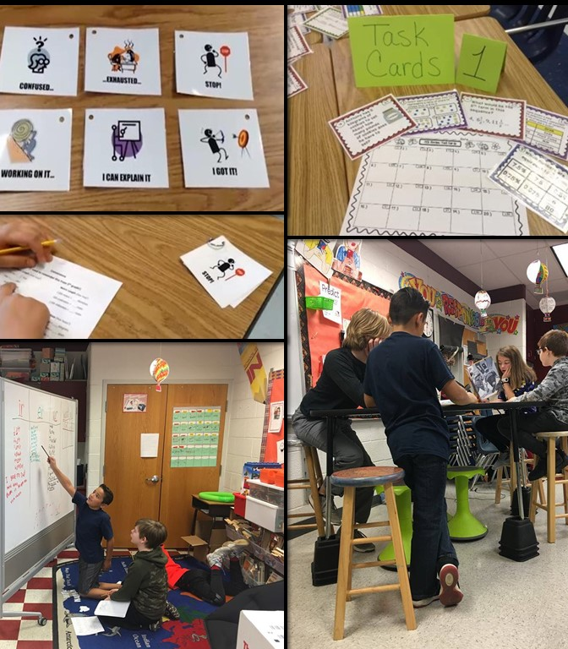

Elementary
“It is important for both teachers to have input with discipline, but it works best when both teachers are on the same page. Positive behavior management strategies are crucial in limiting unwanted behaviors.”
Catie and Kelly
Kindergarten Language Arts and Math
“We consider all students in our class to be ‘our students.’ We take responsibility for student scores, progress, and behavior. Having two teachers in the class allows us to address behaviors without as much disruption and prompt students who need help focusing. We both work on helping students set goals and finding their own strengths to build self-confidence.”
Corryn and Kerry
Grade 3 Reading and Math
“Behavior management is a shared responsibility. Our students accept both of us as equals in the learning process. Fluid positioning in our classrooms is extremely important. During our lessons, we position ourselves based on the lesson content and co-teaching model we are utilizing. We model appropriate behaviors for flexible seating, small group and whole group instruction. Also, we model flexible grouping including team member roles/responsibilities, and noise level considerations. Our classroom discipline is implemented consistently. We are aware of students’ behaviors and maintain constant communication. We are open and honest with our parents, which provides a positive classroom environment. Furthermore, in providing strong classroom management, our students reflect on their goals and build their self-esteem and confidence.”
Alli and Dena
Grade 4 Language Arts, Math and Science
“With our co-teaching classroom, discipline looks very different than in many other classrooms within our school. Having a second teacher provides more appropriate instruction for the students, thus increasing student engagement. Students are active participants in the classroom, and many of the pitfalls such as lack of necessary accommodations or instructions above ability level aren’t present. Our students know to look for us for support and help as they need it without worry. Though it is not often, behavior issues still do occur occasionally. When that does happen, we have a teacher there who can handle it while instruction still continues. Having the additional support allows us to handle the situation in the moment and move on from it instead of delaying instruction or missing a learning opportunity.”
Carolyn and Mike
Grade 5 Math

Middle
“As for discipline, we handle any situation together with the support of our administrative team. We have the most amazing administrative team who provide full support to us as well as all of our students.”
Angela and Amy
English 7
“We used a rewards-based system to influence student behaviors. We distributed ‘good’ tickets for positive behaviors and actions while minimally acknowledging the negative. In instances where this did not work, we wrote or phoned home seeking parental support and additional consequences at home or after school. This has helped us have a more affirmative and encouraging classroom environment in which all parties are stakeholders.”
Lynae and Molly
Math 6
“In terms of effective classroom management, we clearly define the classroom procedures the first week of school. We promote mutual respect, we reach out to parents, and we immediately address behaviors that could create a disruption swiftly during the first weeks of school. Our efforts at the beginning of year entail being consistent and following through with consequences. This minimizes future disruptions.”
Brian and Dana
Grade 8 Civics

High
“In our classroom, we have two rules: Be Respectful; Be Prepared. Manners are always in style, and our discipline revolves around these two rules. Our students need to be accountable for self-regulation. We have high standards for our learners and shared expectations for their behavior. There is no “good cop” or “bad cop,” and we have no tolerance for disrespect or distraction.”
Rosanne and Dave
English 9, 10 and 11
“Rules and expectations should be established and agreed upon together. Before kids even come into the room, there should be many ‘how do you feel about’ conversations. Presenting a unified front and ‘being on the same page’ is essential! Support each other in enforcing rules and encouraging students to rise to expectations.”
Cindy and Jennifer
English 11
“We spoke with each other to establish agreed upon classrooms rules, expectations, and consequences so that students know they will get the same response regardless of which teacher is involved. Teachers should be presented as co-equals in the classroom and students should not see that one has more authority (be it on content matter, discipline, etc.) than the other.”
Shelley and Kim
World Geography

“Real Co-Teachers of Virginia” TTAC Online Resources
Webshop: Real Co-Teachers of Virginia Discuss High Leverage Practices – Elementary
Video: HLP 8 Positive and Constructive Feedback
Video: HLP 9 Teach Social Behaviors
Webshop: Real Co-Teachers of Virginia Discuss High Leverage Practices – Middle and High
Video: HLP 7 Learning Environment – English
Video: HLP 7 Learning Environment – Math

Technology and Instructional Resources
“When technology can actually adjust the level of instruction, support, and practice each student receives, even more time is freed up for teachers to provide personalized attention to individuals or small groups.”
Ashleigh Lutz, 2017
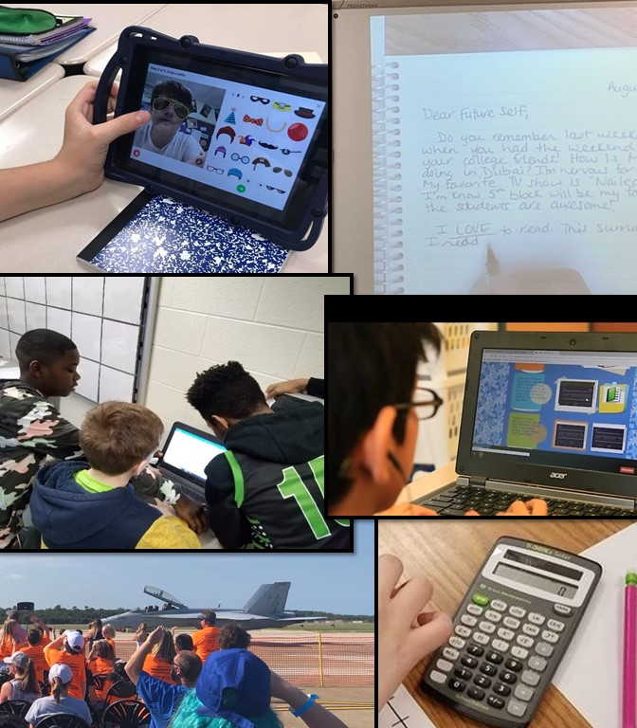

Elementary
“In our classroom we use a lot of engaging hands-on activities to hook our students. When you come into our classroom, you will often see students and teachers using technology.”
Corryn and Kerry
Grade 3 Reading and Math
“Our students benefit from well-planned differentiated instruction. Our skilled, experienced minds effectively plan for all students in the room. Google apps, Quizizz, Nearpod, Padlet, Flipgrid, and our touch screen whiteboards allow us to co-create hyperdocs/documents, presentations, and teaching tools in real time. We take photos of student work samples for evidence, anecdotal notes, and data from our online resources to formulate our small groups, formative, and summative assessments.”
Alli and Dena
Grade 4 Language Arts, Math and Science
“The teachers use technology to collect information, show growth, and to plan further lessons. The students use technology to enhance their learning. We also use programs to help them with their learning. We have audio enhancements for some of our children with below grade level reading: Read to Text, etc. We have assistive technology support for our students whenever we need them.”
Kathy and Tracey
Grade 5 Math and Science

Middle
“Our classroom has its own set of Chromebooks for students to use for quizzes, tests, writing prompts, and other instructional activities. For students with the read aloud accommodation, we check out iPods from the media center when completing English 7 common assessments. Audio for each common assessment is accessible via an app on the iPods.”
Angela and Amy
English 7
“Teresa is a school leader in using and advocating for assistive technology. Due to her knowledge of Google Keep, her students began using it regularly to help with their schoolwork, and Meghann started using it in her personal life too! Teresa definitely takes charge of explaining different add-ons and extensions to students and discovering new ways to help them with their reading and writing.”
Meghann and Teresa
English 8
“We are fortunate to house a Chromebook cart; this allows students regular access. Availability to this technology is beneficial for our students in our English classroom. Using the Chromebooks or iPads, students are able to make use of audible books, speech to text apps, Snap Type, and Audio Exam, to name but a few of the assistive technologies our students have the opportunity to explore.”
Laura and Pam
English 8
“We used assistive technology, such as standing desks, iPods, laptop software, and hand-held manipulatives in order to enhance student outcomes, particularly for our students with disabilities.”
Lynae and Molly
Math 6
“The assistive technology that we use in our classroom consists of a smartboard, computers, manipulatives and graphic organizers. We also design an interactive notebook in our math class. This aids students in their organizational, note taking, and problem-solving skills. Students use this notebook to review for their assessments throughout the year.”
Amanda and Virginia
Math 6
“In our classroom we are basically one to one with Chromebooks. We use the technology often in the classroom. We have had students who have had to be provided a variety of assistive technology. This runs from everything as basic as color coding materials to microphone hearing devices and assistance with taking notes. Our students are very diverse in their needs. This year, we have introduced the use of project-based learning in the implementation of breakout boxes.”
Leslie and Patty
Math 8 Pre-Algebra
“In our classroom we incorporate a variety of assistive technology devices and services including fidget foot rockers and alternative seating such as ball seats and seat cushions. Additionally, we use calculators, a Smart Board, and Chromebooks. All students benefit from the assistive technology provided in our classroom.”
Becky and Carolyn
Math 8 Pre-Algebra

High

“Our school has a one-to-one laptop program and puts heavy emphasis on 21st century skills and project-based learning. We’ve had great success as members of the Real Co-Teachers of Virginia, evidenced by our SOL pass rates increasing from 82 percent to 88 percent in the co-taught classes since joining.”
Shelley and Kim
World Geography

“Real Co-Teachers of Virginia” TTAC Online Resources
Webshop: Real Co-Teachers of Virginia Discuss High Leverage Practices – Elementary
Video: HLP 13 – Curriculum and Materials Adaptation
Webshop: Real Co-Teachers of Virginia Discuss High Leverage Practices – Middle and High
Video: HLP 19 Assistive and Instructional Technologies
Note: Appendix 3 provides links to technology resources mentioned by Real Co-Teachers of Virginia in this section.

Parent/Guardian Communication
“Educators and parents generally agree that positive, supportive and open relationships between home and school, parent and teacher are desirable. Additionally, research has shown that parent engagement and successful parent-teacher partnerships result in improved educational outcomes for students.”
Cindy Perras, 2016
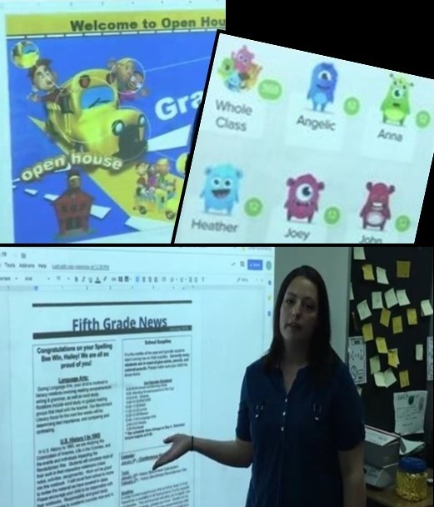

Elementary
“We interact with all parents within the classroom, and share the responsibility of communicating with the parents. We are also both participants on fun things like field trips, assemblies and picture day!”
Tammy and Erica
Grade 1 Math
“Parent interaction is also something in which we have seen great benefits with our co-teaching approach. We have a very open circle of communication between all parties that makes for a great environment for all.”
Carolyn and Mike
Grade 4 Math
“Show parents the good! We always post on Class Dojo to tell or show our parents what their kids are doing in our classroom. Both they and the students are able to comment. This creates a sort of classroom community among parents that would not normally meet. Invariably there comes a time when you must talk about something that isn’t ‘the good,’ but the ‘bad’ and the ‘ugly.’ When you must address areas of concerns, if you have done the former (show the good), then it makes it easier to speak with the parent about other concerns, be it behavior or academic. Try to think of your parent as your ‘silent’ co-teacher (i.e., ‘keep them in the loop!’) and create that ongoing rapport.”
Terri and Ginny
Grade 4 Reading and Math
“During the summer, we create a warm, friendly student and parent introduction letter. We create a Google slide presentation of our co-teaching environments. The communication we build is a bridge to engagement and strong parent partnerships throughout the school year. Once we establish a strong rapport, we work together with our parents to help our students reach their academic potential. Parental communication is the cornerstone of our classroom’s foundation. We communicate in person, technology-based, and written communication. With time and persistence, we communicate effectively with every student’s family in our classroom and our parent-teacher relationship is strong.”
Alli and Dena
Grade 4 Language Arts, Math and Science
“Communication began before the school year started. An introduction letter went home with a picture of us along with our 3rd partner (another general education teacher) with insight to our program. We held Open House, Sneak Peak, and all conferences as a team. The same thing happens with emails and our Remind 101 (teacher/parent communication tool that is similar to text messaging without releasing phone numbers). Each teacher is Cc’d in all communications.”
Kathy and Tracey
Grade 5 Math and Science
“We make sure that we both are at parent teacher conferences to discuss the students’ progress.”
Kim and Tina
Grade 5 Reading and Math

Middle
“For contacting parents/guardians, we use the School Messenger System to send announcements for homework and reminders of important dates. If we need to speak directly to an individual student’s parent/guardian, we attempt to call the parent/guardian together. For each parent/guardian call made, we document the time/date and reason for contact in a Google doc accessible by all teachers and administration.”
Angela and Amy
English 7
“When introducing ourselves to and communicating with parents, we always present ourselves as a team. As for parental contact, it is shared, dependent upon the situation and the teacher involved.”
Laura and Pam
English 8
“Communication is key for a successful year so we made lots of phone calls home, both positive and disciplinary in nature. Our parents, for the most part, were very supportive and receptive to our classroom management strategies.”
Lynae and Molly
Math 6
“We use various forms of communication, such as a group message app called Remind, emails, telephone calls, and meeting when needed. We meet as a team with parents during conferences.”
Amanda and Virginia
Math 6
“All parental communications are shared between us. This is the case for our general education students as well as our special education students. In the classroom context, we view them as all ‘our’ students, they are not ‘hers’ and ‘mine.’ We both email parents, more often than not copying the other on each of the communications.”
Leslie and Patty
Math 8 Pre-Algebra

“We email and call parents often.”
Brian and Dana
Grade 8 Civics

High
“We also try our best to take all meetings and make all parent phone calls together.”
Shelley and Kim
World Geography

“Real Co-Teachers of Virginia” TTAC Online Resources
Webshop: Real Co-Teachers of Virginia Discuss High Leverage Practices – Elementary
Video: HLP 3 Collaboration with Families
Video: HLP 4 Multiple Sources of Information about Students
Webshop: Real Co-Teachers of Virginia Discuss High Leverage Practices – Middle and High
Video: HLP 3 Collaboration with Families

Co-Teaching Benefits to Students
“Benefits to students with disabilities include increased self-confidence and self-esteem, enhanced academic performance, increased social skills, and stronger peer relations Benefits to students without disabilities .... include improved academic performance, increased time and attention from teachers, increased emphasis on cognitive strategies and study skills, increased emphasis on social skills, and improved classroom communities.”
Wendy W. Murawski, 2009
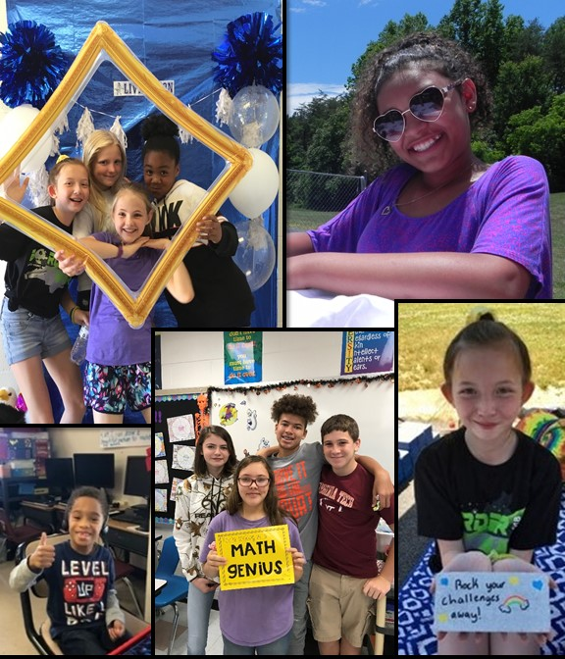

Elementary
“Co-teaching allows more freedom to students in how they would like to demonstrate their learning. One teacher can support those who want to show what they know through a play, a song, a video etc., while the other teacher stays in a quieter location working with students who are creating posters, presentations, pieces of writing, etc. Another benefit is that students who may have otherwise been singled out because of a need or a disability, are more able to participate with their peers with the support of a special educator in the general education classroom. This fosters an appreciation for differences, as well as facilitates new friendships.”
Sarina and Danielle
Grade 3 – All Subjects
“We have learned it is not what unique needs our students have that are in our class, but how we, as a co-teaching team, work together to help them achieve their academic endeavors and dreams. We believe, as a team as well as a school, that anything is possible if you believe in yourself, your team, and your students.”
Kathy and Tracey
Grade 5 Math and Science

Middle
“Through our years of co-teaching together, we have noticed how as a team we have been able to see benefits with student behavior. In some instances, as one teacher is instructing, the other is free to circulate about the room to address any individual student issues. Also, at times, one teacher may be more effective in getting a particular student to complete work because that student responds better to that teacher. In addition, station teaching is much more effective with a co-teacher because there are two teachers to supervise various stations.”
Angela and Amy
English 7
“Being a co-teaching class, you are able to help all students. It is difficult some days to help everyone who needs help being just one person. This is especially true in a lower level class where all students struggle. Having two people helping and assisting students allows you to give assistance to more students. It allows one teacher the opportunity to check for understanding while the other one is presenting the lesson. You are able to have a look at the lesson while the other person presents the information. This will assist you in planning and reteaching things that weren't successful the first go around. Co-teaching allows you the chance to be a teacher and actually teach. You have the availability of another set of eyes and ears. It helps in terms of discipline, effort, and engagement. It is difficult keeping your eyes on everyone while presenting the information. It allows for ‘eyes in the back of your head.’ It is beneficial for all involved. It could also help with personality conflicts by allowing the student to open up to another teacher if there is a conflict in personalities.”
Amanda and Virginia
Grade 6 Math
“In our co-teaching classroom, we have noticed a decrease in need for students to complete assignments at home. For the most part, we are able to have more small group and one-on-one with students for quicker remediation before an ‘incorrect’ methodology becomes the ‘learned’ methodology if they practiced it at all at home. We have also noticed an increase in student engagement due to close proximity to a teacher at all times.”
Lynae and Molly
Math 6
“Co-teaching provides a great learning environment for all students, not just those with a disability. It has allowed us to provide better tiered instruction and remediation, regardless of student identification (special education versus non-special education). Co-teaching lends itself to a better teacher-student ratio and makes utilizing a station approach (i.e., Math Workshop) more effective and efficient. Through the co-teaching process, we have seen great progress from all of our students, even if that progress is not always evident on standardized test results. We are able to recognize and celebrate little victories and encourage continued growth. From a social perspective, we are able to model collaboration for our students. They are able to see what ‘teamwork’ may look like in the work place. Finally, co-teaching allows us to bring a variety of skill sets and approaches to teaching and, subsequently, the learning process. If my way isn’t hitting home for the students, my co-teacher’s way might.”
Jill and Jenny
Math 7
“There are several benefits in our classes that we can attribute to co-teaching. Among those are academic and behavioral improvements. We have seen increases in understanding and decreases in behavioral referrals. These come as a result of the increased time and interaction that we can give to each individual student during the class period. A student has made the statement ‘I feel smart’ when she and her team were able to break-out (during Breakout challenges). We have also had many students and parents state during meetings and at the end of the year that although they did not like math class before, now they love math. The students in our class build deeper relationships with each other and learn the importance of collaborative work both shown to them by example (co-teaching) and by action (working together to problem solve).”
Leslie and Patty
Math 8 Pre-Algebra

High
“The co-taught classroom always runs more smoothly than a classroom taught by one teacher. We want all students to feel that they have an advocate in the classroom, and through co-teaching, there is never any doubt for students that someone has their back. Our students find much more success in a co-taught English class, where our failure rate is lower than that of traditional classrooms. Student behavior is much easier to handle with two adults, and because our standard of expectations is shared, our students know without a doubt how they are expected to conduct themselves. We are warm demanders. They are more motivated to finish their assignments and score well when they know that two adults are expecting greatness from them. There is nowhere to hide when two sets of eyes are keeping watch! Because we can approach them from different angles and with different perspectives, the students have a greater chance of buying-in, and they feel more connected to our class.”
Rosanne and Dave
English 9, 10 and 11
“Co-teaching has definitely impacted our students' overall performance in a positive way. Behaviorally, students tend to receive fewer discipline referrals in our class because we focus on supporting each other's classroom management decisions. Having two teachers in the room gives flexibility to who interacts with a student when they are having a rough day; the rapport built with students decreases the need for more severe discipline actions. Academically, students are more successful in our classroom as compared to non-collaborative classes. We provide more opportunities for practice with feedback and continual reteaching which reinforces student knowledge. We have multiple students who have passed the SOL in our course who have never passed an SOL before.”
Rachel and Caitlin
Algebra 1
“We feel that, as we’ve taken a more intentional approach to co-teaching, the biggest benefit we’ve seen outside of academic progress is classroom behavior. Using the various co-teaching models allows us to teach content in the most appropriate setting for the lesson and has decreased the need for discipline because we as teachers are engaged in the lesson in ways that naturally help kids to stay on task and engaged. Additionally, we are more flexible in the ways we are able to respond to student behaviors that need to be addressed; we both know the students quite well and can quickly determine who is best to deescalate a situation with particular students while the other teacher continues the lesson, leading to less disruption of learning for others.”
Shelley and Kim
World Geography

Final Thoughts about
the Excellence in Co-Teaching Initiative
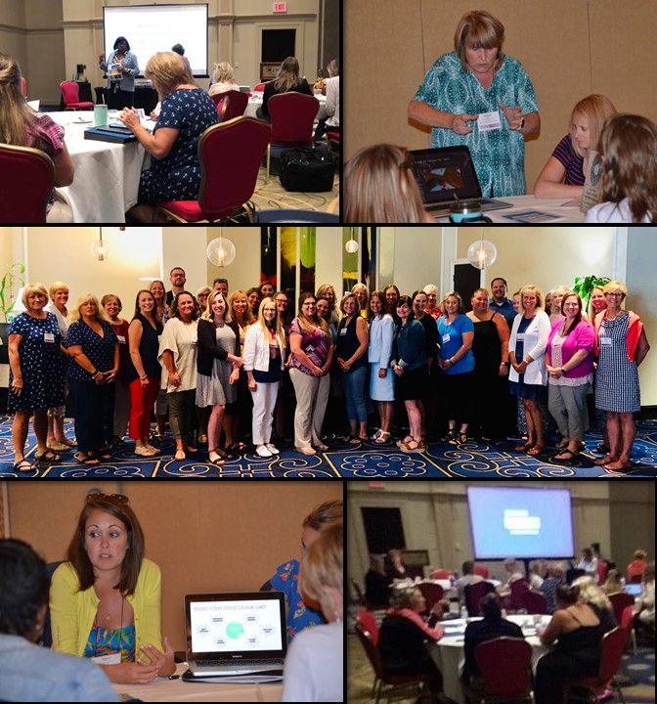

Elementary
“The Excellence in Co-Teaching Initiative gives us an outlet to learn best practices and develop our craft. The knowledge and networking have allowed us to gain an even deeper understanding and drive to meet the needs of all students in a 21st century classroom.”
Carolyn and Mike
Grade 5 Math

Middle
“We love this program because it gives us an opportunity to collaborate with other co-teaching teams, utilize resources, and gain wisdom and insight from excellent teachers all over Virginia. We have found that two teachers are definitely better than one!”
Lynae and Molly
Math 6
“We have enjoyed being a part of this initiative We feel it has helped us become better educators.”
Amanda and Virginia
Math 6

High
“I have been involved with inclusion and co-teaching since 1993. I have been both a special educator and a general educator – so I understand both sides of the co-teacher coin. Over my 24 years of involvement, this initiative has been the first training that has been comprehensive and consistent. Staffing in special education is very fluid, and while I am on my third partner since this project began, I feel as though the training has carried over into each relationship.”
Betsey
Algebra 1
“In order for our co-teaching to be successful, there should be NO confusion about the fact that there are two qualified teachers in the room!
“Set the tone:
- WE, WE, WE! Replace ‘I’ with ‘we’ and ‘my’ with ‘our’ while communicating with students, parents, administrators and other teachers.
- Course syllabus and other course handouts should have two teacher names at the top (roles should be omitted).
- When answering student questions in class, be mindful to collaborate with your co-teacher. This is especially important for academic teachers who are new to co-teaching. For instance, with the following student question, ‘If we turn in our project early, is it possible to earn extra credit?’ Teacher response, ‘That is a great question. Ms. Smith and I will have to discuss that possibility.
“Physical Space:
- In the classroom, a physical space that notifies others that there are two teachers in the room is essential. We have two teacher desks and two teacher computers in our room.
- Bins and supplies should be clearly labeled in order for both teachers to find items quickly.
“The number one tip and piece of advice that we have found that has contributed to our success is our belief in the co-teaching model. There is no doubt in our minds that inclusion using the co-teaching model is the best practice for all students.”
Cindy and Jennifer
English 11

Appendix 1

Primary Authors: 2018-2019 Co-Teaching Teams

Region 1
Chesterfield County – Bensley Elementary School
Kindergarten: Kelly McDougald and Caitlin Reynal
Henrico County – Crestview Elementary School
Reading and Math 4: Terri Crenshaw and Virginia Willis
Henrico County – Dumbarton Elementary School
Grade 3: Kerry Ball and Corryn Moore
Region 2
Chesapeake – Grassfield High School
Algebra 1: Betsey Batten and Nicole Hegedus
Suffolk – Colonel Fred Cherry Middle School
Math 8: Leslie Kelley and Patricia Waegerle
Virginia Beach – Three Oaks Elementary School
Math 4: Allison Sansone and Dena Sciacchitano
Math 5: Kathy Horan and Tracey Wernikowski
Region 3
Gloucester County – Page Middle School
Civics 8: Dana Cooper and Brian Teucke
Spotsylvania County – Livingston Elementary School
Math 4: Michael Hurley and Carolyn Laudicina
Region 4
Culpeper County – Emerald Hill Elementary School
Math 1: Tammy Bradshaw and Erica Hoy
Culpeper County – Eastern View High School
Algebra 1: Rachel Berkstresser and Caitlin Moss
Loudoun County – Discovery Elementary School
Grade 2: Lisa DiLorenzo and Laura Rosa
Grade 3: Danielle Benteler and Sarina Marine
Loudoun County – Harmony Middle School
English 8: Meghann Donohue and Teresa Weis
Region 5
Campbell County – Leesville Road Elementary School
Reading and Math 4: Kim Jacobs and Tina Williams
Staunton – Staunton High School
English 9, 10, 11: David Marino and Rosanne Wykes
Region 6
Botetourt County – Central Academy Middle School
Math 7 and Pre-Algebra 8: Rebecca Clendenin and Carolyn Hoyt
English 8: Pamela Austin and Laura Selkirk
Franklin County – Benjamin Franklin Middle School
English 7: Angela Barbour and Amy Whittaker
Montgomery County – Blacksburg High School
English 11: Cindy Falke and Jennifer Mayotte
Roanoke County – Northside Middle School
Math 6: Molly Carrol and Lynae Young
Roanoke County – William Bird Middle School
Math 7: Jennifer Cain and Jill Meachum
Roanoke County – Hidden Valley High School
World Geography 9: Tammie Sinnes and Shelley Winterer
Region 7
Tazewell County – Richlands Middle School
Math 6: Virginia Justus and Amanda O’Quinn

Appendix 2

Training and Technical Assistance Centers (TTAC)
The success of the Excellence in Co-Teaching Initiative has been due in large part to the TTAC coordinators and specialists who served as facilitators for the project across Virginia’s Superintendent’s Regions. Their support in observing demonstration site classes, helping teams prepare for opening their classrooms to visitors, including teams in professional development, and coaching teams as they completed assignments has been invaluable to the success of the Excellence in Co-Teaching Initiative.
The mission of the Training and Technical Assistance Centers (TTAC) across Virginia is to improve educational opportunities and contribute to the success of children and youth with disabilities (birth–22 years). They work to increase the capacity of schools, school personnel, service providers, and families to meet the unique needs of these children and youth. They also foster the state improvement goals for personnel development by enhancing the knowledge, skills, abilities, and performance of all personnel who work with children and youth with disabilities. TTAC services include professional development, regional training, individual consultation, library loans, and referral services.
Each TTAC has personnel who are members of the Virginia Strategic Instruction Model (SIM) Professional Developers Network. They have provided instruction at the summer institutes and academies in Content Enhancement Routines and Learning Strategies developed by the University of Kansas Center for Research on Learning (KU-CRL) (refer to Appendix 3). They serve as instructional coaches for teachers engaging in a micro-credentialing process to ensure implementation with fidelity, and also coach those who wish to earn credentials to teach the routines and strategies to others. More than 500 SIM micro-credentials have been earned by teachers participating in the Excellence in Co-Teaching summer institutes and academies.
The location of each TTAC is listed below with a link to their website. Each site includes a variety of resources related to inclusion and co-teaching, including articles, training modules, interview podcasts, and videos.
Regions 1 and 8
Virginia Commonwealth University
Virginia Commonwealth University TTAC
Regions 2 and 3
Old Dominion University
Old Dominion University TTAC
William and Mary University
William and Mary TTAC
Region 4
George Mason University
George Mason University TTAC
Regions 5
James Madison University
James Madison University TTAC
Regions 6 and 7
Radford University
Radford University TTAC
Virginia Tech University
Virginia Tech TTAC

Appendix 3

Recommended Resources

VDOE and TTAC Resource
Virginia K-12 Inclusive Practices Guide
“…the K-12 Inclusive Practices Guide… is an informational resource to support school divisions and parents looking to improve outcomes for students with disabilities by meeting their needs to the maximum extent possible in general education settings.”
Real Co-Teachers of Virginia – Elementary
Real Co-Teachers of Virginia – Middle/High
Real Co-Teachers of Virginia Discuss High Leverage Practices (HLPs) – Elementary
Real Co-Teachers of Virginia Discuss High Leverage Practices (HLPs) – Middle/High
These TTAC Online eWorkshops and webshops share basic information about co-teaching and showcase videos and lesson plans created by demonstration site teams in the VDOE’s Excellence in Co-Teaching Initiative.
Links to specific parts of these eWorkshops and webshops are shared as resources at the end of many sections of this document. Readers will be directed to create a free TTAC Online account by providing an email address and entering a password. Once logged into the website, it is possible to easily move from one link to the next. Virginia teachers may be able to earn recertification points for participating in these online trainings. When an entire webshop and an evaluation are completed, a certificate of completion will be generated that shows the amount of time spent on the webshop. This certificate can be submitted to a supervisor or administrator, who will determine how many recertification points may be given. Certificates will be stored in the My TTAC Online Account.
Virginia Tech Co-Teaching Resources
This link on the Virginia Tech TTACC website includes webinars, podcasts and free downloadable resources shared by leading co-teaching advocates.
William and Mary Co-Teaching Considerations Packet
“This Considerations Packet provides basic information to professionals currently engaged in or considering adopting a co-teaching model to support students with mild/moderate disabilities in general education classrooms.”
#GoOpenVA
“#GoOpenVA encourages all Virginia educators and learners to create, share, and use digital resources with the end goals of providing equitable access to great learning materials throughout the state, and supporting new approaches to learning and teaching for all Virginians.”
Although not an exhaustive list, and not endorsed by the Virginia Department of Education, the web resources on the following pages have been recommended by the primary authors and contributors to this document to enhance co-teaching practices.

Resources of Contributors to Annual Initiative Institutes
The Co-Teaching Connection
“This website is dedicated to providing information and resources to educators and parents about co-teaching and helping them in problem solving to ensure student success.” (Marilyn Friend, Inc.)
Inclusion and Beyond (Lisa Dieker)
This website showcases video interviews of Dr. Dieker discussing students with disabilities and co-teaching, as well as other resources.
Inclusive Schools Network
“The Inclusive Schools Network (ISN) is a web-based educational resource for families, schools and communities that promotes inclusive educational practices. This resource .... [is] now sponsored by Stetson and Associates, Inc. ISN’s mission is “to encourage, embolden and empower people to design and implement effective inclusive schools, by sharing insights and best practices and by providing opportunities for connection.”
KU-CRL Content Enhancement Routines
“The Content Enhancement instructional method uses powerful teaching devices to organize and present curriculum content in an understandable and easy-to-learn manner. Teachers identify content that they deem to be most critical and teach it using a powerfully designed teaching routine that actively engages students with the content.”
Learning Strategies - The Strategic Instruction Model (SIM)
“Students use SIM Learning Strategies--an approach to learning and using information--to help them understand information and solve problems. .... SIM Learning Strategy instruction focuses on making students active learners.” (KU-CRL)
Resources and Teaching Tools - Instructional Coaching Group
“This collection of coaching resources includes the Radical Learners blog, Jim Knight’s books and complimentary enrichment tools, videos, presentations, coaching toolkits, and coaching research articles. They are designed to assist coaches, teachers, and leaders in the furthering of their professional development.”

Other Web Resources
Co-Teaching Core Competency Framework
“What this competency based framework provides that is new to the field, is its focus on domains and competencies that can be quickly and easily identified, observed, assessed and then honed. .... The domains and competencies allow teams to work alone, with peers, or with administrators to identify areas that need improvement based on observational data.”
IRIS Center Resource Locator
“The IRL is your gateway to our modules, case study units, activities, and so much more. From accommodations to transition and everything in between, the IRL lets you tailor your search by topic area, resource type, media element, or age group and grade level.” (Vanderbilt University)
PBL Works
“Our services, tools, and research are designed to build the capacity of K-12 teachers to design and facilitate quality Project Based Learning, and the capacity of school leaders to create a culture for teachers to implement great projects with all students.” (Buck Institute for Education)

Technology Resources Recommended by “Real Co-Teachers of Virginia”
Audio Exam
“Audio Exam Creator is a quick and easy way to record test questions for students with print disabilities who need read-aloud testing accommodations. Audio Exam Player (at this time, a free download) gives students a superior way of independently hearing those test questions read aloud with human speech or mechanical speech. Students who had, in the past, refused read aloud testing are eager to take their exams using this app.”
Flipgrid
“Engage and empower every voice in your classroom or at home by recording and sharing short, awesome videos .... together!”
Google Keep
“Capture ideas with your voice, add images to notes, check tasks off your to-do list, and much more. With Google Keep, you can create, share, and collaborate with people on notes and lists. Keep synchronizes across all your devices, so your notes and lists go with you, wherever you are.”
Nearpod
“Nearpod is an instructional platform that merges formative assessment and dynamic media for collaborative learning experiences.”
Padlet
“Collaborate better. Be more productive. Make beautiful boards, documents, and webpages that are easy to read and fun to contribute to.”
Quizizz
“Free gamified quizzes for every subject to play in class and at home. Pick an existing quiz or create your own for review, formative assessment, and more.”
SMARTBoard
“A SMARTBoard is a product of SMART Technologies, is a large, touch-controlled screen that works with a projector (either mounted or not) to provide users with a larger version of their computer screen. The SMARTBoard has a touch-controlled screen that works in conjunction with a projector and a computer.”
Snap Type
“SnapType helps students keep up with their peers in class even when their penmanship holds them back. Students can easily complete school worksheets with the help of a phone or tablet. With SnapType, students can take a picture of their worksheets, or import worksheets from anywhere on their device.”

Appendix 4

Works Cited in Section Quotations
Friend, Marilyn. “Co-Teaching: A Simple Solution That Isn’t Simple Afterall.” Journal of Curriculum and Instruction, vo. 2, no. 2, 2008, pp. 9-19.
Lutz, Ashleigh. “Technology in the Classroom: The Teacher's Companion.” Where Learning Clicks, 2017. Accessed 11 May 2019.
Murawski, W.W. (2009). Collaborative Teaching in Secondary Schools: Making the Co-teaching Marriage Work! Thousand Oaks, CA: Corwin Press.
Murawski, Wendy W. and Lisa A. Dieker. “Tips and Strategies for Co-Teaching in the Secondary Classroom.” Teaching Exceptional Children, vol. 36, no.5, 2004, pp. 52-58.
Perras, Cindy. “Effective Parent-Teacher Partnerships: Considerations for Educators LD@school, 2016.
Vega, Vanessa. “Project-Based Learning Research Review.” Edutopia, George Lucas Educational Foundation, 1 Dec. 2015.
Wong, Harry and Rosemary Wong. “Effective Teaching: The Most Misunderstood Word.” 2013. Teachers Net Gazette.
Wong, Harry and Rosemary Wong. The First Days of School: How to Be an Effective Teacher, Harry K. Wong Publications, 2018.

