Student # | Age  (x-axis and independent variable) | Shoe Size  (y-axis and dependent variable) | # of texts/day  (y-axis and dependent variable) | # of hours of TV/day  (y-axis and dependent variable) | # liked cartoons  (y-axis and dependent variable)
1 | 14 | 7 | 1500 | 1 ½ | 3
2 | 14 | 8 | 0 | 2 | 3
3 | 14 | 11 ½ | 150 | 12 | 4
4 | 13 | 10 ½ | 500 | 5 | 6
5 | 14 | 10 ½ | 2500 | 6 | 2
6 | 13 | 12 11 | 550 | 3 | 5
7 | 14 | 7 | 400 | 5 | 6
8 | 14 | 7 ½ | 700 | 3 | 3
9 | 12 | 9 ½ | 150 | 2 | 7
10 | 12 | 8 | 150 | 1 | 8
11 | 11 | 6 ½ | 150 | ¾ | 8
12 | 12 | 6 ½ | 15 | 3 | 6
13 | 12 | 6 ½ | 200 | ½ | 6
14 | 12 | 6 | 150 | ½ | 7
15 | 11 | 6 | 75 | 2 | 8
Instructional Activity Resources for 8M-PSPFA 1

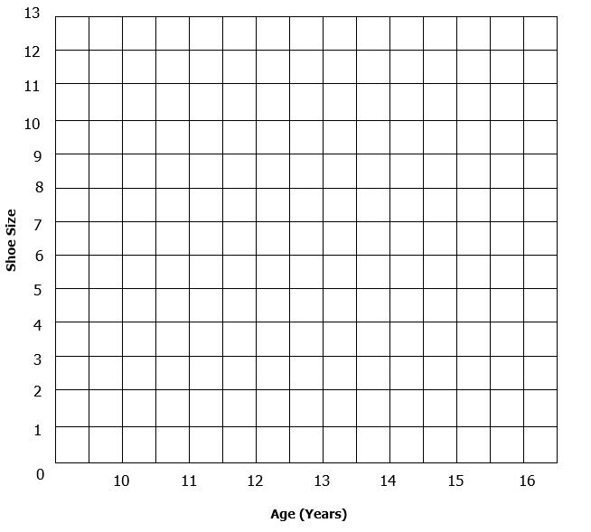
Student # | Age  (x-axis and independent variable) | Shoe Size  (y-axis and dependent variable) | # of texts/day  (y-axis and dependent variable) | # of hours of TV/day  (y-axis and dependent variable) | # liked cartoons  (y-axis and dependent variable)
1 | 14 | 7 | 1500 | 1 ½ | 3
2 | 14 | 8 | 0 | 2 | 3
3 | 14 | 11 ½ | 150 | 12 | 4
4 | 13 | 10 ½ | 500 | 5 | 6
5 | 14 | 10 ½ | 2500 | 6 | 2
6 | 13 | 12 11 | 550 | 3 | 5
7 | 14 | 7 | 400 | 5 | 6
8 | 14 | 7 ½ | 700 | 3 | 3
9 | 12 | 9 ½ | 150 | 2 | 7
10 | 12 | 8 | 150 | 1 | 8
11 | 11 | 6 ½ | 150 | ¾ | 8
12 | 12 | 6 ½ | 15 | 3 | 6
13 | 12 | 6 ½ | 200 | ½ | 6
14 | 12 | 6 | 150 | ½ | 7
15 | 11 | 6 | 75 | 2 | 8
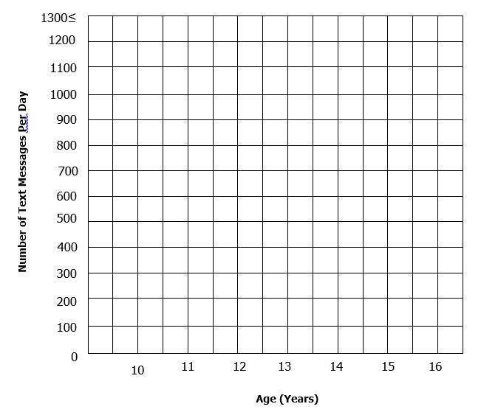

Student # | Age  (x-axis and independent variable) | Shoe Size  (y-axis and dependent variable) | # of texts/day  (y-axis and dependent variable) | # of hours of TV/day  (y-axis and dependent variable) | # liked cartoons  (y-axis and dependent variable)
1 | 14 | 7 | 1500 | 1 ½ | 3
2 | 14 | 8 | 0 | 2 | 3
3 | 14 | 11 ½ | 150 | 12 | 4
4 | 13 | 10 ½ | 500 | 5 | 6
5 | 14 | 10 ½ | 2500 | 6 | 2
6 | 13 | 12 11 | 550 | 3 | 5
7 | 14 | 7 | 400 | 5 | 6
8 | 14 | 7 ½ | 700 | 3 | 3
9 | 12 | 9 ½ | 150 | 2 | 7
10 | 12 | 8 | 150 | 1 | 8
11 | 11 | 6 ½ | 150 | ¾ | 8
12 | 12 | 6 ½ | 15 | 3 | 6
13 | 12 | 6 ½ | 200 | ½ | 6
14 | 12 | 6 | 150 | ½ | 7
15 | 11 | 6 | 75 | 2 | 8
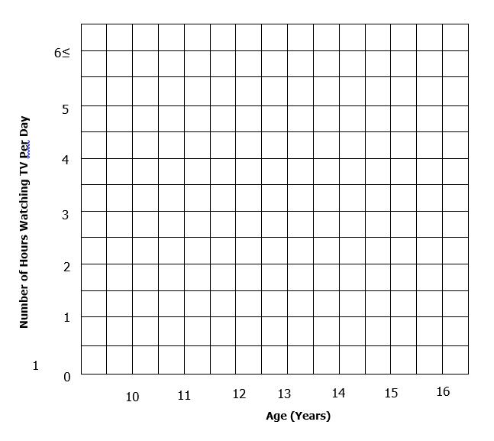
Student # | Age  (x-axis and independent variable) | Shoe Size  (y-axis and dependent variable) | # of texts/day  (y-axis and dependent variable) | # of hours of TV/day  (y-axis and dependent variable) | # liked cartoons  (y-axis and dependent variable)
1 | 14 | 7 | 1500 | 1 ½ | 3
2 | 14 | 8 | 0 | 2 | 3
3 | 14 | 11 ½ | 150 | 12 | 4
4 | 13 | 10 ½ | 500 | 5 | 6
5 | 14 | 10 ½ | 2500 | 6 | 2
6 | 13 | 12 11 | 550 | 3 | 5
7 | 14 | 7 | 400 | 5 | 6
8 | 14 | 7 ½ | 700 | 3 | 3
9 | 12 | 9 ½ | 150 | 2 | 7
10 | 12 | 8 | 150 | 1 | 8
11 | 11 | 6 ½ | 150 | ¾ | 8
12 | 12 | 6 ½ | 15 | 3 | 6
13 | 12 | 6 ½ | 200 | ½ | 6
14 | 12 | 6 | 150 | ½ | 7
15 | 11 | 6 | 75 | 2 | 8
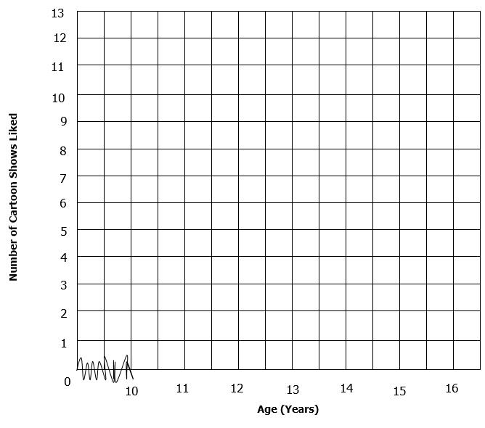

Relationship Cards

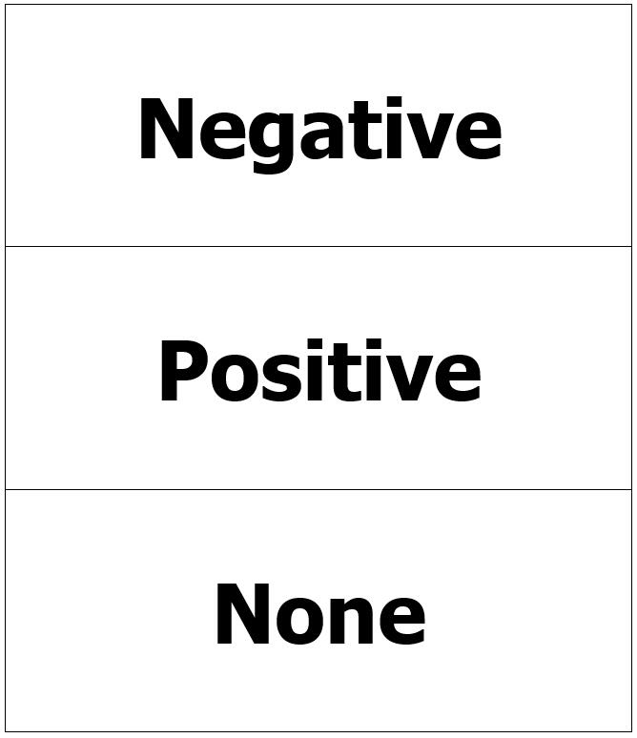

Directionality Cards

