Instructional Activity Resources for HSM-EO 1
Algebraic Expressions
Directions: Match the algebraic expression to the correct picture.
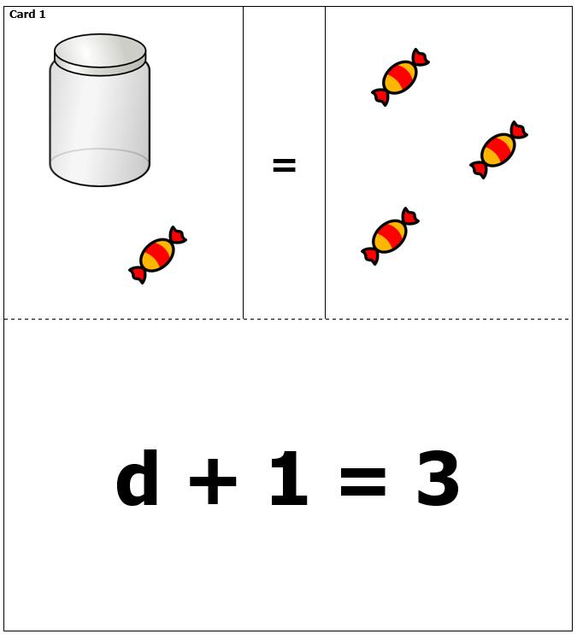
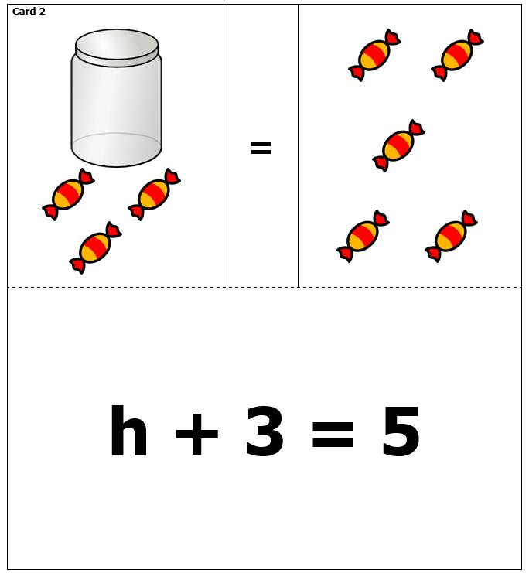
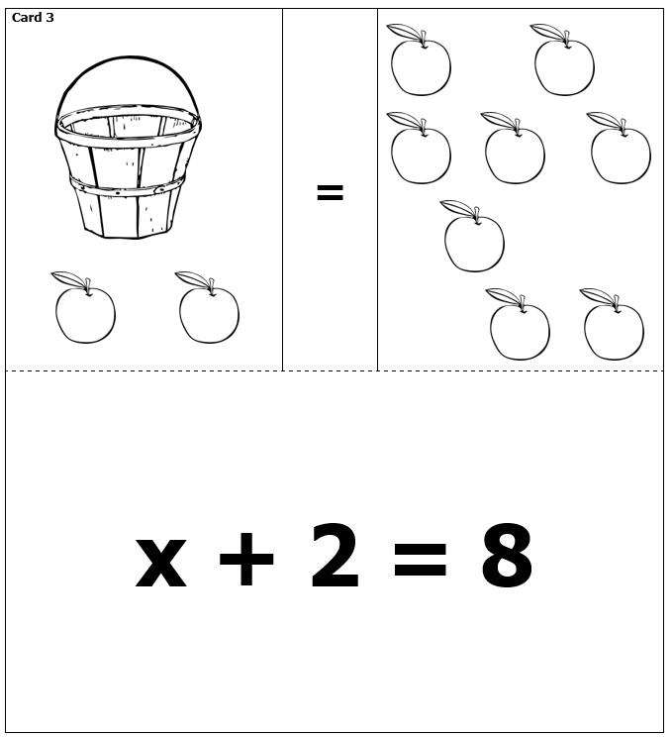
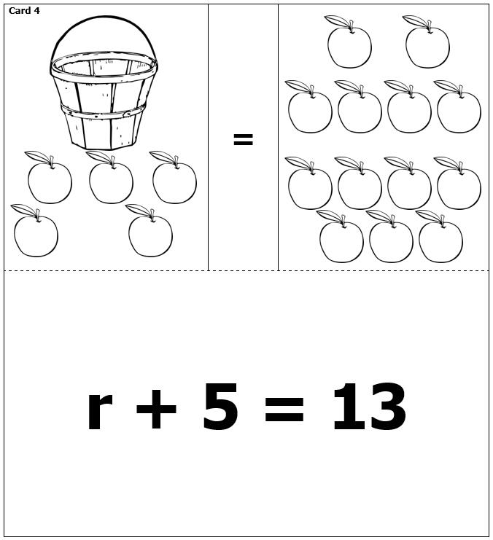
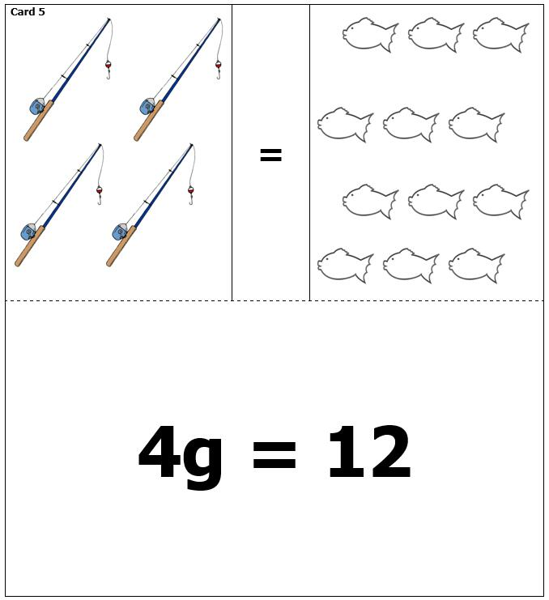
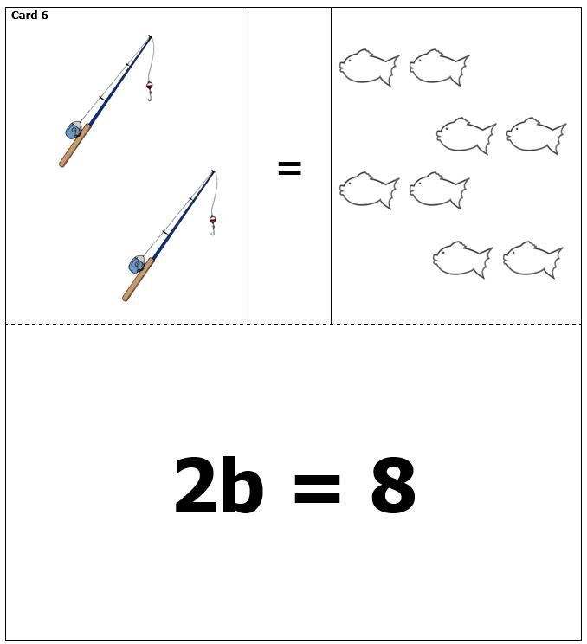
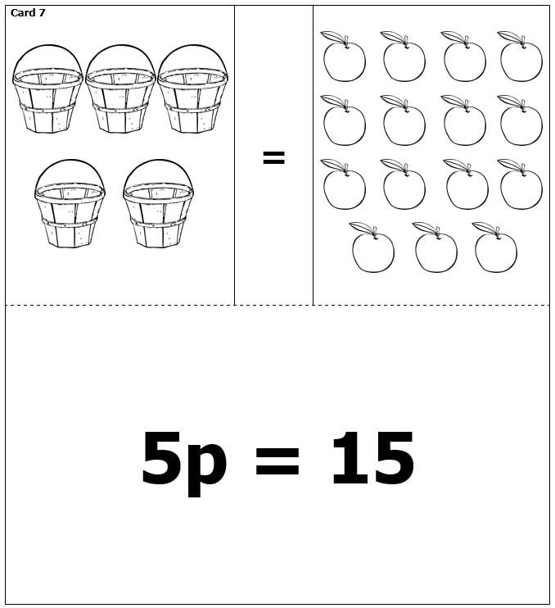
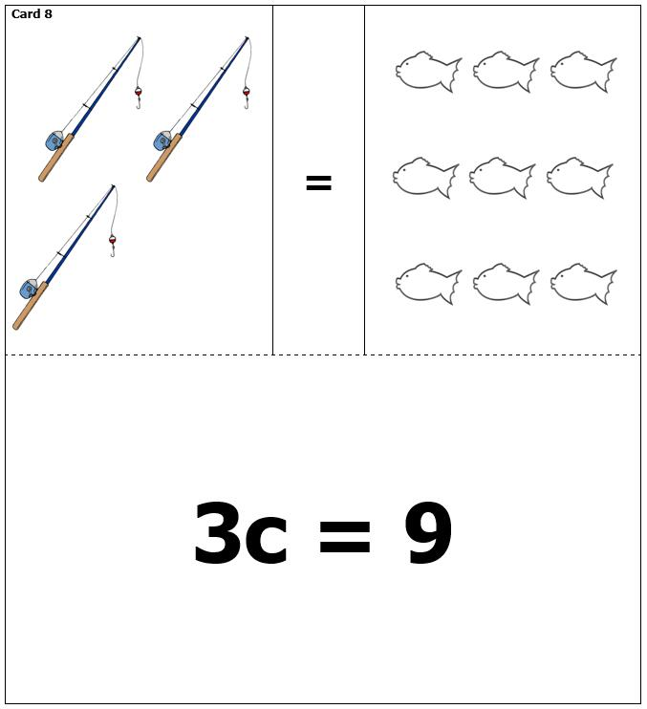

Match Algebraic Expressions to Their Meaning
Sentence | Expression
A number times 75 | 35 + t
A number minus 35 | d - 30
A number divided by 30 | r – 45
The sum of 35 and a number | g ÷ 5
The quotient of a number and 5 | C ÷ 30
The product of a  number and 25 | y - 35
A number decreased by 45 | 5 + p
five more than a number | 25 f
Thirty less than a number | X • 75

Instructional Activity Resources for HSM-EO 2
How Many Leftovers?
Directions:
1. Pull a number card for your dividend. Write it on the first line of the problem.
2. Roll the 10-sided number cube for your divisor. Write it on the second line of your problem.
3. Put out enough squares for your divisor.
4. Pass out the counters evenly to all groups.
5. Write the number of leftovers for your turn.
6. Play for 5 rounds.
Dividend
Divisor
Quotient
Remainders
Total # of coins (card) | # of groups  (on dice) | # in each group | Leftovers

_______________ ÷ _________________ = __________________Remainders_______________

_______________ ÷ _________________ = __________________Remainders_______________

_______________ ÷ _________________ = __________________Remainders_______________

_______________ ÷ _________________ = __________________Remainders_______________

_______________ ÷ _________________ = __________________Remainders_______________

Total Remainders: ____________
Hook Algebraic Unknowns
To play the game:
1. Turn over an equation card. Solve by finding the value of the unknown.
2. Find the answer in the boxes below and place a colored chip in the box.
3. Play until you get three in a row.
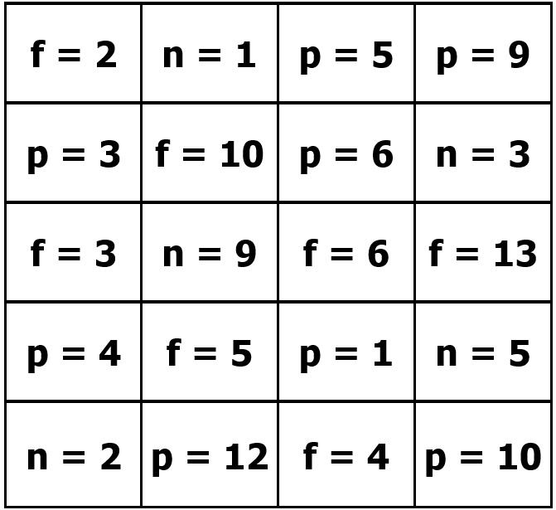
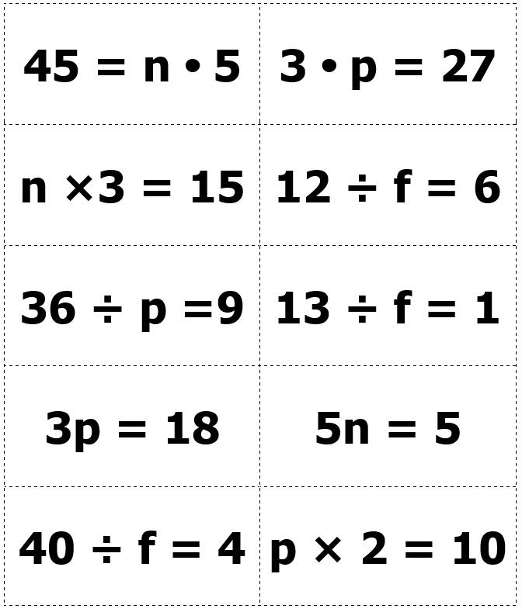
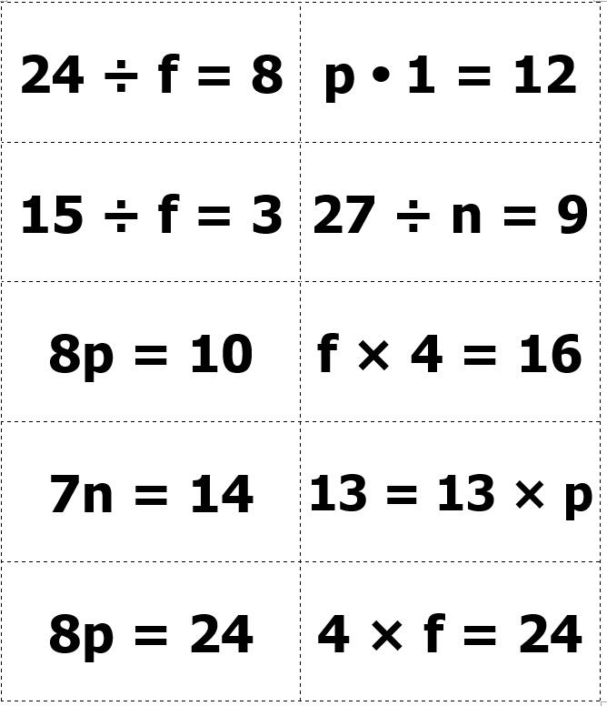

Instructional Activity Resources for HSM-EI 3
The Shape of Graphs
Directions: Match line graphs to the correct story based on the labels of the x and y axis as well as the slope of the line.

- Jay walked the first lap. He ran the second lap. Then he walked the third lap and ran the 4th lap.
- Jane ran the first two laps slowly, then she picked up speed on the third lap, and she ran very fast for the last lap.
- Cody took off running as fast as he could at the start of the race. By lap 3 he was very tired so he walked the rest of the way.
- Sydney and her friend walked the first 3 laps. Then the teacher told them to start running, so they ran the 4th lap.

Instructional Activity Resources for HSM-FS 2

Each day, Maria walks from home to school and then from school to home. The graphs that follow show the distance that Maria is from home at different times during the walk.
Match the graphs to the descriptions of Maria’s walk shown to the right of the graphs. Next to each graph, enter the letter (1,2,3,4) of the description that best matches the graph.
- Maria walks from school to her friend’s house. She visits her friend for a while. Then she walks the rest of the way home.
- Maria walks from home to school at a constant rate.
- Maria starts to walk from home to school. She stops to see whether she has her homework. She realizes she forgot her homework and runs back home to get it.
- Maria walks from school to home at a constant rate.

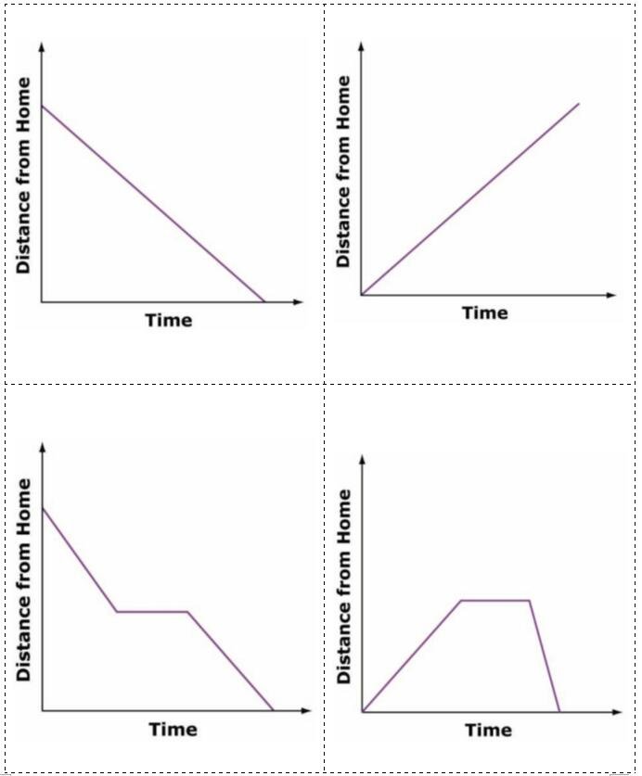

Instructional Activity Resources for HSM-FS 4
