Virginia Essentialized Standards of Learning (VESOL) Literacy Instruction Resource

Teachers providing VESOL literacy instruction should consult the Virginia Department of Education (VDOE) English standards of learning and English/Literacy Instruction, and for up-to-date literacy instruction resources..

Effective teachers of reading should understand the following models to inform instruction:

Models | Resources
The Simple View of Reading (Gough and Tunmer, 1986)  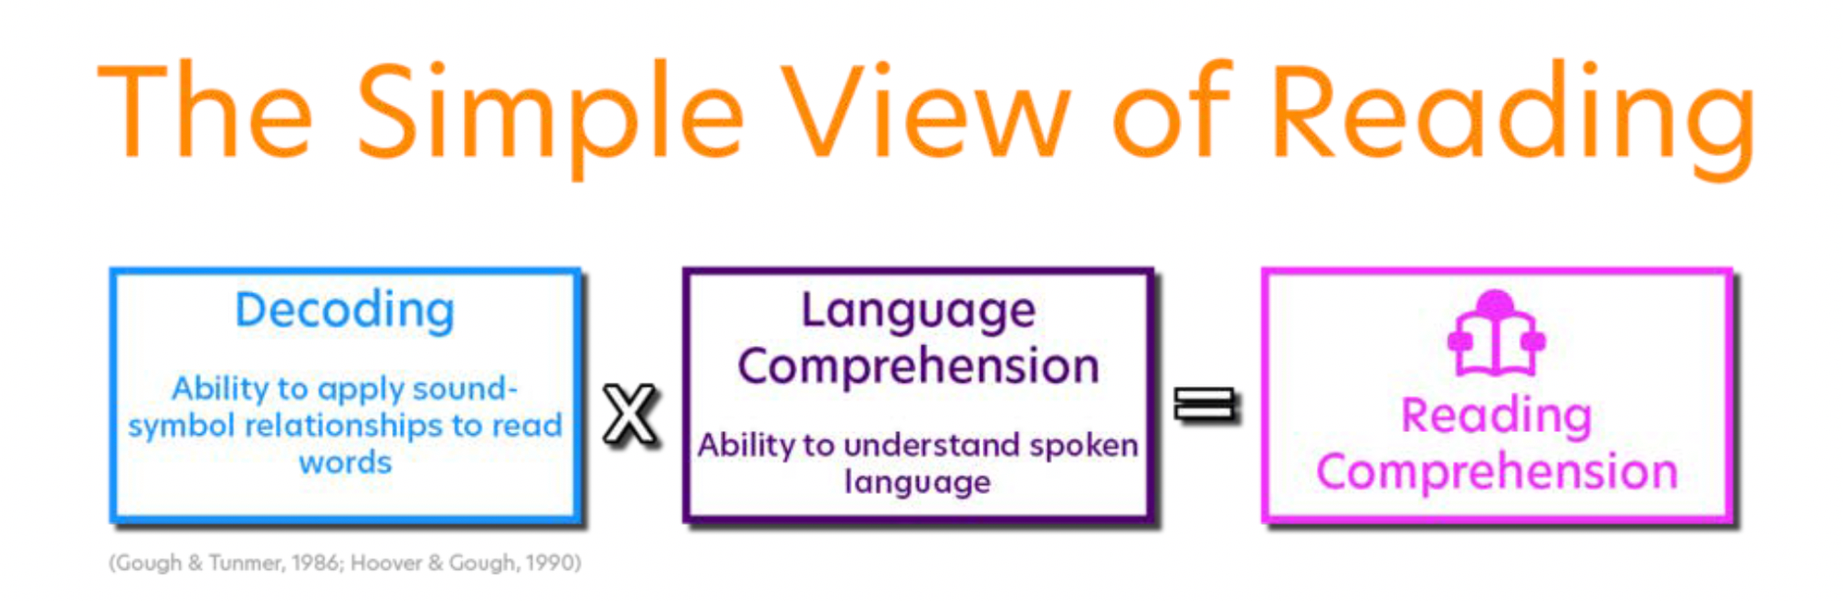  Image retrieved from:  https://www.sadlier.com/school/ela-blog/phonics-and-the-science-of-reading  May 2021 | The Simple View of Reading Video  Reading = Product of Decoding and Comprehension Skills Video  National Center on Improving Literacy-The Simple View of Reading  Really Great Reading
The Reading Rope (Scarborough, 2001)  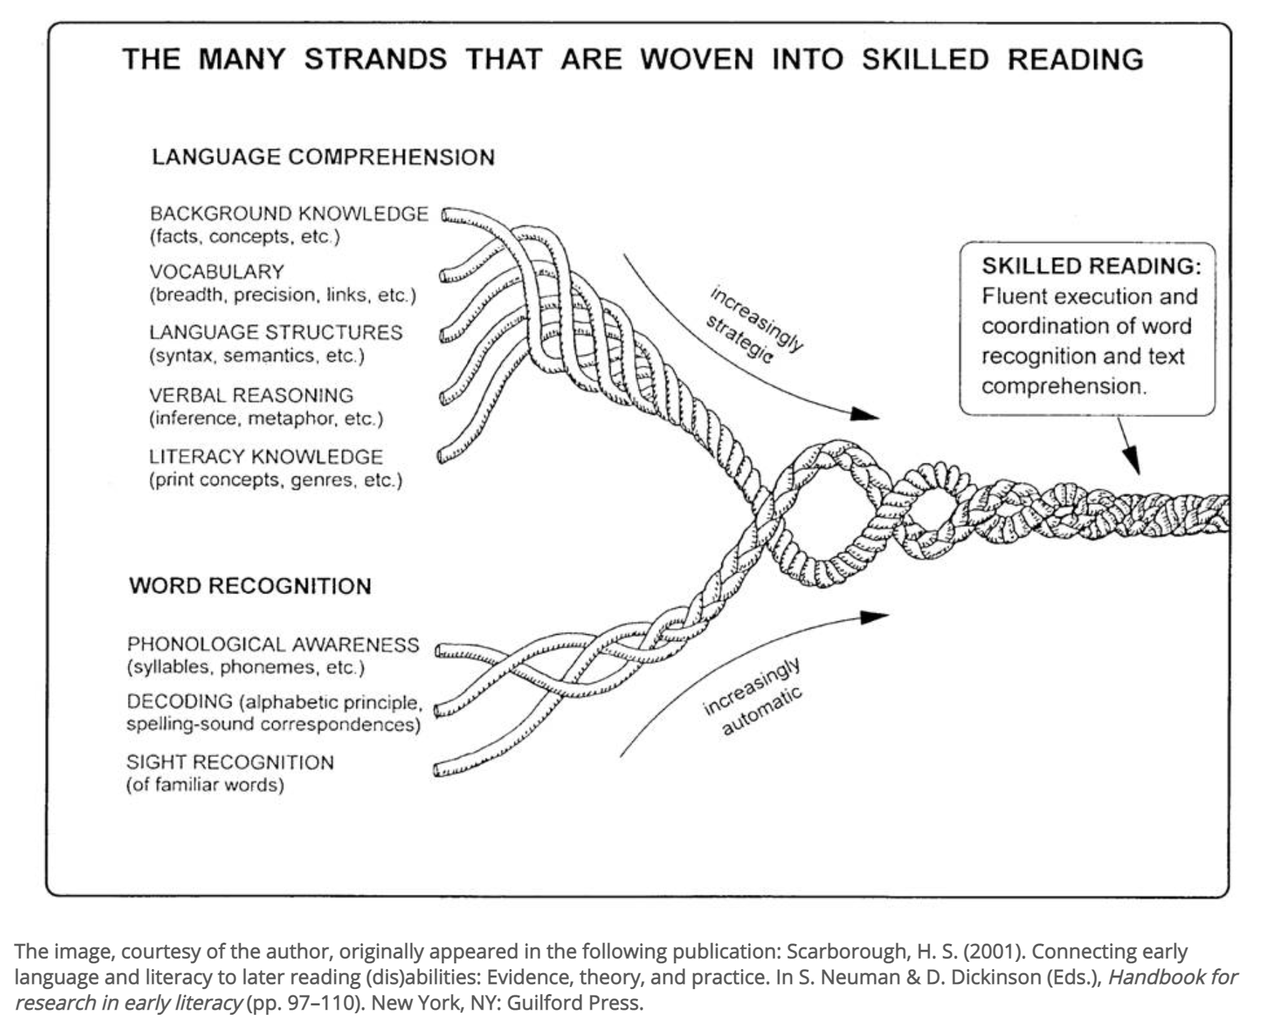 | International Dyslexia Association Scarborough’s Reading Rope Groundbreaking Infographic  Scarborough’s Reading Rope Video  Texas “Progress in the General Curriculum Statewide Network Literacy Strategies for Students with Disabilities” Reading Rope Resources  R.I.S.E. Arkansas Science of Reading Resources  The Reading League – Unraveling Scarborough’s Reading Rope  Nancy Hennessy- Thinking About Comprehension  Hang on Tight to the Rope
Tolman's Hourglass Figure (Tolman, 2018)  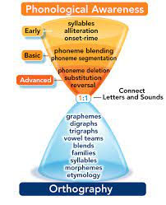  drcaroltolman.com | Carol Tolman video explaining the Hourglass Orthography Model

Students with and without disabilities benefit most from reading instruction that is:
- Sequential and cumulative
- Explicit and systematic
- Multisensory
- Planned with UDL in mind

Instructional resources should align with The Simple View of Reading (Decoding and Language Comprehension components) and The Reading Rope (Word Recognition Strands and Language Comprehension Strands):

Strand | Understanding the Strand | Instructional Resources Related to Strand
Background Knowledge  (facts, concepts, etc.) | Background Knowledge-  It makes good sense that to comprehend a story or text, readers will need a threshold of knowledge about the topic. Sometimes we call it domain-specific knowledge or topical knowledge. Without such knowledge, it becomes difficult to construct a meaningful mental model of what the text is about. (Reading Rockets) | Reading Rockets-Building Background Knowledge Resources  Reading Rockets-Connecting Background Knowledge to Content in the ELL Classroom  IRIS module-Activating Prior Knowledge
Vocabulary | Vocabulary is the knowledge of words and word meanings. As Steven Stahl (2005) puts it, "Vocabulary knowledge is knowledge; the knowledge of a word not only implies a definition but also implies how that word fits into the world." Vocabulary knowledge is not something that can ever be fully mastered; it is something that expands and deepens over the course of a lifetime. Instruction in vocabulary involves far more than looking up words in a dictionary and using the words in a sentence. Vocabulary is acquired incidentally through indirect exposure to words and intentionally through explicit instruction in specific words and word-learning strategies. According to Michael Graves (2000), there are four components of an effective vocabulary program:  - wide or extensive independent reading to expand word knowledge  - instruction in specific words to enhance comprehension of texts containing those words  - instruction in independent word-learning strategies, and  - word consciousness and word-play activities to motivate and enhance learning | Anita Archer-Vocabulary Explicit Instruction video  Florida Center for Reading Research-Explicit Vocabulary Instruction  Reading Rockets-Teaching Vocabulary  Reading Resources Net-Vocabulary Activities  Institute of Education Sciences: Integrating Reading Foundations  IDA Structured Literacy-What is Structured Literacy? A Primer on Effective Reading Instruction  IDA Structured Literacy- Why schools should use structured literacy  Reading Rockets-Structured Literacy Instruction: The Basics  Explanation of Structured Literacy and a Comparison to Balanced Literacy
Language Structures | Language Structure: Words and sentences have parts that combine in patterns, exhibiting the grammar of the language. Phonology is the study of patterns in sound or gesture. Syntax and Semantics involve studying patterns in sentence structure, from the advantages of form and meaning, respectively. | Reading Rockets-Guide to Teaching Reading and Writing  Reading Rockets- Semantic Gradients (antonyms, synonyms etc.)  Reading Rockets-Semantic Feature Analysis  Language Structure
Verbal Reasoning | What is Verbal Reasoning?  Verbal reasoning is the ability to understand what you read or hear. It includes drawing conclusions from limited information and developing an understanding of how new ideas connect to what you already know. We use this skill in and out of school.  Why is Verbal Reasoning so important?  Most of in-school learning involves listening to the teacher or reading, skills that rely heavily on verbal reasoning. Following directions in kindergarten, learning to read, and reading to learn beyond third grade all depend on verbal reasoning. As you might guess, verbal reasoning can be just as important in math and science class as it is in English and history. In fact, verbal reasoning is the skill most highly correlated with standardized test scores in math all the way through high school! | Reading Rockets-Making Inferences and Drawing Conclusions  Techknowledgy Archived Webinar-Assistive Technology Tools in Literacy Instruction and Support
Literacy Knowledge | Literacy Knowledge is the knowledge that we bring of how print presents in text, as well as the different discourse or text structures that an author may use to convey purpose. Literacy knowledge includes basic concepts of print (reading left to right, how to hold a book, how to track from line to line), to more complex concepts (characteristics of different text genres like narrative, informational text, poetry, formal writing) | Virginia Department of Education Comprehensive Literacy Series  Florida Center for Reading Research-Main Idea  Reading Rockets-Main Idea  Reading Rockets-Cause and Effect  Reading Rockets-Story Sequencing  Ontario Teachers Foundation Gateway to Special Education-Sequencing  Education Oasis-Printable Graphic Organizers
Phonological Awareness | Phonological awareness is the ability to recognize and manipulate the spoken parts of words. The levels of phonological awareness are, from simplest to most complex: syllables, onset-rime, and phonemes. Phonemic awareness is the ability to identify and manipulate individual sounds (phonemes) in spoken words. We know that a student's skill in phonological awareness is a good predictor of later reading success or difficulty.  (Reading Rockets) | National Center on Improving Literacy-Critical Role of Phonological Awareness  TTAC Online: Instructional Strategies in Literacy-Phonemic Awareness  Dyslexia-A Deeper Understanding Module Series  International Dyslexia Association-Structured Literacy  Understood-Elkonin Sound Boxes
Decoding | Decoding is the process of translating print into speech by rapidly matching a letter or combination of letters (graphemes) to their sounds (phonemes) and recognizing the patterns that make syllables and words. There is an area in the brain that deals with language processing and does this process automatically.  Decoding is important because it is the foundation on which all other reading instruction builds. If students cannot decode words their reading will lack fluency, their vocabulary will be limited and their reading comprehension will suffer. Teaching higher-level reading strategies to students stuck at the word level is ineffective. We might as well be banging our head against a wall. (Reading Horizons) | University of Florida Literacy Institute Virtual Resource Hub  “Specially Designed Instruction in Reading” archived webinar  TTAC Online-Literacy Instructional Strategies: Systematic Phonics Instruction  National Center on Improving Literacy-Screening, Tools and Resources  Phonics Scope and Sequence Checklist
Sight Recognition | Sight Word Rec- A sight word is any word that is recognized instantly and effortlessly, by sight, whether it is spelled regularly or irregularly.  Becoming a skilled reader with a huge repertoire of sight words requires knowledge of phonemic segmentation, letter-sound correspondences, and spelling patterns. (Ehri, 1980, 1995, 1998) | Really Great Reading-Tools for Struggling Readers  Reading Rockets-High frequency words

Literacy Instruction Resources for Students with Significant Intellectual Disabilities

In addition to understanding the components of literacy, educators should utilize evidence-based practices and communication supports for students with significant cognitive disabilities:
Description | Resource
CEEDAR Center and US Department of Education “Ideas That Work” innovation configuration for literacy instruction for students with multiple and severe disabilities who use augmentative/alternative communication. The tool includes practices for literacy assessment, comprehension, word recognition, self-selected reading, and writing. | Literacy Instruction for Students with Multiple and Severe Disabilities Who Use Augmentative/Alternative Communication
Literacy Instruction for Students with Significant Disabilities information, research-based instructional approaches, and effective instructional and learning strategies to meet the literacy and communication needs of students with significant disabilities, including moderate to severe cognitive disabilities, complex communication needs, multiple disabilities including deaf/blindness and/or physical access challenges | Literacy for All
Conversations with Dr. Caroline Musselwhite, assistive technology specialist eleven session archived video series to support teacher literacy practices for students with significant disabilities | Good Literacy Instruction is Good for All Students  Creating Opportunities for Students to Explore and Understand Text  Symbols and Learning to Read  Choosing Words for the Classroom Word Wall  The Importance of Repetition and Variety  Building Background Knowledge  Reinforcement and Informative Feedback  The Difference Between Teaching Questions and Testing Questions  Attributing Meaning to Student Attempts  Engaging Older Students  The Cost of Underestimating the Potential of Students
10 Conditions for Powerful Literacy Instruction Course | ODU Structured Literacy Course and Resources
Pennsylvania State University Literacy Instruction for Individuals with Autism, Cerebral Palsy, Down Syndrome and Other Disabilities guidelines for teaching literacy skills to learners with complex communication needs | Literacy Instruction for Individuals with Varied Disabilities
Structured Literacy Lesson: Beginner Pack  This PowerPoint lesson template contains activities that can be used to provide systematic, sequential, explicit and multisensory literacy instruction virtually or in a classroom. Slides can be easily modified to meet targeted sounds, letters, and words as well as student specific preferences and needs. Examples of incorporating the EBPs of visual supports and reinforcement are included. Included in this TACtic will be a link to the video A Literacy Conversation: Beginner Pack, that takes you on a guided tour through the lessons and provides you with the opportunity to hear from the 3 speakers as they discuss structured literacy, evidence-based practices, virtual instruction, and inclusion. | Structured Literacy Lesson: Beginner Pack
Structured Literacy: Beginner Sound to Symbol Cards  This PowerPoint contains cards for teaching and practicing sound to symbol connections as part of systematic, sequential, explicit and multisensory literacy instruction virtually or in a classroom. | Structured Literacy: Beginner Sound to Symbol Cards
Structured Literacy: Beginner Symbol to Sound Cards  This PowerPoint contains cards for teaching and practicing symbol to sound connections as part of systematic, sequential, explicit and multisensory literacy instruction virtually or in a classroom. | Structured Literacy: Beginner Symbol to Sound Cards
Structured Literacy: Intermediate Pack  This PowerPoint lesson template contains activities that can be used to provide systematic, sequential, explicit and multisensory literacy instruction virtually or in a classroom. Slides can be easily modified to meet targeted sounds, letters, and words as well as student specific preferences and needs. Examples of incorporating the EBPs of visual supports and reinforcement are included. This template provides examples for long vowels and vowel pairs. | Structured Literacy Lesson: Intermediate Pack
Structured Literacy: Intermediate Symbol to Sound Cards  This PowerPoint contains cards for teaching and practicing symbol to sound connections as part of systematic, sequential, explicit and multisensory literacy instruction virtually or in a classroom. This is the intermediate pack of symbol to sound cards which contains cards to use in conjunction with the Structured Literacy Lesson: Intermediate Pack. | Structured Literacy: Intermediate Symbol to Sound Cards
Structured Literacy: Master pack Sound to Symbol Cards  This PowerPoint contains cards for teaching and practicing sound to symbol connections as part of systematic, sequential, explicit and multisensory literacy instruction virtually or in a classroom. The master deck contains more advanced spellings for each of the sounds. | Structured Literacy: Master Pack Sound to Symbol Cards
OER Services Steps to Success-Literacy Instruction for Students with Intellectual Disabilities  Lumen Learning Course chapter on literacy assessment, planning and instruction for students with intellectual disabilities. | Literacy Instruction for Students with Intellectual Disabilities
Tarheel Reader: Teacher and Student Created E-Books  A collection of free, easy-to-read, and accessible books on a wide range of topics. Each book can be speech enabled and accessed using multiple interfaces, including touch screens, the IntelliKeys with custom overlays, and 1 to 3 switches. You can also write your own books using pictures from the huge collection at Flickr or pictures you upload | Tarheel Reader
See Me, Hear Me, Touch Me, Read Me: Building a Foundation for Literacy and Learning with Adapted Books and Literature Kits  Series of three TTAC Online webshops, “See me, Hear me, Touch me, Read me” will provide you with an overview of the whys and how’s of adapting books. Part 2, “Let’s Get Started Adapting Books” focuses on free online resources for composing electronic versions or print-based book adaptations, and Part 3, “Expanding Adapted Books into Book Kits,” delves into ways of creating book kits that expand upon adapted books using a theme approach.. | See Me, Hear Me, Touch Me, Read Me, Building a Foundation for Literacy and Learning with Adapted Books and Literature Kits
A-Z for Adapting Literacy  TTAC Online guide for adapting literacy activities to make books accessible to all ability levels | A-Z for Adapting Literacy
Center for Literacy and Disability Studies  University of North Carolina Center for Literacy and Disability studies resource hub including alternative pencils, DLM core vocabulary, tactual book kit directions and more | Center for Literacy and Disabilities Studies
Connecting AAC and Literacy  TTAC Online archived webinar on creating practical integration plans and strategies to promote literacy learning for students who use augmentative and/or alternative communication systems | Connecting AAC and Literacy  .
Paths to Literacy  Emergent Literacy instruction resources for students who are blind or visually impaired, or hard of hearing | Paths to Literacy

