Virginia Essentialized Standards of Learning (VESOL)

Instruction Resource

Mathematics Sample Activities

High School Algebra - Functions
VESOL  Code | VESOL  Reporting Category | VESOL  Text | Complexity Continuum
M-HS 6 | Algebra - Equations and Inequalities | Solve one- and two-step linear equations with one variable and solutions from 0 through 40. | Equations could range from having one step of addition, subtraction, multiplication, or division to having two steps with two different operations.

Instructional Example
Objective:
The student will solve one- or two-step linear equations with one variable (solutions 1-40).

Vocabulary:
add, subtract, multiply, divide, solve, equal, equation, number sentence, symbol, variable, inverse operations, one-step equation, two-step equation, sum, total amount

Materials: Sample activities range across a continuum of complexity and may include materials such as:
Cups, counters, white board, sticky notes, tens frame, visual support for order of operations

Procedures for Instruction:
These instructional activities can be used at various points on the complexity continuum, depending upon student ability. Many possibilities exist for lesson creation between the examples presented here. It is important to start instruction where the student is currently functioning and implement the appropriate instructional strategy with them. Once data indicate that the student is ready for the next level of instruction, proceed to it after reviewing the level the student has mastered. Let the data be your guide.

Sample Activity 1

- Use 3 cups/containers and 10 popsicle sticks or other counters. Create a 1 inch square of paper with a plus sign and a 1-inch square of paper with an equal sign.
- Line materials up in a linear fashion, such as, cup + cup = cup.
- Using materials, model addition problems by placing counters in each of the cups on the left side of the equal sign. Count the counters in each cup and label each cup with the amount. Count out loud as you move the counters to the cup that is to the right of the equal sign. Label this cup with the sum (total amount of counters).
- Students practice the modeled strategy with a variety of combinations that equal 10 or less. Students say or use preferred mode of communication to select the sum (total amount).

Sample Activity 2

Review video example of a similar method from Project STAIR Supporting Teaching of Algebra: Individual Readiness
- Use a cup or paper plate with an “x” on it and 10 popsicle sticks or other counters. Create a one inch square of paper with a plus sign, and a one inch square of paper with a minus sign, and a one inch square of paper with an equal sign.
- Model addition and subtraction problems using the cup/plate to represent a variable, or your unknown. Students place the number of popsicle sticks/counters they need to make the two sides of the equal sign be the same.
- Students then say, write or use their preferred mode of communication to select what was the missing amount.

Sample Activity 3
Review video example of a similar method from Project STAIR Supporting Teaching of Algebra: Individual Readiness
- Use a cup with an “x” written on it and 40 popsicle sticks. Create a 1 inch square of paper with a plus sign, and a 1-inch square of paper with a minus sign, and a 1-inch square of paper with an equal sign.
- Model addition and subtraction problems using the cup to represent a variable, or your unknown. Isolate the variable (get the “x” alone) by using the inverse (opposite) operation on both sides of the equation.
- Students then say, write or use preferred mode of communication to select what the variable is equal to.
- Request that the students visually show how they solved the problem with a picture.
- Request that the students write with number sentences showing how they solved the problem.
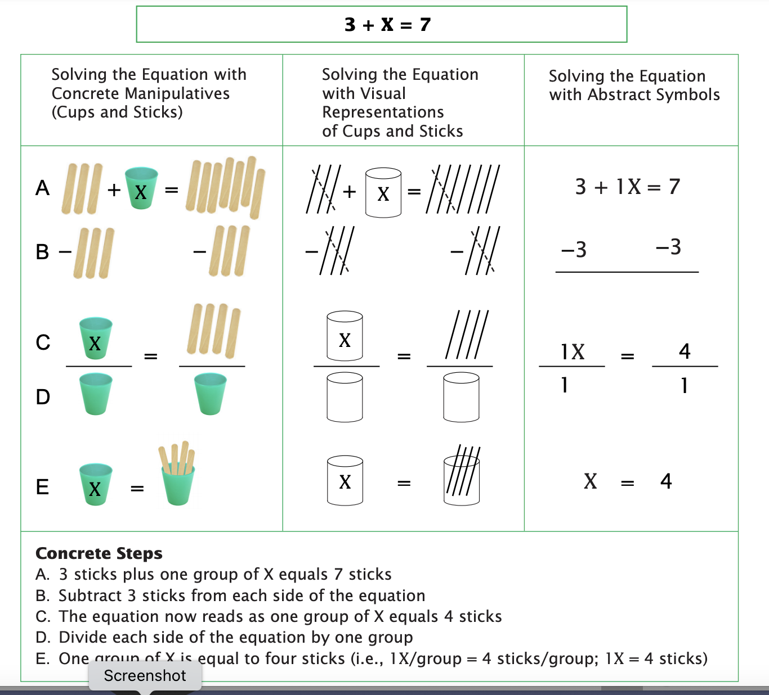

Sample Activity 4

Review video example for multiplication of a similar method from Project STAIR Supporting Teaching of Algebra: Individual Readiness
- Use cups with an “x” written on them and 40 popsicle sticks. Create a 1 inch square of paper with a plus sign, a 1-inch square of paper with a - sign, and a 1-inch square of paper with an equal sign.
- Model addition and subtraction as described in previous sample activities.
- Model multiplication problems using the cups. For example, if the equation is 3x=6, place 3 cups that have “x” on them, the 1-inch square with =, then 6 sticks. Divide both sides into 3 groups. Each cup, or “x” is worth 2 sticks, or 2.
- Model division problems.
Example where x is the dividend: x÷3=4. Say, “The x is in 3 groups, it is not whole. So, if we multiply by 3, we would have the whole x. To keep both sides balanced, or equal, we have to make the other side 3 times larger, so we have to make 3 groups of 4 sticks. This means the x is equal to 12.”
Example where x is the divisor: 12÷x=4. So, we have 12 popsicle sticks with a bar and the x cup underneath the bar, an equal sign, and 4 popsicle sticks on the other side of the equal sign. Say, “12 popsicle sticks are being divided into an unknown number of groups. Multiply both sides by x number of groups, we have 12=4x. Each of the 4 popsicle sticks needs a cup because that is what 4 x means. We do not need the 4 popsicle sticks anymore, because we can see we have 4 xs without the sticks. Now we can line up the four cups with equal numbers of sticks from the 12 sticks, we can see each cup is worth 3 popsicle sticks. So, x=3.”

Additional Resources:
- Video to explain using a balance to solve equations
Linear Equations - Balancing The Equation – YouTube
- Concrete Representational Abstract Approach
- Video example of a similar example for 2 step equations from Project STAIR Supporting Teaching of Algebra: Individual Readiness

- Cups and Cubes
- T/TAC Online- ASOL Teaching Process Resource
High School Materials- Instructional Activity Resources for HSM-EO 1 (Cards 1-8)
Word - ADA Compliant Version PDF
- VDOE Math Instructional Plans
  - 2.17 - Balancing Act (Word) / PDF Version (use the materials, the activity is modified in the instructions above)
  - 5.19 - Variables, Operations, Numbers, Oh My! (Word) / PDF Version
  - 6.13 - Modeling One-Step Linear Equations (Word) / PDF Version
  - 7.12 - Solving Two-Step Equations (Word) / PDF Version
- Create a card with the steps to follow to solve one step or two step equations.
Communication:
- 36 Location Universal Core Board
- Core Vocabulary and Math: Core words that can be modeled and targeted during lessons:
  - More
  - All/Some
  - Up/Down
  - Get more
  - No/not more
  - There
  - Stop/Go

