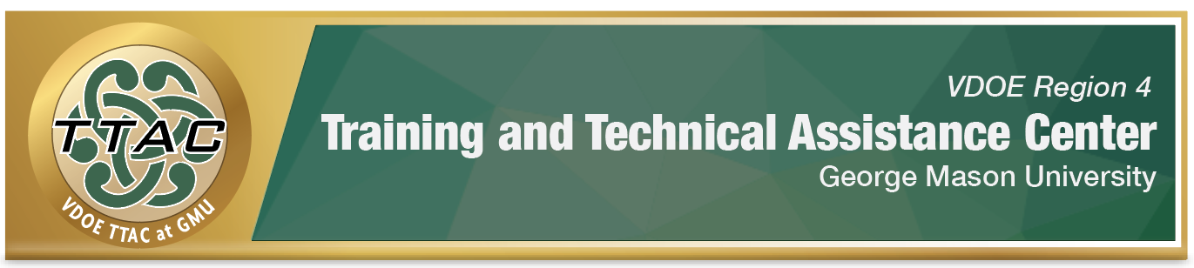
HLP Highlight Tool
HLP 7: Establish a Consistent, Organized, and Respectful
Learning Environment

Here’s What It Is:
- Organize the learning environment and materials for differentiated instruction
- Identify class norms and expectations, involving students in the planning process
- Phrase expectations as positive
- Explicitly teach routines and expectations
- Explicitly re-teach routines and expectations as needed
- Implement positive behavior intervention supports (PBIS) or class incentives
- Develop respectful relationships
- Ask questions, and provide students with opportunities to respond (OTR)

When Do I Use It?
- To plan for the new school year and organize the learning environment
- To create class routines
- To enhance on task behaviors by establishing expectations and class norms (3-5 norms)
- To explicitly teach and review class expectations and routines
- To reinforce positive, on task behaviors
- To develop positive relationships with students, involving students in the learning process

Here’s What It Looks Like:
- HLP #7 Video (20:15)
- Distance Learning Matrix Examples
- Online Classroom Rules with Superb Animation Video (3:21)

Resources to Extend Learning:
- The Iris Center and High Leverage Practices
- VDOE K-12 Inclusive Practices Guide and VDOE Virtual Learning & Accommodations Guide
- Center on PBIS

Here Are My Work Plans:
- Classroom expectations and rules should be defined and taught, View HLP #7 video: 6:10-10:32
- Use a continuum of strategies to acknowledge appropriate behavior with high frequency, View HLP #7 video: 10:35-14:45
- Optimize instructional time, View HLP #7 video: 14:47-18:53

Suggested Activities:
- Create a remote/virtual behavior matrix with your students
- Review rules and expectations each day
- Develop predictable routines and schedule with visual supports
- Reinforce positive behavior when it is exhibited
- Create chat opportunities for students to share positive behavior practices
- Start/end each class with a positive behavior observation

HLP 7 In Action! Build a Behavior Matrix for Remote Learning!

Directions: Collaborate with students to create your classroom behavior matrix. (See Example below)
- We are Safe
- Entering Class
  - Choose distraction-free space
  - Use equipment as intended
  - Use kind words and faces
- Teacher-Led Whole Group Instruction
  - Ask in chat if you need help
  - Use kind words and faces
- One-on-One Instruction
  - Use kind words and faces
- Small Group Activities (Breakout Rooms)
  - “Stop-leave-talk” when you hear disrespect
  - Encourage others to participate
  - Use kind words and faces
- We are Respectful
- Entering Class
- Video on at all times
- Audio off
- Use chat with classmates for first 5 minutes
- Teacher-Led Whole Group Instruction
  - Video on at all times
- Audio off
- Answer questions in chat box on cue
  - Answer polls promptly
- One-on-One Instruction
- Video on at all times
- Audio on
- Listen attentively
- Answer questions out loud on cue
- Small Group Activities (Breakout Rooms)
- Video on at all times
- Audio on
- One speaker at a time: wait or use chat to respond when others are talking
- Respect others’ cultures, opinions and viewpoints
- We are Responsible
- Entering Class
  - Be on time and ready to learn
  - Start class charged or plugged in
  - Have materials ready
- Teacher-Led Whole Group Instruction
  - Ask questions (voice or chat) when you have them
  - Be present – avoid multitasking
- One-on-One Instruction
  - Ask questions out loud when you have them
  - Try your best and be present- avoid multitasking
- Small Group Activities (Breakout Rooms)
  - Encourage each other to stay on topic
  - Complete the work together
  - Use “Ask for Help” button if you have questions
  - Be present- avoid multitasking

References
Center on Positive Behavioral Interventions and Supports. (March, 2020). Creating a PBIS behavior teaching matrix for remote instruction. University of Oregon. https://www.pbis.org/
Hashey, A. I., Kaczorowski, T. L., & DiCesare, D. M. (2020). High-Leverage Practices in Special Education, Guide #3. Council for Exceptional Children.
McLeskey, J. (Ed.). (2019). High leverage practices for inclusive classrooms. New York: Routledge.
Raphael, T. (1986). Teaching children Question-Answer Relationships, revisited. The Reading Teacher, 39, 516-522.

Find additional HLP Highlight Tools on TTAC Online.
For additional information about TTAC Region 4, go to https://ttac.gmu.edu/

