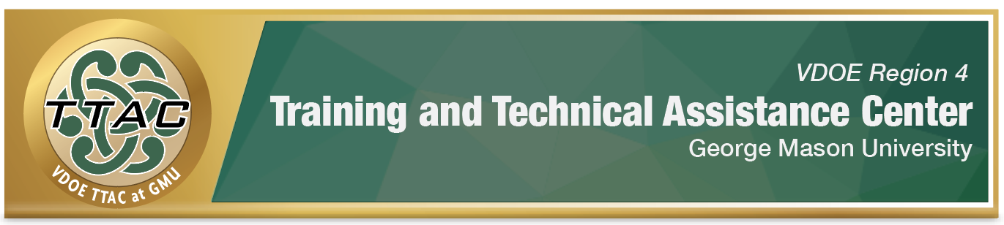

HLP Highlight Tool

HLP 13: Adapt Curriculum Tasks and Materials for Specific

Learning Goals

Here’s What It Is:
- Adapt curriculum materials based on assessment data and student needs
- Using relevant information to make modifications
- Changing task direction and decreasing the amount of material
- Integrating relevant technology

When Do I Use It?
- When creating instruction lessons aligned with the student’s IEP goals
- When making decisions on content to meet stated goals
- When meeting students’ needs and altering the difficulty level and amount of material

Here’s What It Looks Like:
- HLP #13 Video (15:55)

Resources to Extend Learning
- The Iris Center
- Introducing High-Leverage Practices in Special Education: A Professional Development Guide for School Leaders
- VDOE K-12 Inclusive Practices Guide
- VDOE Virtual Learning & Accommodations Guide
- Examples of Mnemonic Strategies

Here Are My Work Plans:
- Identify necessary accommodations and modifications, View HLP #13 Video 8:30-10:15
- Support student needs by combining content enhancements with traditional accommodations, View HLP #13 Video 10:16-13:35
- Evaluate the adaptations for student impact, HLP #13 Video 14:10 – 14:56
Click Here for full HLP #13 Video

Suggested Activities:
- Content Enhancement strategies such as graphic organizers, bold, underlined, italicized, color-coded content,
- Guided notes
- Mnemonics
- Interactive Notebooks

HLP 13 In Action!

Design a Graphic Organizer

Directions: Design a graphic organizer to introduce a new standard concept for a student using the following steps:
Step 1: Identify the information or content you wish to share with students
Step 2: Identify key components from the content
Step 3: Create a graphic representation of the information. The chart should represent key ideas and components of the content and show relationships among them.

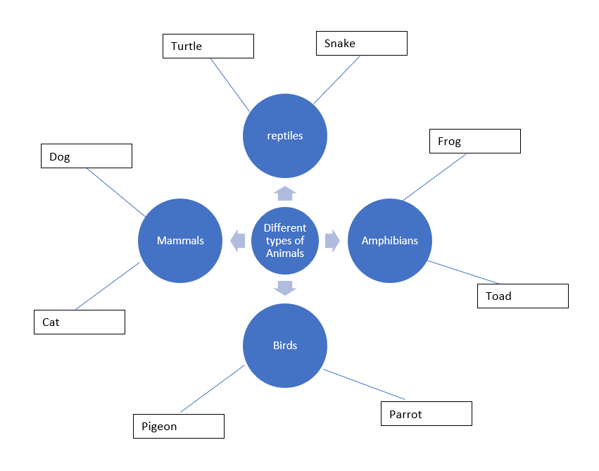

References
Hashey, A. I., Kaczorowski, T. L., & DiCesare, D. M. (2020). High-Leverage Practices in Special Education, Guide 4. Council for Exceptional Children.
McLeskey, J. (Ed.). (2019). High leverage practices for inclusive classrooms. New York: Routledge.

Find additional HLP Highlight Tools on TTAC Online.
For additional information about TTAC Region 4, go to https://ttac.gmu.edu/.

