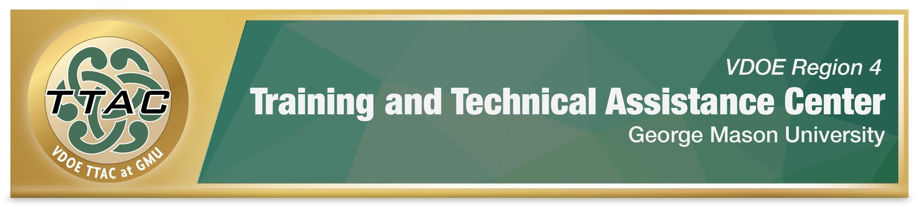
Rubric – HLP # 7 Establish a Consistent, Organized, and Respectful Learning Environment
 | Class Norms, Expectations & Rules | Class Layout, Organization, Routines & Procedures Systems | Teacher Tone and Language | Instruction | Opportunities to Respond | Teacher Feedback
Ineffective | Class norms, expectations and rules are seldom positively stated. Students seldom collaborate to develop classroom norms, expectations, and rules. Class norms, expectations and rules are not visibly posted or seldom explicitly and consistently taught, yet. | Classroom layout, Organization systems lack structure. Daily agendas are seldom posted or discussed. Class procedures and routines are seldom explicitly taught or positively reinforced, yet. | Teacher’s tone and language is seldom encouraging, patient, positive, or respectful, yet. | Teachers seldom identify learning targets or explicitly discuss their relevance yet. Instruction includes too much unstructured student down time, giving students opportunities to engage in off task behaviors. | Teachers seldom engage students in the learning process by asking questions during instruction yet. | Feedback is seldom timely, constructive, specific, or consistently positive yet.
Approaching Effective | Class norms, expectations and rules are sometimes positively stated. Students sometimes collaborate to develop classroom norms, expectations, and rules. Class norms, expectations and rules are not visibly posted or explicitly and consistently taught, yet. | Classroom layout, Organization systems sometimes lack structure. Daily agendas are posted and sometimes discussed. Class procedures and routines are sometimes explicitly taught and positively reinforced. | Teacher tone and language is sometimes encouraging, patient, positive, and respectful. | Teachers sometimes identify learning targets but don’t explicitly discuss their relevance yet. Instruction sometimes includes too much unstructured student down time, giving students opportunities to engage in off task behaviors. | Teachers sometimes engage students in the learning process by asking questions during instruction. Teachers sometimes give students time to respond to questions (recommend 5 seconds). | Feedback is sometimes timely, constructive, specific, and positive.
Effective | Class norms, expectations and rules are often positively stated. Students often collaborate to develop classroom norms, expectations, and rules. Class norms, expectations and rules are visibly posted and often explicitly taught. | Classroom layout, Organization systems often have structure. Daily agendas are posted and often discussed. Class procedures and routines are often explicitly taught and positively reinforced. | Teacher tone and language is often encouraging, patient, positive, and respectful. | Teachers often identify learning targets and discuss their relevance. Instruction is often structured, but students still have time to engage in off task behaviors. | Teachers often engage students in the learning process by asking questions during instruction. Teachers often give students time to respond to questions (recommend 5 seconds). | Feedback is often constructive, specific, and consistently positive.
Highly Effective | Class norms, expectations and rules are always positively stated. Students consistently collaborate to develop classroom norms, expectations, and rules. Class norms, expectations and rules are visibly posted, and always explicitly taught and reviewed. | Classroom layout, Organization systems always have structure. Daily agendas are always posted and discussed. Class procedures and routines are always explicitly taught and positively reinforced. | Teacher tone and language is always consistently encouraging, patient, positive, and respectful. | Teachers always identify learning targets and consistently discuss their relevance. Instruction is always structured, maximizing opportunities for students to fully engage in the learning process. | Teachers always engage students in the learning process by asking questions during instruction. Teachers always give students time to respond to questions. | Feedback is always timely, constructive, specific, and consistently positive.
References:
Hashey, A. I., Kaczorowski, T. L., & DiCesare, D. M. (2020). High-Leverage Practices in Special Education, Guide 3. Council for Exceptional Children.
McLeskey, J. (Ed.). (2019). High leverage practices for inclusive classrooms. New York: Routledge.

For information about TTAC Region 4, go to https://ttac.gmu.edu/.

Comments:

