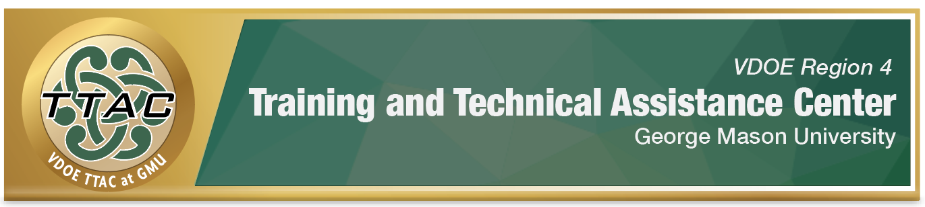HLP # 7: Establish a Consistent, Organized, and Respectful Learning Environment Checklist
Yes or  not yet | Class Organization Systems
 | Student workflow, procedures and systems established (absent student, turn in procedures, return procedures)
 | Explicitly teach students how to use class procedures and systems.
 | Positively reinforce students’ proper use of class procedures and systems.
 | Arrange the classroom to maximize space, workflow, and system efficiency.
 | Classroom organization meets the needs of all students and instructional goals.
 | Student information is organized and systems in place ( accommodations tracking, attendance, etc.)
 | Establish systems to collect data (academic and/or behavior)
 | Specifically designed instruction and progress monitoring tracking system established
 | School contacts’ numbers (counselors, administrators, related services, etc.), school map, procedures (fire drill, etc.) are organized and/or clearly posted.
 | School calendar is established and organized (Collaborative learning team (CLT)/grade level team meetings, faculty meetings, important dates)
 | Filing system is organized digitally and/or physically
 | Accommodations communicated with co-teachers and/or paraprofessionals and regularly reviewed.
Yes or  not yet | Learning Management System (LMS)
 | LMS is organized with contact information, materials, assignments, grading (or other grading system), back to school night presentation, introductory video, etc.)
 | Co-teacher LMS responsibilities agreed upon.
 | Explicitly teach students how to use LMS and identify students’ expectations for LMS if appropriate.
 | Explicitly teach parents how to use LMS and ways to best communicate with teachers
Yes or  not yet | Expectations/Rules
 | Establish culturally relevant expectations and rules that are stated positively and posted in the classroom.
 | Discuss the importance of expectations, rules, and procedures, including students’ suggestions if appropriate.
 | Explicitly teach three to five positively stated expectations/rules.
 | Consistently re-teach expectations, rules, procedures, and systems with a positive tone.
. | Create systems that encourage positive student behaviors aligned with class expectations, rules, and other goals. (PBIS, token economy, Class Dojo)
 | Explicitly communicate PBIS/or token economy/Class Dojo to students and parents.
 | Consistently implement PBIS/token economy and reinforce positive student behaviors
Yes or  not yet | Respectful Learning Environment
 | Structure class lessons and activities with an agenda.
 | Explicitly teach the agenda and behavior expectations for the day’s lesson and class activities.
 | Consider the needs of all students when creating class activities and limit unstructured time.
 | Manage antecedents and unexpected surprises. (Communicate with sensitive students and/or their parents beforehand, prepare for fire drills, assemblies, etc.)
 | Accept that behavior is a form of communication. a
 | Appreciate cultural and linguistic diversity and learning differences in the classroom.
 | Encourage students’ positive verbal and non-verbal communication.
 | Consistently give specific and positive feedback to students on their behaviors.
 | Communicate academic and behavior data with parents and students (if appropriate).
 | Collaborate with other professionals and/or parents about students’ academics and behaviors, if necessary.

References
Council for Exceptional Children. (2021). High leverage practices for students with disabilities leadership guide for HLP #7. Retrieved from: https://highleveragepractices.org/hlp-leadership-guides
McLeskey, J. (Ed.). (2019). High leverage practices for inclusive classrooms. New York: Routledge.

For additional HLP resources, go to https://ttaconline.org/
For additional information about TTAC Region 4 at GMU, go to https://ttac.gmu.edu/

