C"APP"italizing,on Technology
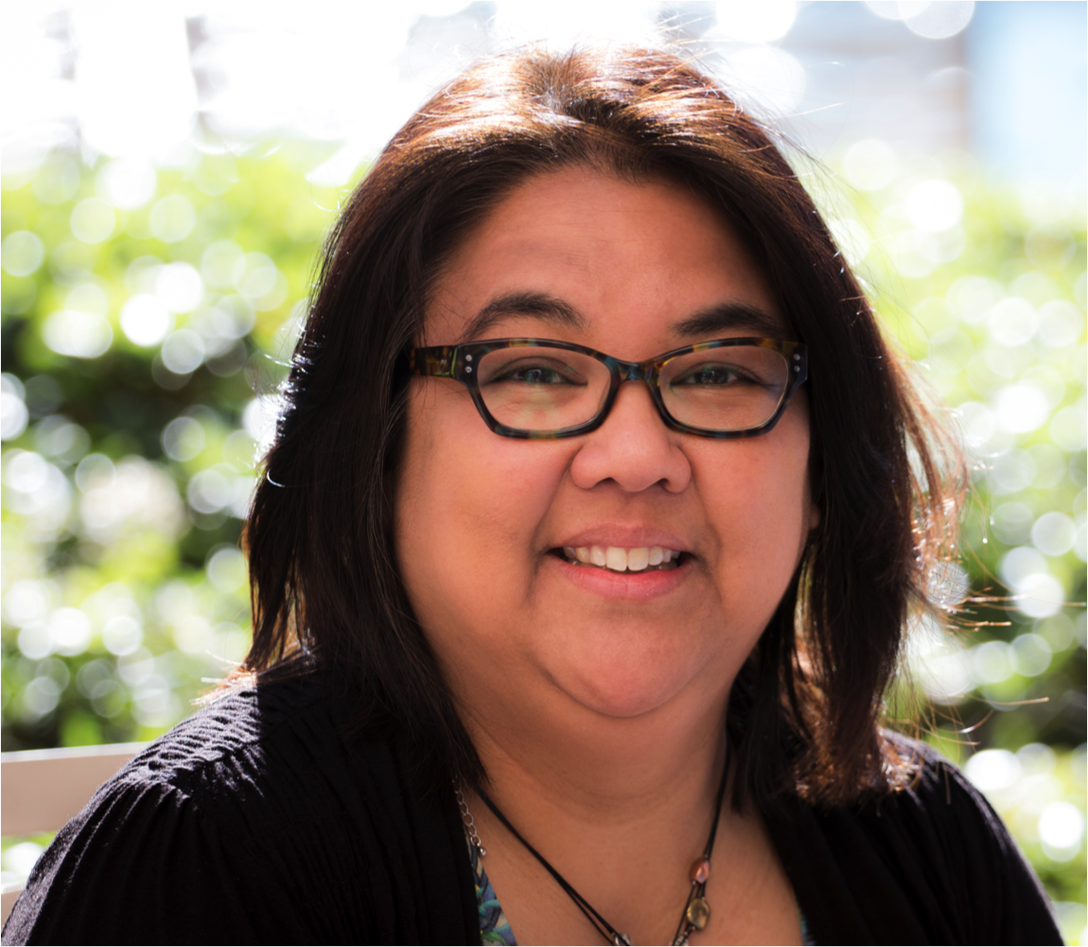 |  | Tina Childress, MA,CCC-A,  Is a trainer for the Illinois School for the Deaf Outreach Program and the 2014 winner of the I. King Jordan Award and Phonak’s Cheryl DeConde Johnson Award for outstanding achievement in Educational and Pediatric Audiology.  As a result of this training, participants will be able to describe features of apps that can be used with children with hearing loss (and with adults), list sources for finding apps for no or low cost, and name apps that can be used to work on receptive and expressive language skills for children developing listening and spoken language skills and/or signing skills.  Target Audience: Speech and language pathologists, teachers of the deaf/hard of hearing, audiologists, Part C providers, parents, and consumers.
October 19, 2015 9:30 – 2:00
J.F. Fick Conference Center, 1301 Sam Perry Blvd, Fredericksburg, VA 22401 (Registration form attached.)
Sponsored by Outreach services
of Virginia School for the Deaf and the Blind,
through grant funding from the Virginia Department of Education
Debbie.Pfeiffer@vsdb.k12.va.us | www.vsdb.k12.va.us

