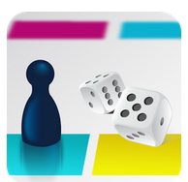

iTunes: MakeAndPlayQuiz App

Google Play: Make & Play Quiz App
  - MakeAndPlayQuiz Published on iTunes or http://tinyurl.com/y9rjtbxg
  - Make & Play Quiz Published on Google Play or http://tinyurl.com/jj9x8vl
MakeAndPlayQuiz or Make & Play Quiz allows teachers to design their own unique board game or "quiz", where students can learn or strengthen their skills by playing a game. Each square can have a Question (Multiple Choice, Fill in the Blank or True/False) or an Event (Stop-skip turns, Go forward, Go Back or Get Points). One to four players can play at a time and the games can be shared with others.

