Family Engagement  in Education  Virginia Department of Education  http://www.doe.virginia.gov/families/  http://vafamilysped.org/family-engagement  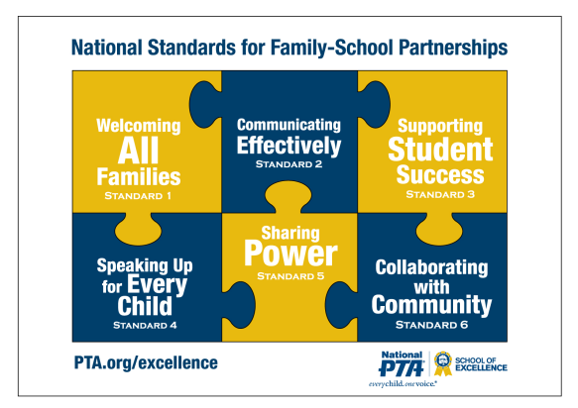  https://www.pta.org/nationalstandards | Family Engagement  in Education  Virginia Department of Education  http://www.doe.virginia.gov/families/  http://vafamilysped.org/family-engagement  https://www.pta.org/nationalstandards | Family Engagement  in Education  Virginia Department of Education  http://www.doe.virginia.gov/families/  http://vafamilysped.org/family-engagement  https://www.pta.org/nationalstandards

