VAAPVI and Outreach Services, VSDB present: Sounds of the James

April 2, 2016 or May 2, 2016
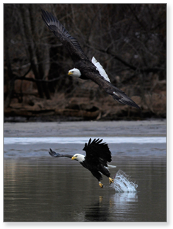  This program is supported by the 2015 Virginia Wildlife eStore (www.ShopDGIF.com) Grant Program through a partnership between the Virginia Department of Game and Inland Fisheries and the Wildlife Foundation of Virginia and by the VA Department for the Blind and Vision Impaired. (Photo by Bob Jones, Jr.) |  | An event for VA students ages 8 – 21 with blindness or visual impairment and their families  Ride aboard a comfortable pontoon boat along the James River as Capt. Mike Ostrander enthralls you with one of the most unique bald eagle tours on the East Coast! Land events include O&M training, education regarding birds of the river, their cries, habitat, and history of the area. This fun and educational event provides the perfect opportunity for students and parents to learn and network!  NOTE: Limited to 6 families each day (April 2 or May 2, 2016, 9:30 – 3:00). Participants will be admitted on a first registered, first served basis; student must be accompanied by one parent/caregiver on the boat. Raindates: April 16 (for Ap. 2) and May 4 (for May 2) Location: Deep Bottom Park, Richmond, VA Please send questions to: debbie.pfeiffer@vsdb.k12.va.us
Register at:
http://goo.gl/forms/Tj9YHwoFkM

