For Immediate Release: October 1, 2018

Contact: Charles B. Pyle, Director of Communications, (804) 371-2420
Julie C. Grimes, Communications Manager, (804) 225-2543

Virginia On-Time Graduation Rises to 91.6 Percent

RICHMOND, Va. — Virginia’s on-time graduation rate improved by a half point as more than nine out of ten students who entered the ninth grade in 2014 earned a diploma within four years, the Virginia Department of Education (VDOE) reported today. Fifty-two percent of the students in the class or 2018 graduated with advanced diplomas.

Of the 97,961 students in the class of 2018, 91.6 percent earned a Board of Education-approved diploma, compared with 91.1 percent of the 2017 cohort. The increase equates to an additional 487 students graduating.

The dropout rate for the class of 2018 was 5.5 percent, compared with 5.8 percent for the previous graduating class. The decrease equates to 187 fewer students dropping out.

“This improvement in graduation is the result of the hard work and dedication of teachers, principals, support staff and other educators who refused to give up on students who might otherwise have dropped out,” Superintendent of Public Instruction James Lane. “It also reflects the responsiveness of school divisions to the state Board of Education’s focus on reducing absenteeism and dropout rates.”

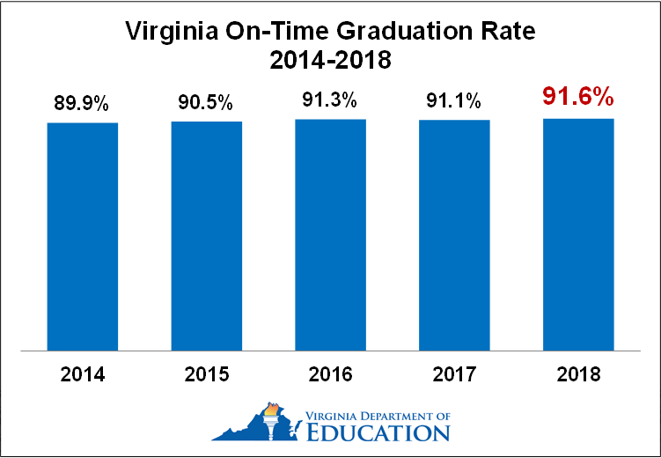

Of the students who entered high school as first-time ninth graders in 2014:
- 50,979 (52 percent) earned an Advanced Studies Diploma (including International Baccalaureate).
- 36,013 (36.8 percent) earned a Standard Diploma.
- 2,733 (2.8 percent) earned an Applied Studies or Modified Standard Diploma
- 1,046 (1.1 percent) earned a GED.
- 5,404 (5.5 percent) dropped out

(more)

Applied Studies and Modified Standard Diplomas are available only to students with disabilities. Students who earn GED certificates or complete high school without earning a diploma are not included as graduates in calculating graduation rates.

The graduation rates and dropout rates for major student racial, ethnic and socioeconomic groups are as follows:
- 97.7 percent of Asian students graduated and 1.4 percent dropped out.
- 89.6 percent of black students graduated and 6 percent dropped out.
- 87.6 percent of economically disadvantaged students graduated and 7.8 percent dropped out.
- 72.5 percent of English learners graduated and 24.6 percent dropped out.
- 80.9 percent of Hispanic students graduated and 16 percent dropped out.
- 88.2 percent of students with disabilities graduated and 9.5 percent dropped out.
- 94.5 percent of white students graduated and 3.1 percent dropped out.

Since 2011, high schools have had to meet an annual benchmark for graduation and completion to earn state accreditation. Schools receive full credit for students who earn diplomas and partial credit for students who remain enrolled, earn GEDs or otherwise complete high school. In addition, revisions to the accreditation standards adopted by the state Board of Education last November include benchmarks for reducing absenteeism and dropout rates.

High school cohort reports for schools, school divisions and the commonwealth are available for viewing and downloading on the VDOE website and on School Quality Profile reports under the “College and Career Readiness” tab.

# # #

