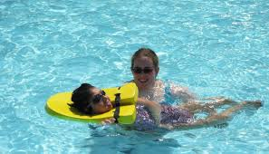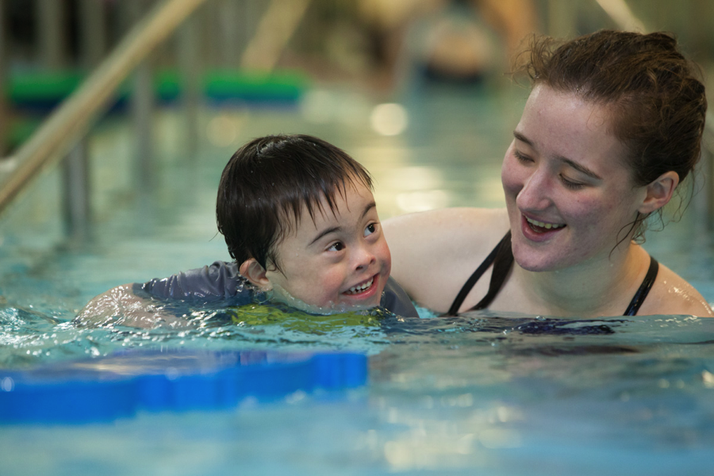  Saturday, August 25th  Southwest Family Fair  Join the Center for Family Involvement and the Virginia Department of Education at the Coomes Recreational Center in Abingdon for a great afternoon of networking with other families with children with disabilities, learning about resources, and having fun!  Local and Southwest area agencies will be on hand to provide information and resources for children and adults with disabilities  To register: https://www.eventbrite.com/e/southwest-va-family-fair-making-waves-together-tickets-48533208132 | Coomes Rec Center  300 Stanley St  Abingdon  REGISTRATION OPEN 2:30 P.M. ~  EVENT RUNS 3:00 - 5:00 P.M  ────  LET’S MAKE WAVES TOGETHER!!!  ────  THE POOL IS OPEN 3:00 - 5:00 - BRING YOUR BATHING SUIT!  OUTDOOR ACTIVITIES...DOOR PRIZES...MELLOW MUSHROOM PIZZA!  Questions?  Lisa Richard  lrichard3@vcu.edu  276-644-1999  