**Instructional Activity Resources for 4M-NSCE 1**

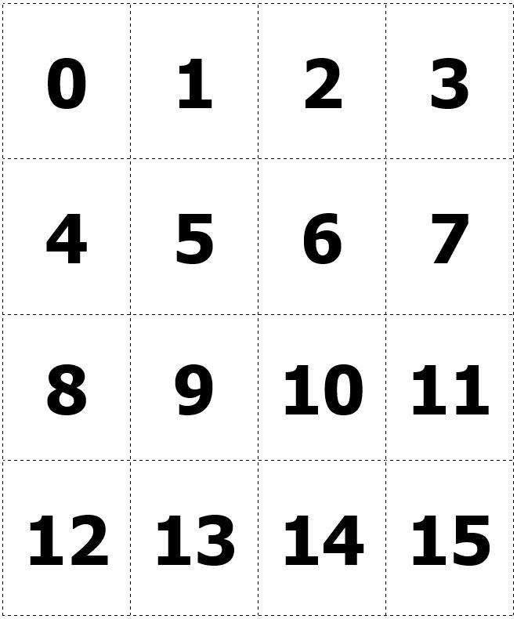

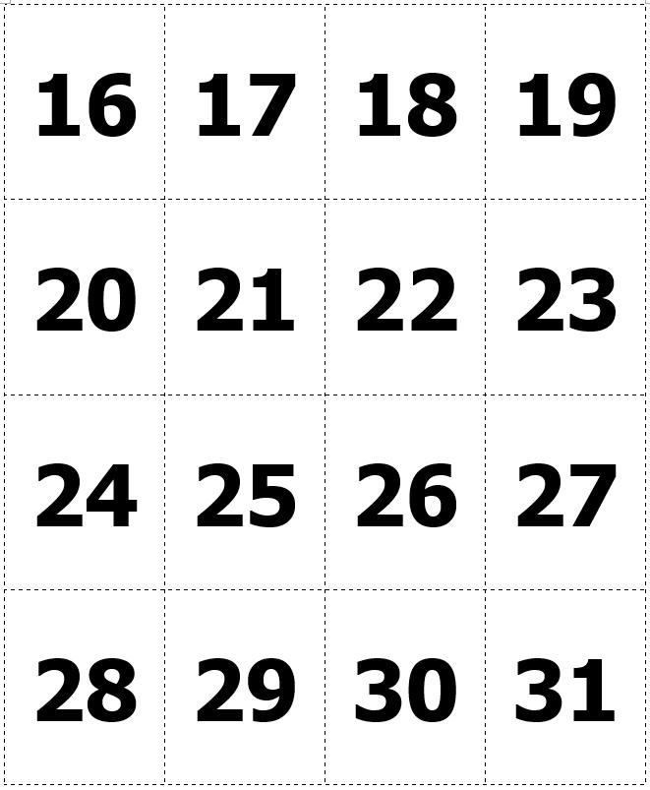

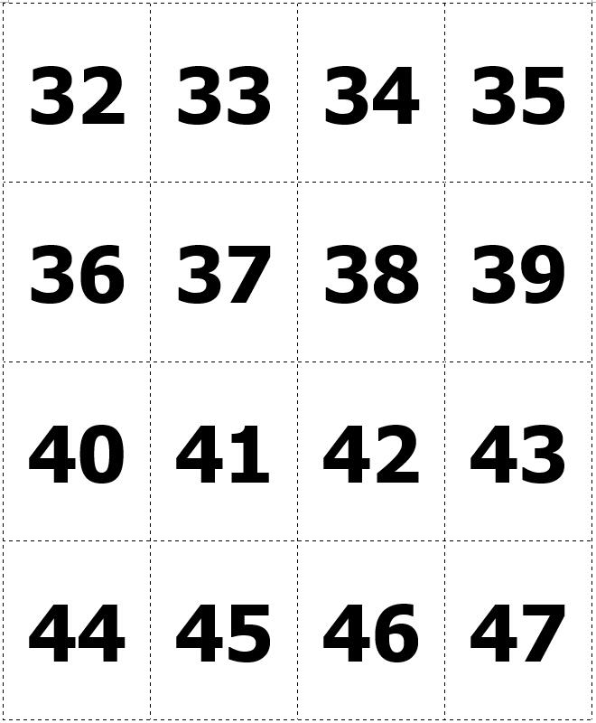

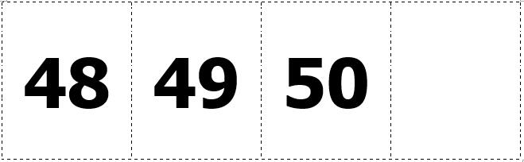

**0-50 Number Line**

4 number lines:
0 to 13, 14 to 27, 28 to 42, 43 to 50


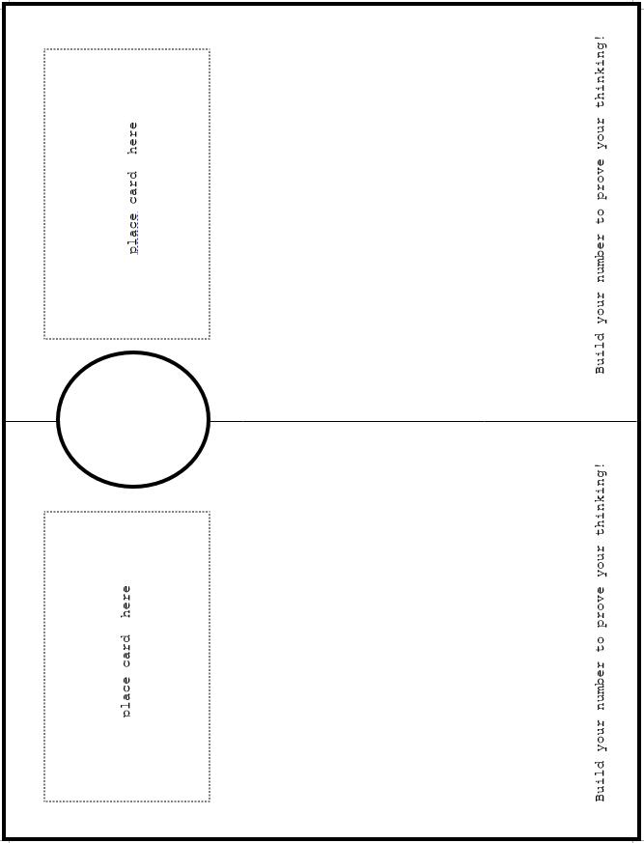

number lines:
0 to 10, 10 to 20, 20 to 30, 30 to 40, 40 to 50, 50 to 60, 60 to 70, 70 to 80, 80 to 90, 90 to 100.

**Instructional Activity Resources for 4M-NSCE 2**

**Equivalent Fractions**

**Directions: Use fraction bars to find equivalent fractions for each fraction below.**

Worksheet:
1/2 = fill in  three equivalent fractions
1/3 = fill in three  equivalent fractions
1/4 = fill in three equivalent fractions
1/5 = fill in three  equivalent fractions


**Instructional Activity Resources for 4M-NSCE 3**

5 number lines:
$0.00 to $0.50 to $1.00,
$1.00 to $1.50 to $2.00,
$2.00 to $2.50 to $3.00, 
$3.00 to $3.50 to $4.00,
$4.00 to $4.50 to $5.00

**Instructional Activity Resources for 4M -NSCE 4**

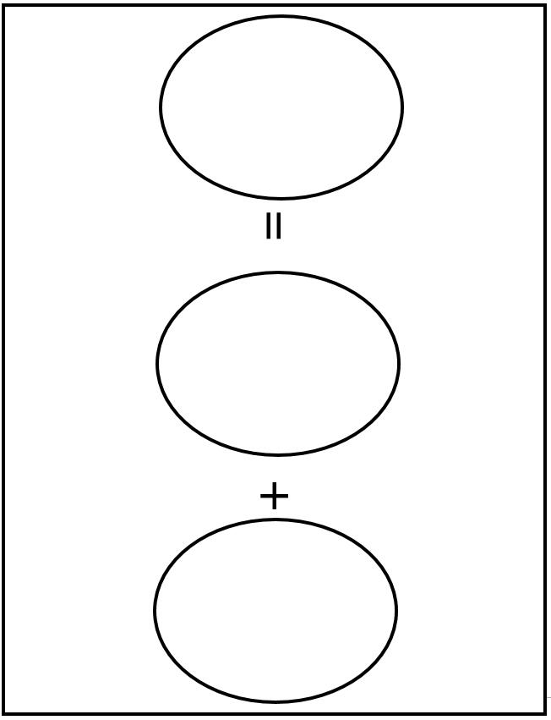

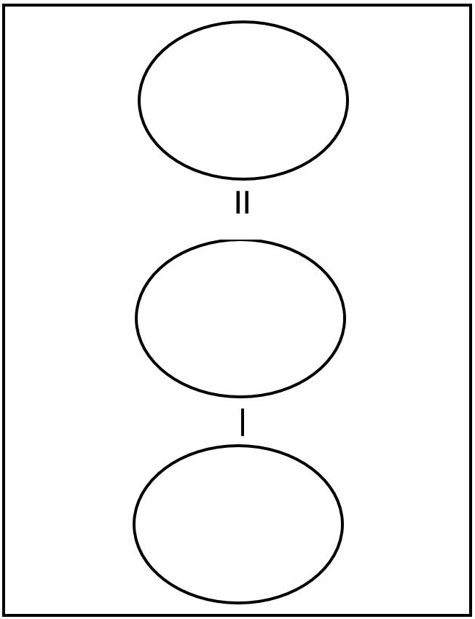

**Instructional Activity Resources for 4M -NSCE 5**

**Multiplication Jumps on a Number Line**

number line from 0 to 11.
number line from 0 to 11.
number line from 0 to 14.
number line from 0 to 14.

**Instructional Activity Resources for 4M-MG 3**

