Reporting Category | Standard | Essential Skills and Knowledge | Related Basic Skill or Concept | Sample Instructional Activities
Number, Number Sense, Computation and Estimation | 5M-NSCE 1 | - Compare numbers to each other based on place value groups by composing and decomposing to 99.  - Recognize patterns in the number of zeros when multiplying a number by powers of 10.  - Round two-digit whole numbers to the nearest 10 from 0-90. | - Understanding of the ones and tens place and their values  - Understanding of <, >, and = symbols  - Use of repeated addition or making equal groups to solve a basic fact when multiplying | - With a deck of cards, have the student turn over two cards and build the largest number and place them on one side of the mat. Have the student turn over two more cards and again, build the largest number. Then have the student build both numbers using base 10 pieces. Compare the two numbers using the <, >, or =.  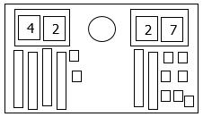  - Use base-10 pieces to multiply by powers of 10. Relate this to skip counting by 10s.  - Have student roll two 10-sided digit generators. Have them build the largest number with the 2 numbers they rolled. Have them find where the number would belong on the number line below and then identify the closest ten (e.g., If they roll and build the number 36 they would place it between 30 and 40 and see that it would round to 40.
Number, Number Sense, Computation and Estimation | 5M-NSCE 2 | - Multiply whole numbers up to 5.  - Apply the concept of fair share and equal shares to divide. | - Understanding of repeated addition  - Make equal groups to find a total  - Subtracting equal groups from a whole | - Ask the student to model a multiplication problem by building equal groups. Give them two different choice mats they could use to build the problem. For example, you ask the student to find the product for 4 x 3. You could give them the choice to use a mat that has four circles or a mat that has 2 circles and then solve the problem using the mat they chose.  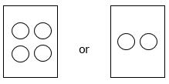
Number, Number Sense, Computation and Estimation | 5M-NSCE 3 | - Illustrate the concept of division using fair and equal shares. | - Understanding of various methods such as multiplication and subtraction (partial quotients) | - Give the student a division problem to solve. Have them identify the divisor and put out that many square pieces of paper in front of them. They should then count out enough counters for the dividend. Then the student should fair share the counters until they find the quotient.  Ex:  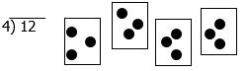  The quotient would be 3.  - Use repeated addition to find the quotient. The student would circle the number of groups subtracted from the total to find the quotient.  Ex.  15 ÷ 3  15 – (3) = 12  12 – (3) = 9  9 – (3) = 6  6 – (3) = 3  3 – (3) = 0  Five groups of 3 were subtracted. The quotient would be 5.
Number, Number Sense, Computation and Estimation | 5M-NSCE 4 | - Differentiate between halves, fourths, and eighths.  - Solve two-step word problems using addition and subtraction of whole numbers.  - Represent and interpret data on a picture, line plot, or bar graph given a model and a graph to complete. | - Name and identify fractional parts from a whole  - Recognize that shapes can be cut into equal and/or unequal parts  - Understand that addition involves combining and subtraction involves separating  - Exposure to using strategies such as counting on, counting back, making jumps on number lines  - Understand that estimation skills are valuable in determining the reasonableness of the sum or difference when solving for the exact answer  - Understand the terms used in addition and subtraction problems (addend, sum, minuend, subtrahend, difference)  - Recognize bar graphs, picture, and line plots  - Use collected data in graphs | - Give the students several different fraction cards. Have the student sort the fraction pictures by halves, fourths, and eighths.  - Use real-world two-step problems. Have the student act out the problem using manipulatives. Some examples of two-step problems are:  - Jacob is opening presents at his birthday party. His mom gives him 4 gifts. His Dad and sister each give him 2 gifts. How many gifts did Jacob receive?  - Amy and Sarah are planning to collect cans for a food drive. They collected 25 cans of soup, 6 cans of green beans, and 12 cans of tuna fish. How many more cans of soup did they collect than cans of green beans and tuna fish?  - Marcus is buying new football equipment for the season. He spent $7 on a football and $15 dollars on a jersey. If he went into the store with $30, how much money did he have after he bought the football and jersey?
Measurement and Geometry | 5M-MG 1 | - Use customary units to measure weight and length of objects. | - Understand that things can be measured using various tools  - Identify tools to measure weight and length | - Students should measure the length of objects around them using rulers, measuring tapes, and yard sticks.  - Students should weigh things that they use on a daily basis using a scale or balance pan.
Probability, Statistics, Patterns, Functions, and Algebra | 5M-PSPFA 1 | - Compare two sets of data within a single data display such as a picture graph, line plot, or bar graph. | - Recognize bar graphs, picture, and line plots  - Use collected data in graphs  - Interpret data | - Students should read a graph and compare items to one another within the graph they are reading, (e.g., More students like strawberries than apples. Four more students like bananas than oranges.)  - Identify bar and pictographs from several graphing formats (e.g.;  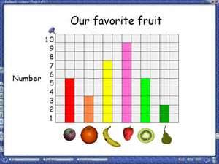  (bar graph)  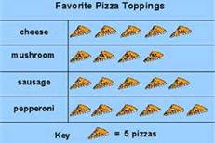  (picture graph)  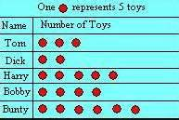  (pictograph)
Probability, Statistics, Patterns, Functions, and Algebra | 5M-PSPFA 2 | - Identify and extend numerical patterns. | - Understand that patterns can repeat and grow | - Student should have multiple opportunities to look at patterns and predict what would come next based on the number pattern.

