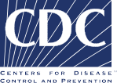

Directors Information Sessions for 2016-2017 Northern Virginia Childhood Obesity Prevention Learning Collaboratives:

To learn more about this project and how it works, these Online Directors Webinars are being held to provide the following information:

- Overview of project
- Benefits for participating ECE programs
- Commitments asked of participating ECE programs
- Schedule & location of training sessions
- Q&A

Online Directors Webinar Dates
You may sign up for more than one session, and log in by computer, or call in by phone to the session that is most convenient for you. The current schedule for webinars is:

Oct. 7 9 AM to 9:20 AM or 1:00 PM to 1:20 PM
Oct. 10 9 AM to 9:20 AM or 1:00 PM to 1:20 PM
Oct. 11 9 AM to 9:20 AM or 2:00 PM to 2:20 PM
Oct. 12 8:30 AM to 8:50 AM or 9:30 AM to 9:50 AM
Oct. 14 9 AM to 9:20 AM or 1:00 PM to 1:20 PM

You must sign up in advance in order to get the sign-in information. To request a registration link to sign-up for an online webinar, email Emily Keenum at emily@vecf.org.

For additional information, contact Child Care Aware Director of Professional Development Peggy Watkins at PeggyW@va.childcareaware.org or 804-285-0846.

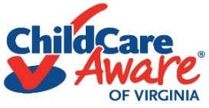

Funding for this publication was made possible by the Centers for Disease Control (CDC). Virginia Early Childhood Foundation is a subawardee to Nemours, who is currently funded by the CDC under a five-year Cooperative Agreement (1U58DP004102) to support states in launching ECE learning collaboratives focused on obesity prevention. Its contents are solely the responsibility of the authors and do not necessarily represent the official views of the Department of Health and Human Services, Centers for Disease Control and Prevention, or the U.S. Government.

