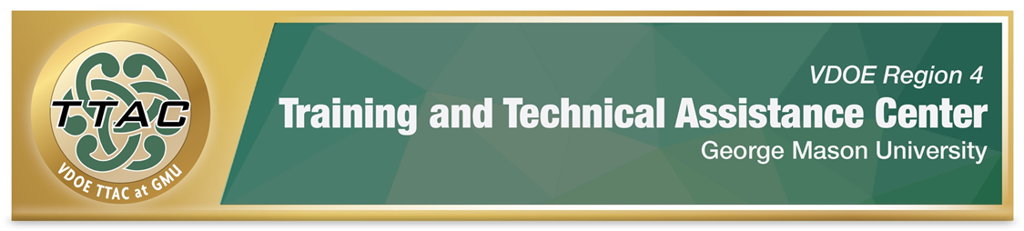 SDI Spotlight – Mathematics: Place Value, Decimals, Percent

SDI Spotlight Purpose: This spotlight was based on practices identified in VDOE’s Evidence Based Specially Designed Instruction in Mathematics, and focuses on specific strategies for place value using the Concrete-Representational-Abstract (CRA) method, an evidence-based practice. Brief videos demonstrating how to teach whole number operations with CRA and lesson plans when available are shared.

Considerations: Dr. Sarah Powell, Assistant Professor discusses important considerations when teaching students with difficulties in mathematics (8:22 mins): Considerations for teaching students with math difficulties video. To better understand the needs of students with mathematics disabilities, read: VDOE Students with Disabilities in Mathematics Frequently Asked Questions.

Explicit Instruction (HLP 16): Explicit instruction forms the foundation for delivering specially designed instruction. CEC created a checklist that walks teachers through phases of explicit instruction: CEC HLP 16 Checklist.

Proper Mathematics Vocabulary: It’s essential to use and encourage student dialogue with proper mathematical vocabulary. VDOE identified important mathematics vocabulary: VDOE Word Wall Cards. Scaffolds like Frayer Models enhance students’ understanding of mathematics vocabulary.

Progress Monitoring: Monitoring student progress is an essential component of instruction. When students are not making meaningful progress, we gather data to analyze instructional practices and make necessary adjustments to improve student outcomes. Progress Monitoring Tools:
- National Center on Intensive Interventions Student Progress Monitoring Tool for Data Collection and Graphing
Learn: How to interpret progress monitoring data: Project Stair (4:29 mins.) and how to use error analysis in mathematics IRIS Center (2015) Page 7 Error Analysis for Mathematics.

Concrete-Representational Abstract (CRA) Method, an Evidence Based Practice (EBP)
Read about CRA & Visual Representations IRIS Center (2017) Page 5 Visual Representations.
- Learn about CRA: LD@School self-paced learning - Concrete-representational-abstract method.

CRA with Place Value Decimals & Percentages

- Explicitly teach place value.
- Explicitly teach how to read decimals.
- Use base 10 blocks to demonstrate decimals.
- Place value mat helps students align decimals.

Modeling Decimals
Concrete-Representational-Abstract
- Place Value
- Teach how to read decimals.
Example:
Instead of 2.25 say, “two and 25 hundredths.”
Instead of 7.1, say “7 and 1 tenth.”
Instead of 2.345 say, “2 and 345 thousandths.”
- Use base 10 blocks to demonstrate decimals.
- Place value mat helps students align decimals.

Video Demonstrations
Adding and Subtracting Decimals with manipulatives
Multiplying Decimals with Based 10 Blocks
Dividing with Decimals
Khan Academy – Comparing Decimals
Fraction-Decimal-Percent -Visual Model from Khan Academy

Resources and Lesson Plans:
- National Center on Intensive Interventions Place Value
- Intensive Interventions in Action Video

Additional Resources

Intensive Interventions and Lesson Plans The National Center on Intensive Intervention identified several strategies and interventions that enhance the skills of students with math difficulties in number system and counting, place value computation, basic facts, fractions as numbers, place value concepts, and computation of fractions.

The IRIS Center. (2017). High-quality mathematics instruction: What teachers should know. Retrieved from https://iris.peabody.vanderbilt.edu/module/math/

Learning Mathematics through Representations
“Learning Mathematics through Representations (LMR) is a research-based curriculum unit for the teaching and learning of integers and fractions in the elementary grades (26 lessons).

Henrico County, VA Mathematics Courses – Activities and links that are aligned to grade level SOL

University of Texas
Researchers at the University of Texas created an Instructional Routines for Mathematics Intervention Grades 3 - 8 document that has pre-created resources and materials for mathematics for 23 interventions, which focus on different mathematical content. Each of the 23 interventions include vocabulary cards and problem sets to use during instruction. The interventions all require explicit instruction (I do, we do, you do). Though the interventions align with standards from the Texas Essential Knowledge and Skills (TEKS), the resources and materials include skills identified in Virginia’s Standards of Learning. Check out Inclusion in Texas.

Whilst GMU TTAC strives to adhere to the accepted guidelines and standards for accessibility and usability, it is not always possible to do so when linking to documents and sites outside of our site. We are continually seeking out solutions that will bring these other areas up to the same level of overall web accessibility. In the meantime, should you experience any difficulty in accessing the material, please don’t hesitate to contact us at ttacnews@gmu.edu.

References

The IRIS Center. (2015). Intensive intervention (part 2): Collecting and analyzing data for data-based individualization. Retrieved from https://iris.peabody.vanderbilt.edu/module/dbi2/

The IRIS Center. (2017). High-quality mathematics instruction: What teachers should know. Retrieved from https://iris.peabody.vanderbilt.edu/module/math/

