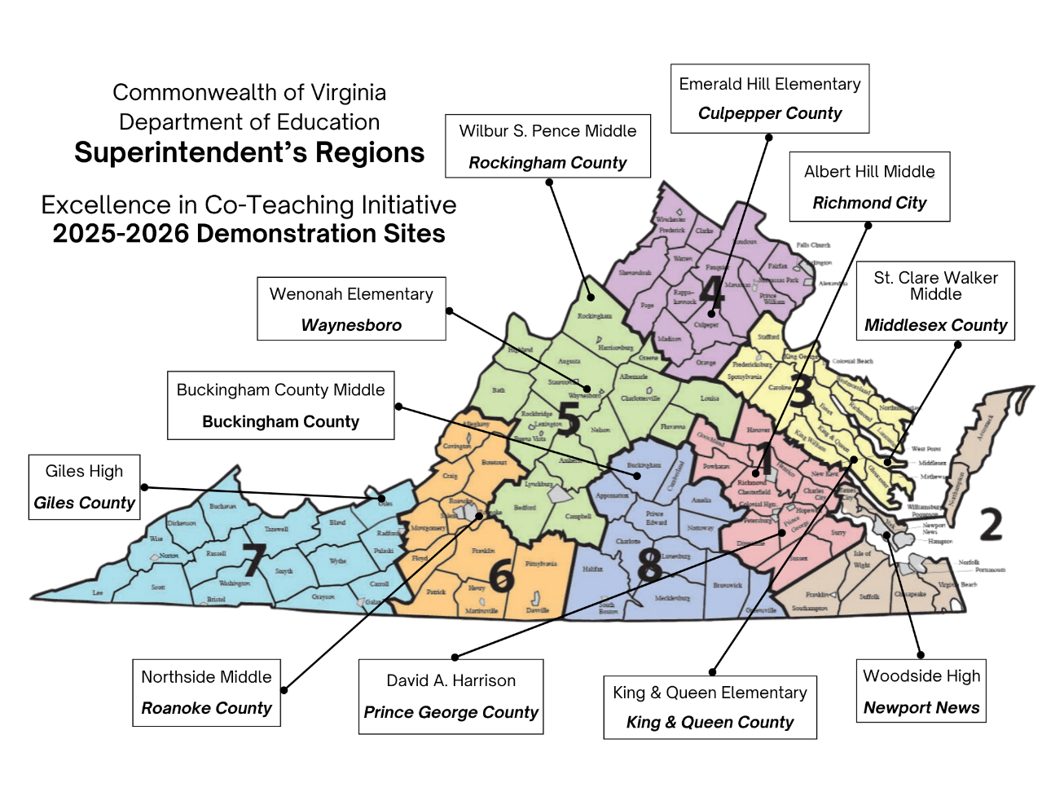

|  |  |  |  |  |
| --- | --- | --- | --- | --- |
| Region | Division & School | General Educator  Special Educator | Principal | TTAC Facilitator |
| **1** | *Prince George County*  **David A. Harrison**  **Grade 2** | **Jessica Alderman**  [jalderman@pgs.k12.va.us](mailto:jalderman@pgs.k12.va.us)  **Candace Adair**  [cadair@pgs.k12.va.us](mailto:cadair@pgs.k12.va.us) | **Christopher Scruggs**  [cscruggs@pgs.k12.va.us](mailto:cscruggs@pgs.k12.va.us) | **VCU** (Region 1 & 8)  **Mary Addeo**  [mjaddeo@vcu.edu](mailto:mjaddeo@vcu.edu) |
| **1** | *Richmond City*  **Albert Hill Middle**  **Math** | **Diamond Scott** [dscott4@rvaschools.net](mailto:dscott4@rvaschools.net)  **Jenna Ross**  [jbarker@rvaschools.net](mailto:jbarker@rvaschools.net) | **Tashiana Ivy** [tmayo@rvaschools.net](mailto:tmayo@rvaschools.net) | **VCU** (Region 1 & 8)  **Mary Addeo**  [mjaddeo@vcu.edu](mailto:mjaddeo@vcu.edu) |
| **2** | *Newport News*  **Woodside High**  **English 11** | **Alexander Riccio**  [alexander.riccio@nn.k12.va.us](mailto:alexander.riccio@nn.k12.va.us)  **Courtney Privette**  [courtney.privette@nn.k12.va.us](mailto:courtney.privette@nn.k12.va.us) | **Mary Hardesty**  [mary.hardesty@nn.k12.va.us](mailto:mary.hardesty@nn.k12.va.us) | **ODU** (Region 2 & 3)  **Danielle Sentz**  [dsentz@odu.edu](mailto:dsentz@odu.edu)  **Crystal Pope**  [cmpope@odu.edu](mailto:cmpope@odu.edu) |
| **3** | *King and Queen County*  **King and Queen Elem.**  **Grade 5**  **Math** | **Rachelle Pohlman**  [rpohlman@kqps.net](mailto:rpohlman@kqps.net)  **Kelly Harvey**  [kharvey@kqps.net](mailto:kharvey@kqps.net) | **Mack Harvey**  [mharvey@kqps.net](mailto:mharvey@kqps.net) | **WM** (Region 2 &3)  **Shelley Littleton** [sblittleton@wm.edu](mailto:sblittleton@wm.edu)  **Jason Betzner** [jpbetzner@wm.edu](mailto:jpbetzner@wm.edu)  **Alexis Swanson**  [ahswan@wm.edu](mailto:ahswan@wm.edu) |
| **3** | *Middlesex County*  **St. Clare Walker Middle**  **Math 8** | **Kate Messner**  [kmessner@mcps.k12.va.us](mailto:kmessner@mcps.k12.va.us)  **Bailey Hooper** [bhooper@mcps.k12.va.us](mailto:bhooper@mcps.k12.va.us) | **Dr. Elizabeth Sanders** [esanders@mcps.k12.va.us](mailto:esanders@mcps.k12.va.us) | **WM** (Region 2 &3)  **Shelley Littleton** [sblittleton@wm.edu](mailto:sblittleton@wm.edu)  **Jason Betzner** [jpbetzner@wm.edu](mailto:jpbetzner@wm.edu)  **Alexis Swanson**  [ahswan@wm.edu](mailto:ahswan@wm.edu) |
| **4** | *Culpepper County*  **Emerald Hill Elementary**  **Grade 4** | **Aimee Morehead** [amorehead@ccpsweb.org](mailto:amorehead@ccpsweb.org)  **Kimberly Moon** [km9767@culpeperschools.org](mailto:km9767@culpeperschools.org) | **Tori Gelbert** [vg5933@ccpsweb.org](mailto:vg5933@ccpsweb.org) | **GMU** (Region 4)  **Melissa Gunter**  [mgunter2@gmu.edu](mailto:mgunter2@gmu.edu) |
| **5** | *Rockingham County*  **Wilbur S. Pence Middle**  **Math 7** | **Monica Johnson** [mjohnson01@rockingham.k12.va.us](mailto:mjohnson01@rockingham.k12.va.us)  **Nicole Meredith** [nmeredith@rockingham.k12.va.us](mailto:nmeredith@rockingham.k12.va.us) | **Teresa Shank** [tshank@rockingham.k12.va.us](mailto:tshank@rockingham.k12.va.us) | **JMU** (Region 5)  **Jillian Shifflett**  [shiffljm@jmu.edu](mailto:shiffljm@jmu.edu) |
| **5** | *Waynesboro*  **Wenonah Elementary**  **Grade 3**  **Math & Reading** | **Nicole Mickens**  [nmickens@waynesboro.k12.va.us](mailto:nmickens@waynesboro.k12.va.us)  **Taylor Rose**  [trose@waynesboro.k12.va.us](mailto:trose@waynesboro.k12.va.us) | **Abby Aery**  [aarey@waynesboro.k12.va.us](mailto:aarey@waynesboro.k12.va.us) | **JMU** (Region 5)  **Jillian Shifflett**  [shiffljm@jmu.edu](mailto:shiffljm@jmu.edu) |
| **6** | *Roanoke County*  **Northside Middle**  **Math 8** | **Amber Benson**  [abenson@rcps.us](mailto:abenson@rcps.us)  **Ruby Voss**  [rvoss@rcps.us](mailto:rvoss@rcps.us) | **Dr. Paul Lineburg**  [plineburg@rcs.k12.va.us](mailto:plineburg@rcs.k12.va.us) | **RU** (Region 6 & 7)  **Suzanne Graham**  [s-graham@radford.edu](mailto:s-graham@radford.edu) |
| **7** | *Giles County*  **Giles High**  **Grade 9**  **Algebra 1** | **Katherine Wright**  [kwright@gilesk12.net](mailto:kwright@gilesk12.net)  **Mandy Seeberger**  [mseeberger@gilesk12.net](mailto:mseeberger@gilesk12.net) | **Shelley Boggess**  [sboggess@gilesk12.net](mailto:sboggess@gilesk12.net) | **RU** (Region 6 & 7)  **Suzanne Graham**  [s-graham@radford.edu](mailto:s-graham@radford.edu) |
| **8** | *Buckingham County*  **Buckingham County Middle**  **Grade 8 English** | **Shawn Stinson**  [sstinson@bcpschools.org](mailto:sstinson@bcpschools.org)  **Lynn Scruggs**  [lscruggs@bcpschools.org](mailto:lscruggs@bcpschools.org) | **Dr. Jeffrey Garrett** [jgarrett@bcpschools.org](mailto:jgarrett@bcpschools.org) | **VCU** (Region 1 & 8)  **Leslie Murphy-Brown** [lmmurphybrown@vcu.edu](mailto:lmmurphybrown@vcu.edu) |