Now Available:

online REsources

through VSDB

outreach services!
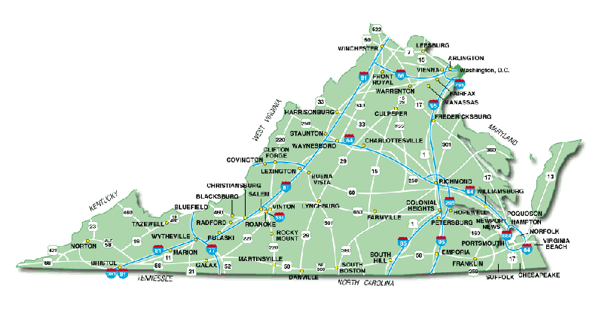  The Goal of the Virginia School for the Deaf and the Blind Outreach Services is to assist school personnel and early intervention providers across Virginia in meeting the needs of all children who are Deaf/Hard of Hearing, Blind/Visually Impaired, or Deaf-Blind and their families. |  | Need some new ideas?  Go to www.vsdb.k12.va.us and select “Outreach Services”.  First, a big “THANKS” to the hundreds of people who completed our Needs Assessments. In response to your feedback, we have expanded our webpages to include links to great resources and tools that can be used by families of and professionals serving children from birth to 22 years who are deaf/hard of hearing, blind/visually impaired, or deaf-blind.  Our Outreach webpages will continue to evolve. If you have valuable resources you would like to share, please send your ideas to be added to our online resources.  Debbie.Pfeiffer@VSDB.k12.va.us  (540) 414-5249
Stay tuned for alerts as more resources become available through the VSDB Outreach Services!

Virginia School for the Deaf and the Blind’s Outreach Services are funded through a grant from the Virginia Department of Education.

