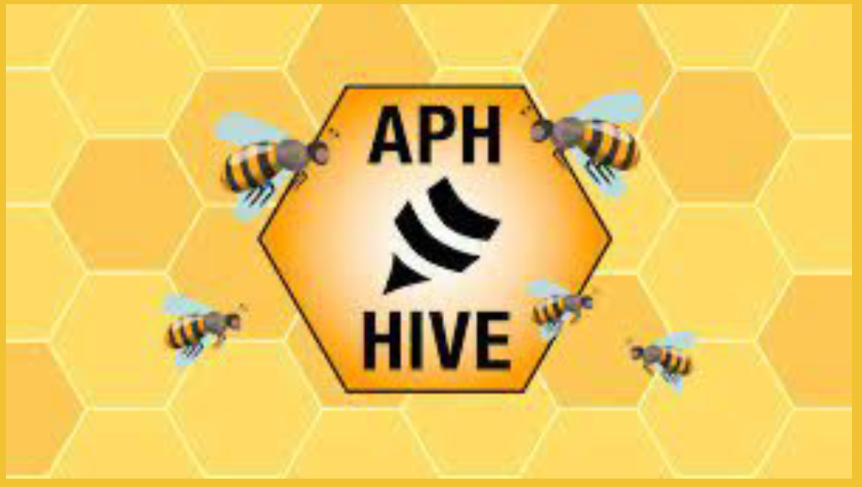

The APH Hive:

What's all the Buzz About?

Outreach Services at VSDB is excited to bring you Amy Campbell, Learning Management System Administrator at American Printing House for the Blind, will join us to explain The Hive and how you can use it to benefit your practice!

In the past twenty years e-learning increased globally by 900%. Its self-paced, student-centered, and quick delivery of instruction makes it appealing for many whom want to learn more. Now professionals in the field of Visual Impairment have access to a new hub of learning opportunities called the APH Hive. Join this conversation and discover how this free resource equips educators to meet the service needs of individuals with visual impairment, including blindness.

This FREE course is designed for teachers of the visually impaired and other professionals working with children with visual impairments including blindness in the state of Virginia ages 2-21. This session will be recorded!
February 16, 2022
11:30am-1pm
Zoom

Registration for The APH Hive: What's all the Buzz About?
Questions? Robin Bliven, Director of Outreach Services: robin.bliven@vsdb.k12.va.us

Outreach Services of the Virginia School for the Deaf and the Blind are available through grant funding from the Virginia Department of Education.

