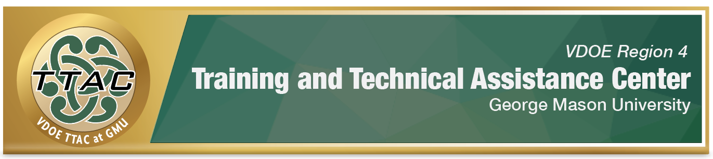

# **Dyslexia Community of Practice**

Intensifying Reading Instruction to Align with Student Needs

Intended Audience:Region 4 Dyslexia Advisors

## Learning Intentions:

**After this presentation, participants will be able to:**

1. Better consider the variation of reading related disabilities according to comprehensive evaluation for special education.
2. Develop a clearer understanding of what kind of instructional approach best serves a student based on the nature of their disability.
3. Begin to assess the approved programs for their alignment to meeting varied student needs.
4. Practice outlining specially designed instruction to aligned to student need profiles.

## Presenter:

Jennifer Sassano, Co-Director, TTAC GMU

## Event Details:

3:00pm-4:30pm Tuesday, February 4, 2025