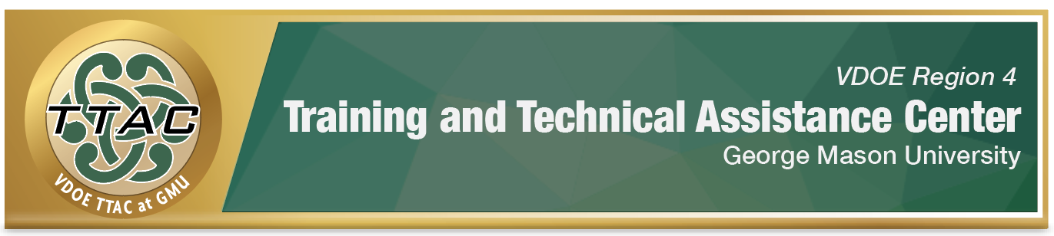

# **Region 4 GMU TTAC’s Unlocking Big Words:**

# **Strategies for Decoding Multisyllabic Words**

# **Fall 2024 Professional Learning Series**

Intended Audience:Region 4 educators who support older students who struggle with decoding, oral reading fluency and spelling multisyllabic words.

## Learning Intentions:

Participants will learn, practice and apply:

* Concepts related to syllable instruction and syllable division;
* Evidence-based literacy practices for decoding and encoding multisyllabic words in English Language Arts instruction, tiered interventions and/or across content areas.

Facilitators: Jennifer Sassano & April Lennox, Literacy Coordinators @ GMU TTAC

## Participants must attend all Session Dates:

* Tuesday, October 1, 2024 from 4:00p – 5:30p
* Tuesday, October 8, 2024 from 4:00p – 5:30p
* Tuesday, October 22, 2024 from 4:00p – 5:30p
* Tuesday, October 29, 2024 from 4:00p – 5:30p
* Tuesday, November 12, 2024 from 4:00p – 5:30p
* Tuesday, November 19, 2024 from 4:00p – 5:30p

**If you are eligible and interested, please submit a** [**application**](https://forms.office.com/r/B3SNfyKvDW) **by 4pm, 9/12/24.**

All current, grades 4–8 educators, who are actively teaching in VDOE’s Region 4 public schools are welcome to apply. In the application process, preference will be given to special education teachers. If you are uncertain of your VDOE Region please check <https://ttac.gmu.edu/about> for a list of the school divisions GMU TTAC serves.

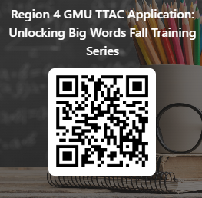Selected participants will receive instruction on how to use the principles of syllabication to build fluent word recognition skills in their struggling readers, grades 4-8, including those with specific learning disabilities. Participants will be provided digital instructional materials and an opportunity to receive ongoing support from TTAC. <https://bit.ly/UBW2024>