Instructional Activity Resources for 6M-NSCE 2
Identify the Missing + or - Number
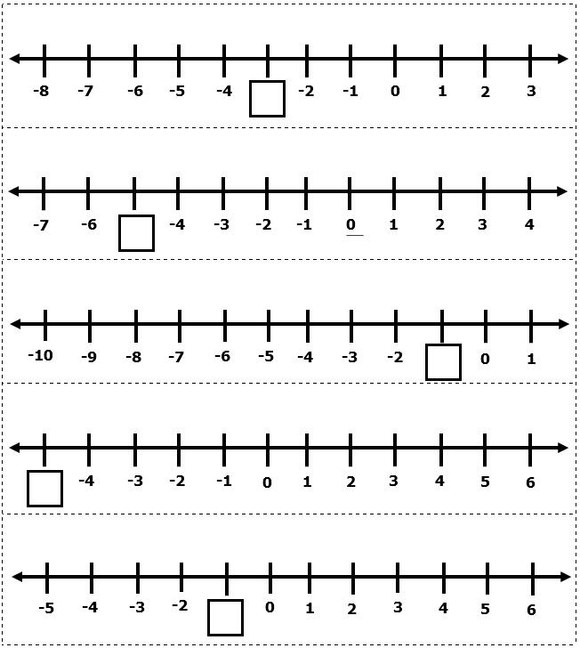

Identify Large or Small Integer
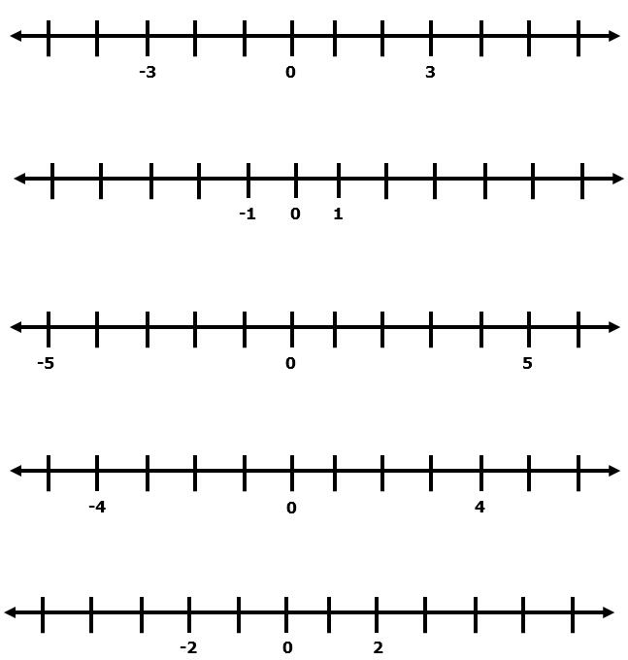

Instructional Activity Resources for 6M-MG 1
Finding Area
Determine the area of a given surface by estimating and then finding the number of square units needed to cover the surface. Use tiles or cheese crackers to find the area.
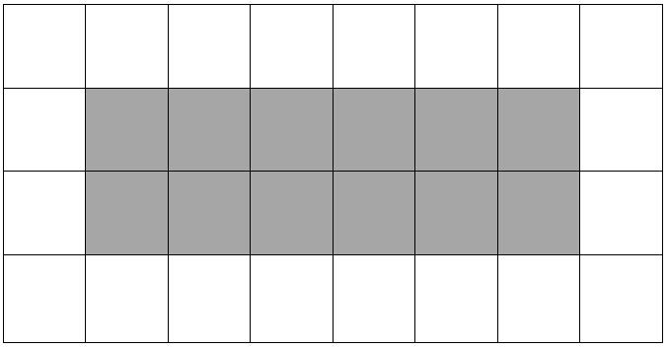

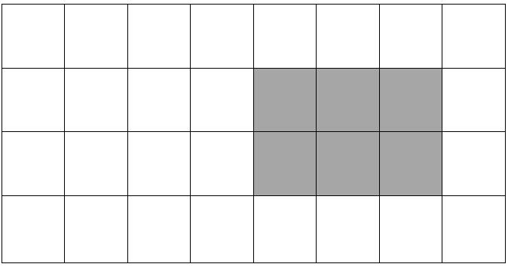
Finding Area
Determine the area of a given surface by estimating and then finding the number of square units needed to cover the surface. Use tiles or cheese crackers to find the area.
