Switch Site Location & Positioning Chart
This document provides guidelines for linking reliable, consistent and repeatable movements to potential switch site locations and positions. It also provides some benefits and challenges for each specific movement and location. This chart is meant to be a guide. Remember, switch type selection is highly dependent on the unique profile of the person using a switch.
Note of caution: If the person using a switch is also operating their wheelchair with a body movement (i.e.: leaning their head back), you must select a different movement for the function of communication (i.e.: tilting their head to the right) in order to keep the two functions separate.

Hand
What movement was selected? | Position of Switch | Benefits | Challenges
Pressing down  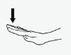 | Flat on Surface  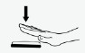 | Can be mounted to table or lap tray with Velcro  Easy to consistently position the switch on a flat surface | Difficult to position when a flat surface is not accessible  Can be fatiguing if the individual tends to move their arm around  Mis-hits are common because of difficulty lifting off the switch  Accuracy may be negatively affected if the individual has difficulty reaching a specific spot consistently
Pressing down | Recessed into laptray  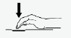 | Potential for fewer mis-hits than above position | Requires specific fabrication of laptray  and mounting of switch  Requires extra effort to hit the switch  Accuracy may be negatively affected if the individual has difficulty reaching a specific spot consistently
Reaching forward  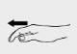 | In front of hand  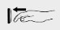 | Accommodates a variety of movements of the hand (i.e. punch, palm or finger movement)  Easy to position switch | Must target a specific spot  Release may be difficult for some individuals
Lifting wrist  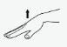 | Above hand  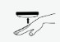 | Potentially good control because the movement is small and specific  Ease of release may result in reduced mis- hits | Positioning switch so it won’t move can be challenging  Difficult to position when not in wheelchair  Repetitive movement against gravity can be fatiguing
Moving to the side  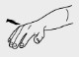  Turning hand in or out  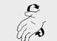 | Next to hand  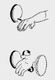 | Potentially good control because the movement is small and specific  Ease of release may result in reduced mis- hits | Requires additional equipment for positioning switch in each location  Difficult to position when user is not in a supported position
Grasp  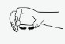 | In hand  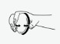 | Potentially good control because the movement is small and specific  Ease of release may result in reduced mis- hits  The arm can be anywhere as long as the hand can grasp | Can be difficult to release if spasticity is present  Often requires frequent repositioning  May be difficult for others to place correctly  Interference from the cord may occur

Finger
What movement was selected? | Position of Switch | Benefits | Challenges
Pressing down  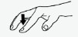 | Flat on surface  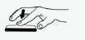 | Requires only Velcro to mount on table or lap tray  Easy to consistently position switch | Difficult to position when not in wheelchair  Can be fatiguing if the individual tends to move their arm around  Mis-hits are common because of difficulty lifting off the switch  Accuracy may be negatively affected if the individual has difficulty reaching a specific spot consistently
Pressing down | Recessed into laptray  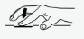 | Accidental hits may be avoided | Requires specific fabrication of laptray and mounting of switch  Requires extra effort to activate the switch  Accuracy may be negatively affected if the individual has difficulty reaching a specific spot consistently
Thumb  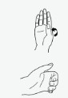 | In palm  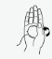 | Takes advantage of what may be a strong isolated movement  Easy setup for others using a Velcro strap | May require repositioning  Cords may interfere with movement
Thumb | On Fingers  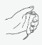 | Takes advantage of what may be a strong isolated movement  Easy setup for others using a Velcro strap | May require repositioning  Cords may interfere with movement

Head
What movement was selected? | Position of Switch | Benefits | Challenges
Turning head  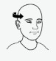 | At jaw line  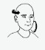 | Tends to be movement that can be produced consistently  Will not interfere with glasses | Positioning may be difficulty especially in bed  Could interfere with maintaining gaze on target if individual tries to look at the switch or if it is positioned far from jaw  May trigger Asymmetrical Tonic Neck Reflex (ATNR) reflexes in some individuals  Partners may mistake movement for “no” response but would certainly learn to distinguish over time
Turning head | At cheek  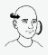 | Some individuals may prefer with this location | Position near mouth may result in saliva production or rooting behaviors in some individuals  May trigger ATNR reflexes in some individuals  Partners may mistake movement for “no” response but would certainly learn to distinguish over time
Turning head | At temple  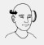 | Some individuals may prefer with this location | Position near eye may interfere with glasses  Need to consider potential for damage to eye if the individual’s movement is inconsistent  Partners may mistake movement for “no” response but would certainly learn to distinguish over time  Individual could lose focus if they tend to look at the switch  Should not be considered if the individual wants to look at the switch
Tilting head  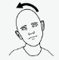 | At jaw line  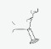 | Will not interfere with glasses | Positioning may be difficulty especially in bed  Could interfere with maintaining gaze on target if individual tries to look at the switch or if it is positioned far from jaw  May trigger ATNR reflexes in some individuals  Partners may mistake movement for “no” response but would certainly learn to distinguish over time
Tilting head | At cheek  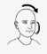 | Some individuals may prefer with this location | Position near mouth may result in saliva production or rooting behaviors in some individuals  May trigger ATNR reflexes in some individuals  Partners may mistake movement for “no” response but would certainly learn to distinguish over time
Leaning head back  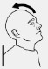 | Behind head  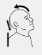 | Switch is not obvious to others | Partners may mistake movement for “yes” response but would certainly learn to distinguish over time  Individual cannot see switch
Lowering head  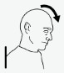 | Under chin  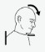 | Some individuals may prefer with this location  Can be a good alternative if other head movements are problematic | Position near mouth may result in saliva production or rooting behaviors in some individuals  May result in loss of eye contact with partners or ability to see target on device  May trigger ATNR reflexes in some individuals  Partners may mistake movement for “yes” response but would certainly learn to distinguish over time

Shoulder
What movement was selected? | Position of Switch | Benefits | Challenges
Shrugging shoulders  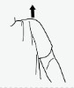 | Above shoulder  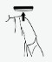 | Tends to be movement that can be produced consistently | Positioning of switch may be challenging.  Partners may mistake movement for “I don’t know” response but could learn to distinguish over time  Potential for accidental hits with movement of the wheelchair

Elbow
What movement was selected? | Position of Switch | Benefits | Challenges
Backward  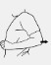 | Vertical behind elbow  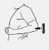 | Takes advantage of strong one directional movement | Positioning of switch may be challenging  Partners may mistake movement for “I don’t know” response but could learn to distinguish over time  Potential for accidental hits with movement of the wheelchair
Away from body to side  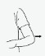 | Vertical between body and elbow  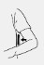 | Takes advantage of strong one directional movement | Positioning of switch may be challenging  Can be difficult to release switch  Cannot see target
Toward body  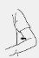 | Vertical between body and elbow | Takes advantage of strong one directional movement | Positioning of switch may be challenging  Can be difficult to release switch  Cannot see target

Knee
What movement was selected? | Position of Switch | Benefits | Challenges
Movement: Open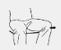 | Next to knee  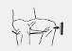 | Takes advantage of strong one directional movement | Positioning of switch may be challenging
Movement: Close  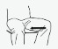 | Between knees  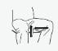 | Takes advantage of strong one directional movement | Positioning of switch may be challenging  Can be difficult to release switch
Movement: Lift  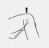 | Above knee  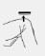 | Takes advantage of strong one directional movement | Positioning of switch may be challenging  Mis-hits may occur if startle reflex is present  Potential for fatigue to interfere with use

Leg and Foot
What movement was selected? | Position of Switch | Benefits | Challenges
Lifting lower leg  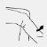 | Front of lower leg  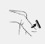 | Takes advantage of strong one directional movement | Positioning of switch may be challenging.  Can be difficult to release switch.  Mis-hits may occur if startle reflex is present
Pushing backward with lower leg  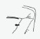 | Behind lower leg  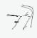 | Takes advantage of strong one directional movement | Positioning of switch may be challenging.  Can be difficult to release switch  Mis-hits may occur if startle reflex is present
Lifting foot  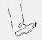 | Above foot  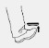 | Takes advantage of strong one directional movement | Positioning of switch may be challenging  Mis-hits may occur if startle reflex is present
Pushing down with foot  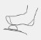 | Below foot  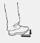 | Takes advantage of strong one directional movement | Positioning of switch may be challenging  Can be difficult to release switch  Strong pressure could break a switch  Mis-hits may occur if startle reflex is present
Foot/Pushing down with toes | Below toes  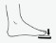 | Takes advantage of strong one directional movement | Not recommended for those with excess tone in the foot or toe areas  Recommended for use in bed because gravity is not impacting activation  Can be difficult to release switch  Mis-hits may occur if startle reflex is present

Isolated Muscle Movements
What movement was selected? | Position of Switch | Benefits | Challenges
Eyebrow lift | On/near eyebrow  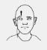 | Takes advantage of strong one directional movement | Positioning of switch may be challenging  Can interfere with use of facial expression and eye gaze/contact for communication
Eye Blink | Near eye  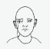 | Takes advantage of strong one directional movement | Positioning of switch may be difficult to permit natural eye blinks versus intentional  Can interfere with use of facial expression and eye gaze/contact for communication
Contraction | On muscle  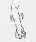 | Can be an option when success is not met through typical movement patterns | Sensors to control switch must be worn  Positioning of switch may be challenging initially and for caregivers  Consistency may be challenging if contraction is not strong

© 2020 Tobii Dynavox. All Rights Reserved.

