Sure, I can label an elephant…

…but I can do so much more

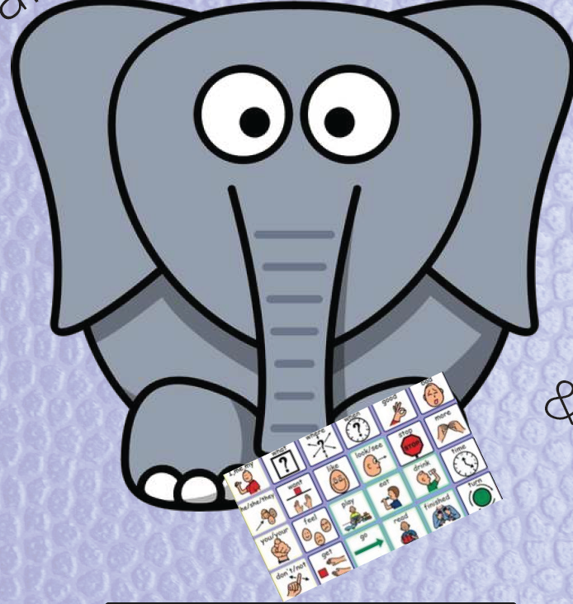
Big & Smart, Rough, Gray. Heavy & Loud
“Big, smart, heavy, gray animal”
Descriptive Teaching & Core Vocabulary
Integrate my words to teach me language

Kathryn Helland, MS, CCC-SLP, AACCommunity.net

