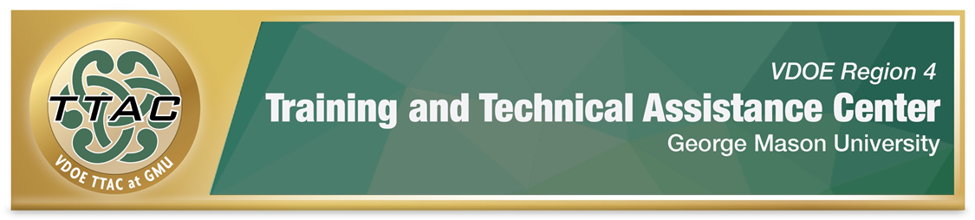 SDI Spotlight – Mathematics: Geometry

SDI Spotlight Purpose: This spotlight was based on practices identified in VDOE’s Evidence Based Specially Designed Instruction in Mathematics, and focuses on specific strategies for Geometry, using the Concrete-Representational-Abstract (CRA) method, an evidence-based practice. Brief videos demonstrating how to teach whole number operations with CRA and lesson plans when available are shared.

Considerations: Dr. Sarah Powell, Assistant Professor discusses important considerations when teaching students with difficulties in mathematics (8:22 mins): Considerations for teaching students with math difficulties video. To better understand the needs of students with mathematics disabilities, read: VDOE Students with Disabilities in Mathematics Frequently Asked Questions.

Explicit Instruction (HLP 16): Explicit instruction forms the foundation for delivering specially designed instruction. CEC created a checklist that walks teachers through phases of explicit instruction: CEC HLP 16 Checklist.

Proper Mathematics Vocabulary: It is essential to use and encourage student dialogue with proper mathematical vocabulary. VDOE identified important mathematics vocabulary: VDOE Word Wall Cards. Scaffolds like Frayer Models enhance students’ understanding of mathematics vocabulary.

Progress Monitoring: Monitoring student progress is an essential component of instruction. When students are not making meaningful progress, we gather data to analyze instructional practices and make necessary adjustments to improve student outcomes. Progress Monitoring Tools:
- National Center on Intensive Interventions Student Progress Monitoring Tool for Data Collection and Graphing
Learn: How to interpret progress monitoring data: Project Stair (4:29 mins.) and how to use error analysis in mathematics IRIS Center (2015) Page 7 Error Analysis for Mathematics.

Concrete-Representational Abstract (CRA) Method, an Evidence Based Practice (EBP)
Read about CRA & Visual Representations IRIS Center (2017) Page 5 Visual Representations.
- Learn about CRA: LD@School self-paced learning - Concrete-representational-abstract method.

Geometry
Early Geometry Skills
Students recognize shapes through concrete manipulation of objects, paired with proper vocabulary words. REL Appalachia (Department of Education Information Sciences) shares an 8:49 minute video about effective Geometry practices for young children. Learn how to implement best practices:
- REL Appalachia Early Childhood Geometry Videos
Vocabulary
VDOE Geometry Word Walls identify essential vocabulary words for Geometry, which is a subject that requires a high level of vocabulary comprehension.

Perimeter & Area
Geoboards are helpful for teaching perimeter and area. The following videos demonstrate how to use a geoboard to teach area and perimeter.
- Geoboard Area Perimeter Video
- MathLearning Center Area Perimeter Video

Concrete Representational Abstract
Skill | Video
Geometry – Quadrilaterals | Project Stair How to Teach Geometry with Representations (14 minutes)
Geoboard | How to Teach with Geoboards Video
GeoGebra (FREE)  GeoGebra helps students visualize geometric concepts, enhancing understanding of abstract geometry concepts. | GeoGebra – The BasicsVideo  Learn how to use GeoGebra

Selected Cognitive Strategies
Skill | Mnemonic
Area Of a Circle | Apple pies are squared: A = π × r²  Apple pies are too! Area = π × r²
Circumference Of a Circle | Cherry pies delicious! Circumference = π × d
Trigonometric functions | SohCahToa - Remember three basic trigonometric functions: sine, cosine, and tangent.

Additional Resources

Intensive Interventions and Lesson Plans The National Center on Intensive Intervention identified several strategies and interventions that enhance the skills of students with math difficulties in number system and counting, place value computation, basic facts, fractions as numbers, place value concepts, and computation of fractions.

The IRIS Center. (2017). High-quality mathematics instruction: What teachers should know. Retrieved from https://iris.peabody.vanderbilt.edu/module/math/

Learning Mathematics through Representations
“Learning Mathematics through Representations (LMR) is a research-based curriculum unit for the teaching and learning of integers and fractions in the elementary grades (26 lessons).

Henrico County, VA Mathematics Courses – Activities and links that are aligned to grade level SOL

Whilst GMU TTAC strives to adhere to the accepted guidelines and standards for accessibility and usability, it is not always possible to do so when linking to documents and sites outside of our site. We are continually seeking out solutions that will bring these other areas up to the same level of overall web accessibility. In the meantime, should you experience any difficulty in accessing the material, please do not hesitate to contact us at ttacnews@gmu.edu.

References

The IRIS Center. (2015). Intensive intervention (part 2): Collecting and analyzing data for data-based individualization. Retrieved from https://iris.peabody.vanderbilt.edu/module/dbi2/

The IRIS Center. (2017). High-quality mathematics instruction: What teachers should know. Retrieved from https://iris.peabody.vanderbilt.edu/module/math/

