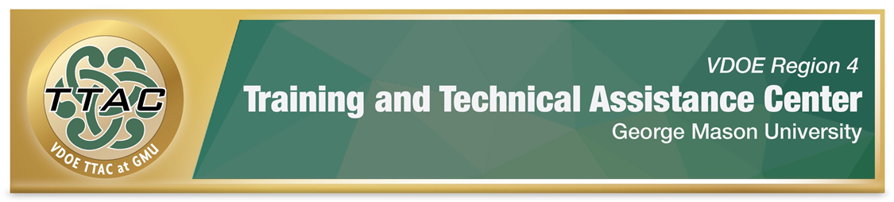

SDI Spotlight – Mathematics: Rational Number Operations

SDI Spotlight Purpose: This spotlight was based on practices identified in VDOE’s Evidence Based Specially Designed Instruction in Mathematics, and focuses on specific strategies for rational number operations using the Concrete-Representational-Abstract (CRA) method, an evidence-based practice. Brief videos demonstrating how to teach rational number operations with CRA and lesson plans when available are shared.

Considerations: Dr. Sarah Powell, Assistant Professor discusses important considerations when teaching students with difficulties in mathematics (8:22 mins): Considerations for teaching students with math difficulties video. To better understand the needs of students with mathematics disabilities, read: VDOE Students with Disabilities in Mathematics Frequently Asked Questions.

Explicit Instruction (HLP 16): Explicit instruction forms the foundation for delivering specially designed instruction. CEC created a checklist that walks teachers through phases of explicit instruction: CEC HLP 16 Checklist.

Proper Mathematics Vocabulary: It’s essential to use and encourage student dialogue with proper mathematical vocabulary. VDOE identified important mathematics vocabulary: VDOE Word Wall Cards. Scaffolds like Frayer Models enhance students’ understanding of mathematics vocabulary. For students with decoding difficulties, decoding strategies and syllabication can integrate with vocabulary word instruction. This video from Anita Archer demonstrates how to introduce new vocabulary words with decoding strategies.

Progress Monitoring: Monitoring student progress is an essential component of instruction. When students are not making meaningful progress, we gather data to analyze instructional practices and make necessary adjustments to improve student outcomes. Progress Monitoring Tools:
- National Center on Intensive Interventions Student Progress Monitoring Tool for Data Collection and Graphing
- Adapted Virginia Tech TTAC CRA Mathematics Progress Monitoring Data Collection Form
Learn: How to interpret progress monitoring data: Project Stair (4:29 mins.) and how to use error analysis in mathematics IRIS Center (2015) Page 7 Error Analysis for Mathematics.

Concrete-Representational Abstract (CRA) Method
CRA is an evidence-based practice. Listed below, are resources to learn more:
- Read about CRA & Visual Representations IRIS Center (2017) Page 5 Visual Representations.
- VDOE’s Evidence Based Specially Designed Instruction in Mathematics
- Learn about CRA: LD@School self-paced learning - Concrete-representational-abstract method.

Virtual Manipulatives (free)
- Didax Virtual Manipulatives
- EquatIO Activities Database
- Kentucky Center for Mathematics
- Math Playground
- Math Learning Center
- National Library of Virtual Manipulatives
- Toy Theatre

What does the CRA Method for Rational Numbers Look Like?
Listed below are specific research-based interventions/practices to teach rational number concepts and operations with CRA. When available, lesson plans and videos are shared. For comprehensive professional learning: Check out National Center on Intensive Intervention Module 7 Rational Number Content for Intensive Interventions.

CRA Methods for Teaching Rational Number Concepts and Operations
There are three methods for teaching rational number concepts and operations: Length Method; Area Method; Set Method.
- Watch: National Center on Intensive Intervention Video of Length, Area & Set Methods (2:32 mins.).
- Watch: Project Stair Comparing Fractions video (5:48 mins.).

Length Method | Area Method | Set Method
Fraction Tiles & Cuisenaire rods  - Focus on denominator first (the whole)  - Next, represent the numerator, equal parts.  - Identify and match the abstract fraction.  - Show 0 and 1 on a number line.  - Demonstrate how to break the whole into parts.  Number lines  - Illustrate fraction magnitude on number lines.  National Center on Intensive Intervention Video example of a teacher using fraction tiles to teach fractions  National Center on Intensive Interventions Video on Composing Fractions | Break an area into equal parts.  Circle  - Show the whole circle first (denominator)  - Divide the whole into equal parts.  - Next, show the numerator (parts)  Geoboard  - Math learning Center virtual geoboard  Pattern blocks or Legos  - Toytheatre.com pattern blocks | Create the set with concrete objects that represent the denominator.  Use a different color of objects to represent the numerator.  Recommendation: when using counters, make the numerator red, because many students color numerators in fractions and red is a darker shade  National Center on Intensive Intervention Set Method Video  National Center on Intensive Intervention Set Method to understand 1/2  National Center on Intensive Interventions  Comparing Fractions with the SETT Model

Lesson Plans: FREE Research- based Lesson Plans - Meadows Center at the University of Texas

Rational Number Procedures

Addition
Concrete Objects
- Start with parts with the same value or denominator.
- Add the numerators when the denominators are the same.

Representation (Pictorial) show fraction
Abstract

Teach Easiest to Hardest

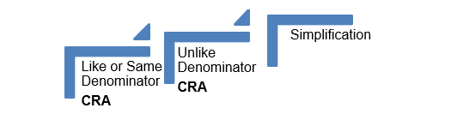

Video Demonstrations: Rational Number Addition
National Center on Intensive Intervention has videos that demonstrate best practices in teaching addition with rational numbers.

Adding fractions with like denominators:
- Adding fractions with like denominators – concrete manipulatives (1 minute)

Adding fractions with unlike denominators:
- Dr. Brad Witzel Adding fractions with unlike denominators – concrete manipulatives (4:38 minutes)
- Adding fractions with unlike denominators – concrete manipulatives (1:30 minutes)
- Adding fractions with unlike denominators – concrete manipulatives (1 minute)
- Adding fractions with unlike denominators – Area Model (1 minute)
- Adding fractions with unlike denominators – abstract method (2 minutes)
- Addition of fractions with unlike denominators and common denominators – concrete (2 mins)
- Project Stair -Adding Fractions with Unlike Denominators (4 minutes)

Subtraction
Concrete Objects
- Start with parts with the same value or denominator.
- Add the numerators when the denominators are the same.

Representation (Pictorial) show fraction
Abstract

Teach Easiest to Hardest

Video Demonstrations: Subtraction
National Center on Intensive Intervention has videos that demonstrate best practices in teaching fraction subtraction.

Subtracting fractions with like denominators:
- Adding & Subtracting fractions with like denominators concrete manipulatives (50 seconds)
- Subtracting fractions with the SETT model (2:28 minutes)

Subtracting fractions with unlike denominators:
- Subtracting fractions with unlike denominators – concrete manipulatives (50 seconds)
- Subtracting fractions with unlike denominators – concrete manipulatives (1 minute)

Multiplication & Division
The multiplication sign means “of.” Use manipulatives to demonstrate the concepts.

Video Demonstrations: Multiplication
National Center on Intensive Intervention has videos that demonstrate best practices in teaching fraction multiplication with concrete manipulatives and representations, using the Length, Area, and Sett Methods.

Multiplication & Division
- Beginner multiplication with manipulatives (1 minute)
- Area & Length Models (3:20 minutes)
- Fraction and a whole number multiplication with manipulatives (1 minute)
  - Fraction and whole number multiplication with sett model (1 minute)

Division
- Project Stair Dividing Fractions (5:48 minutes)

Additional Resources

Intensive Interventions and Lesson Plans The National Center on Intensive Intervention identified several strategies and interventions that enhance the skills of students with math difficulties in number system and counting, place value computation, basic facts, fractions as numbers, place value concepts, and computation of fractions.

The IRIS Center. (2017). High-quality mathematics instruction: What teachers should know. Retrieved from https://iris.peabody.vanderbilt.edu/module/math/

Learning Mathematics through Representations
“Learning Mathematics through Representations (LMR) is a research-based curriculum unit for the teaching and learning of integers and fractions in the elementary grades (26 lessons).

Henrico County, VA Mathematics Courses – Activities and links that are aligned to grade level SOL

University of Texas
Researchers at the University of Texas created Instructional Routines for Mathematics Intervention documents that have pre-created resources and materials for mathematics for 23 interventions, which focus on different mathematical content. Each of the 23 interventions include vocabulary cards and problem sets to use during instruction. The interventions all require explicit instruction. Though the interventions align with standards from the Texas Essential Knowledge and Skills (TEKS), the resources and materials apply to teaching mathematics skills identified in the Virginia Standards of Learning.
- Instructional Routines for Mathematics Intervention User Guide (31 pages)
- All of the Instructional Routines Files (2951 pages)
- Texas Instructional Routines for Mathematics Interventions Modules

Whilst GMU TTAC strives to adhere to the accepted guidelines and standards for accessibility and usability, it is not always possible to do so when linking to documents and sites outside of our site. We are continually seeking out solutions that will bring these other areas up to the same level of overall web accessibility. In the meantime, should you experience any difficulty in accessing the material, please don’t hesitate to contact us at ttacnews@gmu.edu.

References
The IRIS Center. (2015). Intensive intervention (part 2): Collecting and analyzing data for data-based individualization. Retrieved from https://iris.peabody.vanderbilt.edu/module/dbi2/

The IRIS Center. (2017). High-quality mathematics instruction: What teachers should know. Retrieved from https://iris.peabody.vanderbilt.edu/module/math/

