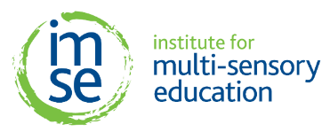
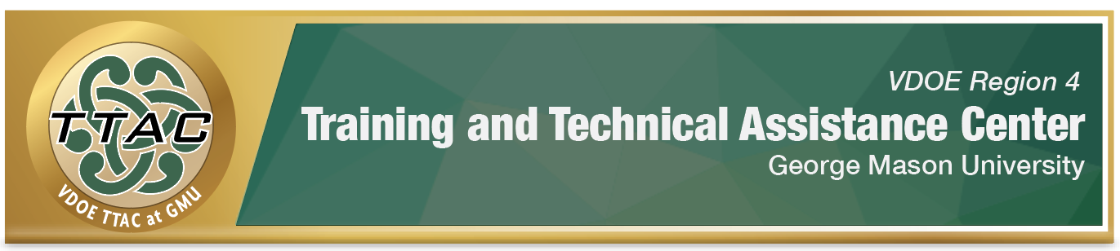

Virtual IMSE Morphology Summer Sessions

Option 1 | July 10th – 12th  8 AM – 3:30 PM
Option 2 | July 30th – August 2nd  8 AM – 3:30 PM

Available to all classroom educators, grades 4-12, who provide direct reading instruction in Region 4.

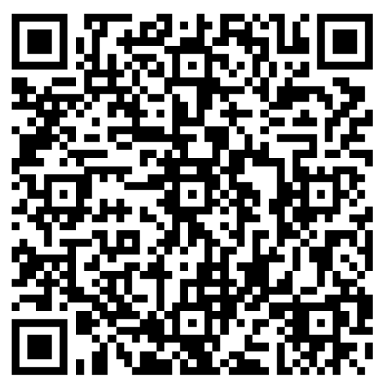
The application can be accessed here
or by scanning the QR code.
All applications must be submitted by
close of business June 9, 2023.
Accepted participants will be notified by
June 13, 2023.

