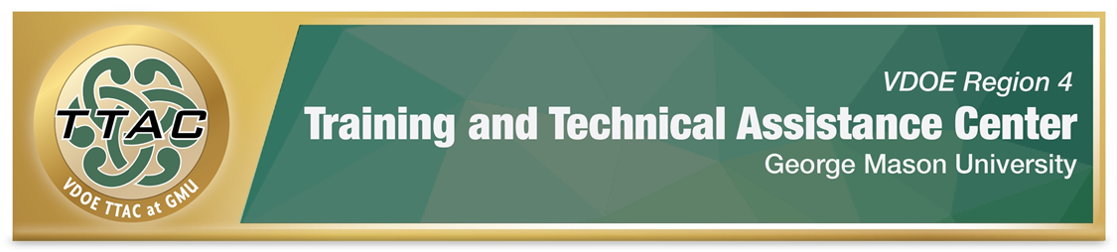

High Leverage Practices for Inclusive Classrooms

Resources | Description
HLP Highlight Tools | Each Highlight Tool contains a brief description,  video clips, suggested activities, a Plan of Action activity teachers can implement with students to help get them started, and additional resources.
HLP Leadership Guides | These guides are intended for school leaders to  support their teams in effectively implementing the  High Leverage Practices in the classroom. Each  guide includes tips; questions to prompt discussion, self-reflection, and feedback; observable behaviors; and references/additional resources.
HLP Rubrics | Each HLP rubric identifies essential components of each HLP and the teacher behaviors that facilitate implementation. These rubrics can be used to provide meaningful feedback about areas of strength and growth related to specific HLPs.
VA Professional Teaching Standards and HLP Crosswalk | This crosswalk aligns HLPs to each professional  standard and provides practical resources to  support implementation. School leaders can use  this tool to identify teachers’ strengths and areas of growth, ultimately improving teaching practices
High Leverage Practices Website | This website houses information about HLPS,  resources to support implementation, videos, and  additional professional learning opportunities.
Collection of Videos | Dr. Michael Kennedy, professor at University of  Virginia, has created videos to support teachers’  and professionals’ knowledge and implementation  of evidence-based and High Leverage Practices.
Self-Paced Professional Learning Modules | Virtual Virginia and the Training and Technical  Assistance Center (TTAC) at George Mason  University (GMU) partnered to offer six professional learning courses about HLPs.

