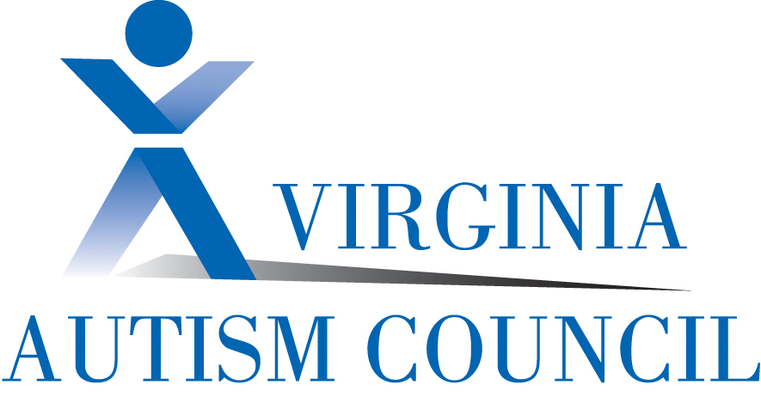
State Special Education Advisory Committee (SSEAC)
Autism Resources for Parents, Professionals and Support Staff
- Current statistics and basics of autism: http://www.cdc.gov/ncbddd/autism/index.html

Ages 1-5

- VDOE’s ASD guidance document, “Guidelines for Educating Students with Autism Spectrum Disorders”: http://www.doe.virginia.gov/special_ed/disabilities/autism/technical_asst_documents/autism_guidelines.pdf
- New Path, The Support Network for Families Receiving Early Intervention Services, The Arc of Virginia: www.thearcofva.org/newpath/
- Virginia’s “Guidance document for Autism Early Intervention Services”: http://infantva.org/documents/pr-PartC-ASD-Guidance.pdf
School Age/Adulthood
- Autism Society of America’s Virginia Chapters-Parent support groups that assist in providing advocacy and training for the autism community in Virginia. Chapters: Richmond - www.asacv.org; Northern VA - www.asanv.org; Norfolk - http://tidewaterasa.org Arc of the Tidewater
- Commonwealth Autism Service-Provides and maintains services to the autism community including but not limited to, Information and Referral services, Autism Actions Groups, Public Safety Workgroup, Trainings and a Statewide Conference each year. http://www.autismva.org
- National Professional Development Center- Promotes the use of evidence-based practice for children and adolescents with autism spectrum disorders. http://autismpdc.fpg.unc.edu/
- OCALI Autism Internet Modules-Content from experts on ASD across the nation on topics including assessment and identification, characteristics, evidence-based practices and interventions, transition to adulthood, and employment. http://www.autisminternetmodules.org/
- VDOE Training and Technical Assistance Centers (TTAC’s)- A statewide system emphasizing collaboration in the planning and provision of services to meet state and local staff development needs. http://www.ttaconline.org
- VDOE’s “Autism Spectrum Disorders and the Transition to Adulthood”- Tools for educators, administrators and parents working to improve services for students with ASD transitioning to adulthood. http://www.doe.virginia.gov/special_ed/disabilities/autism/technical_asst_documents/autism_transition.pdf
- VDOE’s “Models of Best Practice in the Education of Students with Autism Spectrum Disorders” - Tools for educators, administrators and parents working to improve services for students with ASD. http://www.doe.virginia.gov/special_ed/disabilities/autism/technical_asst_documents/autism_models_of_best_practice.pdf
- Virginia Autism Council’s “Skill Competencies for Professionals and Paraprofessionals in Virginia Supporting Individuals with Autism across the Lifespan”- A list of competencies for professional and paraprofessional staff in all fields of service delivery that are specific, unique, and/or critical to successfully serving individuals with ASD. http://www.autismtrainingva.org/competencies/
- Virginia Commonwealth University’s Autism Center for Excellence- Online training for parents, professionals, paraprofessionals and supports staff as well as news of activities occurring across Virginia. http://www.vcuautismcenter.org/index.cfm
- Virginia Department of Behavioral Health and Developmental Disabilities (DBHDS)- Resource information on Intellectual Disability Medicaid Waiver and Person Centered Practices. www.dbhds.virginia.gov/ODS- default.htm
- Virginia Department of Medical Assistance Services- Resource information on the Developmental Disability Waiver and Elderly and Disabled with Consumer Direction Waivers. www.dmas.virginia.gov
- Virginia Department of Aging and Rehabilitative Services (DARS)- Employment Services, Assistive Technology Services www.dars.virigina.gov

Compiled by the Virginia Autism Council for the State Special Education Advisory Committee May 2013

What You Need to Know About Me: A Student with Autism
Developed by the Virginia Department of Education Training and Technical Assistance Centers’ Autism Network, 2012
I am a student first. Like all other students, I have things I like and don't like. I'm good at many things. But because I have an autism spectrum disorder, certain things might be really hard for me, including
Understanding what people say,
Knowing what to say, and
Knowing how to interact with others.

Keep In Mind, I Might….

- Need more time to respond
- Be a literal thinker
- Need structure and boundaries
- Not understand sarcasm and/or jokes
- Learn better when I know the routine
- Need simple and clear instructions
- Not respond to sights, sounds, smells and touch the way you would expect
- Experience anxiety and frustration
- Not make friends easily, but with your help I can
You Can Help Me By…

- Supporting me to become independent
- Respecting me as an individual
- Advocating for me
- Talking less and showing me more
- Talking with me, not about me
- Giving me clear expectations
- Being consistent
- Giving me choices
- Offering me visual supports
- Developing a schedule that I can understand and use
- Preparing me for transitions and changes
- Supporting me to make friendships
- Preparing me for employment and adulthood

Teach Me By Using…
- Visual Supports - I need visual tools to support me as I move throughout the day. These might include written words, labels, pictures, objects, boundaries, or schedules.

- Communication -I need communication supports to help me better understand what you and others are saying to me, and help me better express what I want to say. This might include using lists, scripts, pictures, objects, or speech generating devices. You might need a speech and language pathologist to help with this.

- Reinforcement- I learn best when you are consistently positive about what I do. To improve my communication, academics, and behavior, you can give me praise, give me items as a reward, or take away things I don't like. It will be helpful to both of us if you discover what is uniquely reinforcing to me.
Don’t Take My Behavior Personally

Before you get frustrated with my behaviors, remember I have delays in language and communication. I might use unusual behaviors to convey my thoughts, needs and desires.

My behaviors all happen for a reason (i.e., the function):

- I might want to avoid or escape something
- I might want attention
- I might have sensory needs
- I might want to get or do something
When I try to talk, the words do not always come out the way I want. This frustrates me, and what makes it worse is that I often can't explain my frustration.
I need you to believe in me and focus on what I can do. I learn best when people use supports.

