Virtual TechKnowledgy
Content for Spring Sessions

REGISTRATION: https://techknowledgy.ttaconline.org/Registration

Date: March 19, 2020

12:00 pm – 1:00 pm and 3:00 pm – 4:00 pm (session repeated)
Webinar Title: AAC Implementation: Making the Most of Every Opportunity!

Presenter: Holly Nester, MS, CCC-SLP, ATP, Coordinator of Low-Incidence Disabilities, VDOE Training and Technical Assistance Center at Virginia Tech

Webinar Description:
Teams spend a great deal of time and effort thoughtfully considering the most appropriate communication device for a particular student; However, the roadblock often comes once it is time to actually implement the device throughout the student's day. An AAC user needs opportunities to use their device, something to talk about, and most importantly someone to talk to! Furthermore, the user has to be taught how to use the device. In this webinar, we will discuss natural times throughout the day to incorporate AAC devices to cover a variety of communicative tasks and how devices can be used to teach and develop language skills. You will learn about activities and resources for additional practice, ways to appropriately model, strategies for selecting appropriate vocabulary to target, and learn from several school teams that are implementing effective practices.

BIO: Holly is a graduate of Radford University where she obtained her Bachelor's degree in communication sciences and disorders and her Master of Science degree in speech pathology. She is an ASHA certified Speech Language Pathologist and a RESNA certified Assistive Technology Professional and has worked for the T/TAC @ Virginia Tech for almost 10 years. Prior to joining T/TAC, Holly served students preschool through high school-age with a wide range of speech and language needs. She is also an adjunct faculty member at Radford University where she supervises graduate students in the speech pathology program and has taught coursework in the education department.
Date: April 23, 2020

12:00 pm – 1:00 pm and 3:00 pm – 4:00 pm (session repeated)
Webinar Title: The Periodic Table of Google Extensions

Presenter: Denise Henry-Orndorff, Instructional Technology Resource Coach, Shenandoah County Public Schools - Northern Campus, VA

Webinar Description: Do you use Google Extensions? Do you want or need a few more tools for your Google Toolbox? Come and learn about over 80 extensions you and your students can use via a Periodic Table of Google Extensions. You will learn about everything from text to speech extensions to brain breaks to tools for productivity. You are guaranteed to learn a few more tools you can use!

BIO: Denise is currently finishing her 23rd year of teaching in Shenandoah County Schools. She has a Bachelor Degree in early childhood education (K-3 licensure) and a Master’s Degree in curriculum and instruction in computer education. In her 23 years, she has taught kindergarten, second grade, third grade, computer lab (kindergarten through fifth grade), and has served as an instructional technology resource coach. She is also actively involved with the Assistive Technology Committee in Shenandoah County Schools. She is a Google Certified Trainer, Seesaw Ambassador, and Certified BrainPOP Educator. Denise is also involved with Discovery Education, where she is a DEN STAR member and a member of the DEN Leadership Council. She loves technology and everything it has to offer and she just wishes she could keep up with the ever-changing world of technology. Denise is married and has two children. Her days are busy with baseball, Relay for Life, and church.

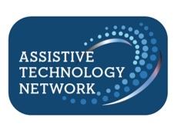 |  | 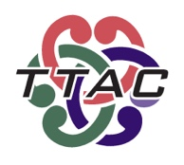 | 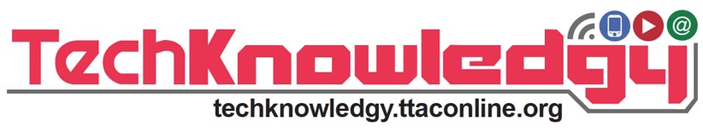

Date: May 7, 2020

12:00 pm – 1:00 pm and 3:00 pm – 4:00 pm (session repeated)
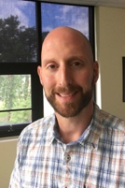 | Presenter: Matthew Newton, ATP Technology Coordinator, VDOE Training and Technical Assistance Center at Virginia Tech

Webinar Title: Adapting Play - Making Toys Accessible

Webinar Description:Toys cost money and accessible toys can cost a LOT of money. However, with some simple, cheap materials and tools that can be acquired at a local craft store or online, along with a little know-how, YOU can adapt simple plush toys up to remote controlled cars to make them switch accessible. Join us for this online session to learn how simple it can be to adapt toys yourself. Participants will receive a kit of materials in the mail to follow along with the facilitator and will end the session with their own adapted switch and battery interrupter to use with toys in their schools. NOTE: These sessions are live sessions repeated from the Fall, 2020, due to popular demand.

BIO: Matt serves as the coordinator of assistive and educational technology for the Virginia Department of Education’s Training and Technical Assistance Center (T/TAC) at Virginia Tech. His focus is supporting general and special education teachers, administrators, and related service providers in finding and implementing low to high-tech solutions and strategies for PK-12 students with disabilities. Matt began his career in education as a special education teacher working with students with multiple disabilities in Roanoke City Public Schools and also served there as an instructional technology resource teacher. He was recognized as Roanoke City's Teacher of the Year in 2014 and Virginia's Region 6 Teacher of the Year in 2015.

