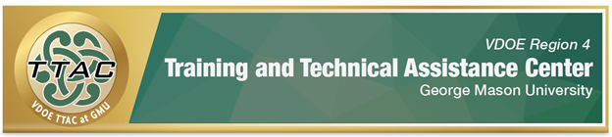
Administrator & Instructional Coach Professional Learning Series
TTAC Region 4 at GMU will offer a series of professional learning opportunities that introduce a framework that supports new teacher induction programs and teacher retention in Virginia.
Administrators & School Leaders – Strategies for Teacher Induction, Retention & Support with High Leverage Practices (HLPs) Session
By the end of the session, administrators and school leaders will:
- Understand the importance of HLPs in improving student outcomes.
- Learn about a framework that supports novice teachers and teacher retention.
- Understand ways TTAC supports schools and divisions by designing and customizing professional learning in HLPs.
- Learn ways TTAC helps schools and divisions build capacity to implement HLPs and support teachers’ ongoing professional learning.
Synchronous Session, register by selecting the date below:
June 21, 2022, from 9:00 – 10:30 AM
June 22, 2022, from 4:00 – 5:30 PM
June 23, 2022, from 9:00 – 10:30 AM
Instructional Coaches – Strategies for Teacher Induction, Retention & Support with High Leverage Practices (HLPs) Session
By the end of the session, instructional coaches will:
- Understand the importance of HLPs in improving student outcomes.
- Learn about a framework that supports novice teachers and ongoing individualized professional learning, growth, and development.
- Understand resources available to support instructional coaches.
- Earn 1.5 hours – Certificate of Attendance.
Lunch & Learn Synchronous Session, register by selecting the date below:
June 21, 2022, from 12:30 – 2:00 PM
June 22, 2022, from 12:30 – 2:00 PM
June 23, 2022, from 12:30 – 2:00 PM

