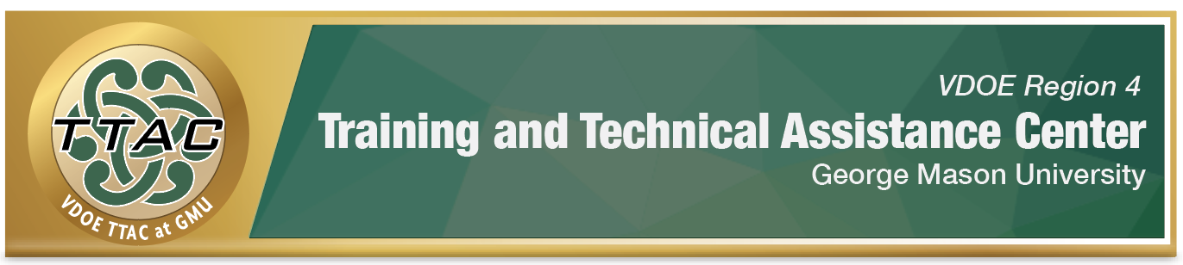

HLP Highlight Tool

HLP 3: Collaborate with Families to Support Student Learning

and Secure Needed Services

Here’s What It Is:
- Promoting positive relationships with families and students
- Understanding of family culture
- Providing resources and services to meet students’ needs
- Maintaining communication with parents
- Encouraging students to self-advocate
- Providing appropriate technology services

When Do I Use It?
- Collaborating with parents and team planning
- Eligibility and Screening meetings
- IEP goal planning and instructional planning
- On-going School improvement planning

Here’s What It Looks Like:
- Michael Kennedy’s Collaboration HLPs 1-3: Introduction video (12:59)

Resources to Extend Learning
- The Iris Center
- High Leverage Practices
- VDOE K-12 Inclusive Practices Guide
- The Center for Positive Behavioral Intervention and Supports (PBIS)

Here Are My Work Plans:
- Promote positive interactions between educators and families Collaboration video 2:11-5:20
- Effectively communicate with families Collaboration video: 5:22-6:55
- Tips for Mentors, Supervisors and Other School Leaders Collaboration video: 6:56-9:44
- Watch Michael Kennedy’s HLP #1-3 video

Suggested Activities:
- Become familiar with the 7 Partnership Principles with Jim Knight (57:02)
- Make sure members bring the identified data/materials for the meeting
- Practice active listening skills
- Create opportunities to provide input regarding their child’s strengths, interests and weaknesses:
  - Parent Questionnaire
  - Real Co-Teachers of Virginia share ideas for parent communication/input (3:00) Requires sign in to free TTAC Online account.

HLP 3 In Action!

Create a Meeting Agenda
Directions: When school teams share agendas in advance with families, it allows all stakeholders to feel prepared and provide input that can lead to more meaningful communication. For planning purposes, complete the agenda template below and share with members at least 2 days prior to your next meeting.

Meeting Agenda for: ___________________________________ Date: _______________

Goal/Purpose of Meeting:
- What is the topic being discussed?

Facilitator:
- Who is going to lead the meeting?

Team Members/Roles:
- Stakeholders:
- Note taker:
- Time Keeper:

Time/Length of Meeting:

Agenda Items: (List the items to be discussed)

Data/materials needed: (assessments, checklists, records, files)

Next Steps: (What are we going to do as a result of this meeting?)

Next meeting date/time: (if needed)

References

Hashey, A. I., Kaczorowski, T. L., & DiCesare, D.M. (2020). High-Leverage Practices in
Special Education, Guide 1. Council for Exceptional Children.
McLeskey, J. (Ed.). (2019). High leverage practices for inclusive classrooms. New York:
Routledge.

Find additional HLP Highlight Tools on TTAC Online.
For information about TTAC Region 4, go to https://ttac.gmu.edu/.

