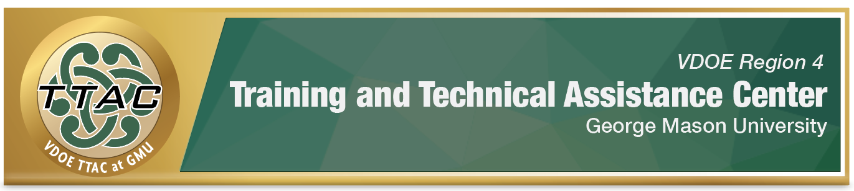

HLP Highlight Tool

HLP 17: Use Flexible Grouping

Here’s What It Is:
- Homo- and hetero- generous student groupings
- Based on specific learning goals
- Providing positive/corrective feedback to support learning
- Small learning groups (2-6)
- Learning tasks to promote student collaboration

When Do I Use It?
- When differentiated instruction is needed
- When students need additional time for mastery
- To help students meet individual academic goals
- To allow students the opportunity for lesson feedback

Here’s What It Looks Like:
- HLP #17 Video (17:08)

Resources to Extend Learning
- The Iris Center
- High Leverage Practices
- VDOE K-12 Inclusive Practices Guide

Here Are My Work Plans:
- Groups should be highly structured and include clear directives. View HLP #17 video 6:09-9:55
- Some groups should be homogeneous and some heterogeneous to accommodate learning goals. View HLP #17 video 10:06-12:44
- Flexible grouping should be used in combination with other HLPs and in conjunction with evidence-based practices. View HLP #17 video 13:01-13:55
View HLP #17 Video (17:08)

Suggested Activities:
- Rally Robin
- Timed Pair Share
- Round Robin
- Rally Coach

Clowes, G. The Essential 5: A Starting Point for Kagan Cooperative Learning. San Clemente, CA: Kagan Publishing. Kagan Online Magazine, Spring 2011.

HLP In Action!

Directions: Choose one of the activities below and apply it to one of your instructional lesson groupings.
Name of Activity | In Classroom Application | Virtual Application
Numbered Heads Together: (Kagan)  assessment and understanding | Each student in the group is assigned a number from 1 – 4.  Teacher provides question/prompt.  Students answer question.  Teacher calls out a number.  The student with that number provides the answer. | Chat rooms
Jot Thoughts:  Assessment and understanding | Teacher provides question/prompt.  Students take turns writing ideas on sticky notes and place them in center of table. | White Board activity  Chat rooms
Sage-N-Scribe:  Assessment and understanding | Teachers provides numerous questions.  Partner A (sage) describes possible answers to Partner B. | Break out rooms

Helpful Tool You Can Use During Flexible Grouping

Website | Response Type | Description
Kahoot | Multiple choice, quiz, discussion, survey | Teacher provides question and students respond anonymously using device for immediate corrective feedback.
Quiz Socket | Multiple choice, true/false | Teacher displays question and students hold up response cards with symbols while teacher scans cards with cell phone/tablet.
Jamboard (Google) | Interactive, small group discussion, assignments | Teacher displays information on whiteboard for instruction and students can respond.

References
Hashey, A. I., Kaczorowski, T. L., & DiCesare, D. M. (2020). High-Leverage Practices in Special Education, Guide 5. Council for Exceptional Children.

Kagan, S. & Kagan, M. (2009). Kagan cooperative learning. San Clemente: Kagan Publishing.
McLeskey, J. (Ed.). (2019). High leverage practices for inclusive classrooms. New York: Routledge.

Find additional HLP Highlight Tools on TTAC Online.
For additional information about TTAC Region 4, go to https://ttac.gmu.edu/.

