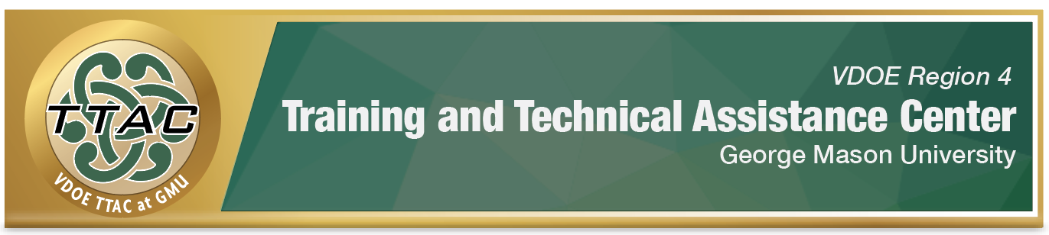

HLP Highlight Tool

HLP 12: Systematically Designed Instruction

Here’s What It Is:
- A form of explicit instruction (HLP 16) used across content areas
- Identifying critical content and skills, task analyzing, sequencing and scaffolding lessons to meet individualized needs
- Deliberate and purposeful (data based)
- Intensity increases for students with disabilities

When Do I Use It?
- When going from less complex to more complex material
- To link prior knowledge with new knowledge to deepen understanding
- To help students make connections between facts, concepts, and principles

Here’s What It Looks Like:
- HLP #12 Video (17:26)

Resources to Extend Learning
- The Iris Center
- Explicit Instruction
- High Leverage Practices
- National Center on Intensive Interventions

Here Are My Work Plans:
- Set clear, concise measurable learning goals for students (individual, group, class),
View HLP #12 Video 6:00-6:56
- Organize/sequence lessons logically towards those learning goals, View HLP #12 Video 8:10-10:15
- Support students in organizing new knowledge by providing scaffolds and structures for learning, View HLP #12 Video 12:05-15:37
View Full HLP #12 Video

Suggested Activities:
- Allow students to retain and express learning content through:
  - Computers, videos, audio
  - Opportunities to use different learning devices with peers
- Provide review sessions in small group settings
- Provide alternative assessment opportunities to evaluate learning goals

HLP 12 In Action!

I Do, We Do, You Do

Directions: Complete the advanced notes graphic organizer as you watch the “I Do, We Do, You Do: Scaffolded Reading in Social Studies” video

Concept/Strand of Instruction: What is the teacher’s learning goal?
I Do: What step-by-step instruction did the teacher model?
We Do: How did the student’s practice?
You Do: How did the students show independent work/check for understanding?
Reflection: How does the teacher know that she achieved her learning goal?

References

Hashey, A. I., Kaczorowski, T. L., & DiCesare, D. M. (2020). High-Leverage Practices in Special Education, Guide 4. Council for Exceptional Children.
McLeskey, J. (Ed.). (2019). High leverage practices for inclusive classrooms. New York: Routledge.

Find additional HLP Highlight Tools on TTAC Online.
For additional information about TTAC Region 4, go to https://ttac.gmu.edu/.

