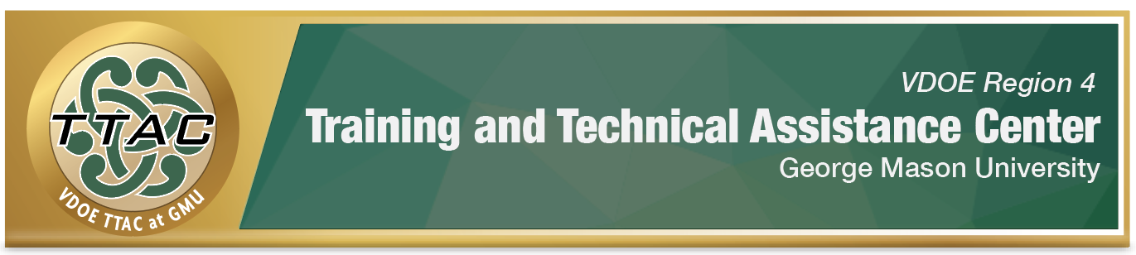
HLP 15 Highlight Tool
HLP 15: Provide Scaffolded Supports

Here’s What It Is:
- Temporary assistance for students with gradual release of responsibility
- Assessment based
- Targeted visual, verbal, and written supports
- Pre-planned or on-the-spot instruction

When Do I Use It?
- When students need additional support for mastery of curriculum
- When students need multiple opportunities to independently practice skills
- When differentiating instruction is needed

Here’s What It Looks Like:
- Pennsylvania Department of Education's Teaching Matters: Scaffolding (5:13)
- Scaffolding Instruction for Students (5:45)

Resources to Extend Learning
- The Iris Center
- High Leverage Practices
- VDOE K-12 Inclusive Practices Guide
- Conducting a Task Analysis
- Intervention Central

Here Are My Work Plans:
- Understanding Scaffolding, Teaching Matters Video: 0:34-1:26
- Planning Scaffolding Lessons Teaching Matters Video:1:35-2:39
- Examples of Scaffolding Teaching Matters Video: 2:39-3:48
- Classroom Scaffolding Scaffolding Instruction for Students Video: 2:29-3:23
- Whole Classroom Scaffolding Scaffolding Instruction for Students Video: 4:13-4:55

Suggested Activities:
- Alpha Boxes, Anticipation Guides
- Interactive Graphic Organizers
- Read, Cover, Recite, Check and Retrieval Practice
- Self-Check Behavior Checklist Maker
- Academic Survival Skills Checklist Maker

Click here to access all of the activities listed above and more techniques and strategies collected here are organized by The Art and Science of Teaching framework for instruction (Marzano, 2007 & 2014)

HLP 15 In Action!

Directions: Visit Learning Disabilities Association of America (LDA) website.
- Select one of the 4 graphic organizers listed on LDA’s website for an upcoming lesson.

- Which graphic organizer did you select?

- What are characteristics of students that would benefit from the scaffolding that the graphic organizer affords?

- How do you plan to use this graphic organizer?

References

Hashey, A. I., Kaczorowski, T. L., & DiCesare, D. M. (2020). High-Leverage Practices in Special Education, Guide 5. Council for Exceptional Children.
McLeskey, J. (Ed.). (2019). High leverage practices for inclusive classrooms. New York: Routledge.

Find additional HLP Highlight Tools on TTAC Online.
For additional information about TTAC Region 4, go to https://ttac.gmu.edu/.

