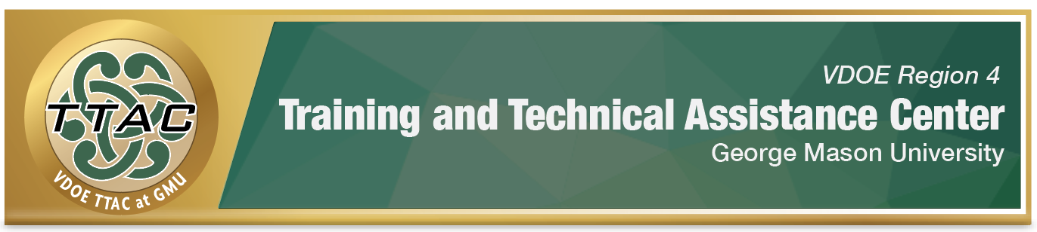

HLP Highlight Tool

HLP 11: Identity and Prioritize Long- and Short-Term Goals

Here’s What It Is:
- Linking goals to students’ present level of performance
- Setting goals that are aligned with grade-level standards and individual needs
- Written with the student to establish ownership, understanding and motivation
- Using data assessment on an on-going basis for planning explicit instruction

When Do I Use It?
- When reviewing assessment data and planning instruction, behavior, and/or transition goals
- When collaborating with IEP teams
- Data based individualization

Here’s What It Looks Like:
Student Involvement in the IEP (0:51)
I’m Determined Goal Setting Videos
- Goal Setting in the Classroom (2:21)
- Goal Setting at the Elementary Level (1:07)
- Goal Setting at the Secondary Level (1:19)

Resources to Extend Learning
- National Center on Intensive Interventions
- The Iris Center
- Planning Templates for Students

Here Are the Key Elements:
- Set clear, concise, and measurable learning goals for students (individual, group, class)
- Organize/sequence lessons logically towards those learning goals
- Support students in organizing new knowledge by providing scaffolds and structures for learning

Suggested Activities:
- Goals should clearly state the criteria needed for success (based on IEP and assessment data)
- Utilize classroom checklists for self-monitoring
- Ask students to graph their progress
- Establish student/teacher conferences to discuss and monitor goals

HLP 11 In Action!

K-W-L Chart for Goal Planning

Directions: Watch the video, “Instructional Strategies - The KWL Strategy (4:01)”. Then, work with your student to complete a K-W-L Chart as the first step in helping him/her identify and prioritize short and long-term learning goals.

Student Name: _______________________________________________
Lesson: ______________________________________________________
Standard: ____________________________________________________
K-W-L Chart
What I Know | What I Want to Know | What I Have Learned

References
McLeskey, J. (Ed.). (2019). High leverage practices for inclusive classrooms. New York: Routledge.

Find additional HLP Highlight Tools on TTAC Online.
For additional information about TTAC Region 4, go to https://ttac.gmu.edu/

