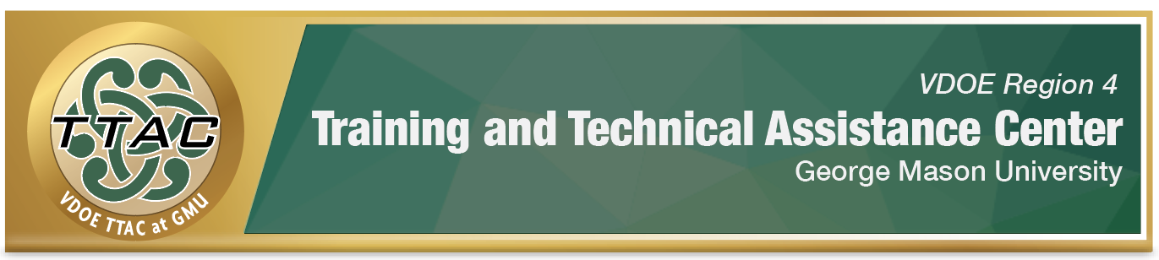
HLP Highlight Tool
HLP 2: Organize and Facilitate Effective Meetings with Professionals and Families

Here’s What It Is:
- Establishing an agenda & allocating adequate time on a mutually agreed schedule
- Active listening so all views are heard
- Ensuring communication is culturally sensitive and responsive
- Building consensus and soliciting feedback
- Ensuring equity of voice

When Do I Use It?
- Individual Education Program (IEP) goal planning
- Instructional planning
- Planning meetings with families so they have the knowledge and skills to support learning
- On-going school improvement planning
- Eligibility and screening meetings

Here’s What It Looks Like:
- HLP #2 Collaboration with Families

Resources to Extend Learning
- The Iris Center
- High Leverage Practices
- VDOE K-12 Inclusive Practices Guide
- The Center for Positive Behavioral Intervention and Supports (PBIS)
- CADRE- The Center for Appropriate Dispute Resolution in Special Education

Here Are My Work Plans:
- Prepare to lead an effective meeting Collaboration video 4:22-6:03
- Prepare to facilitate an effective meeting Collaboration video: 6:04-9:45
- Tips for Mentors, Supervisors and Other School Leaders Collaboration video: 9:46-12:16
- Watch the full HLP #2 Collaboration with Families video.

Suggested Activities:
- Post the meeting agenda at least 24 hours before the scheduled meeting
- Make sure members bring the identified data/materials for the meeting
- Practice active listening skills
- Watch “A Tale of Two Meetings”, which demonstrates the impact of effective communication and family partnerships on meeting outcomes.
- Participate in CADRES’ “Working Together” webinar series to develop your collaborative problem solving and conflict resolution skills.

HLP 2 In Action!
Directions
- Watch the 2 “A Tale of 2 Meetings” videos on CADRE’s website.
- After viewing the second video, reflect on the participants’ actions, words and non-verbal communication skills and summarize your thoughts of the second meeting example.

Reflection Prompt
How did each participant approach the meeting with positive regard for one another?

Notes:

Reflection Prompt
How did each participant express their perspective in a positive manner?

Notes:

Reflection Prompt
How did each participant listen effectively?

Notes:

Reflection Prompt
Identify 2 underlying interests of the administrator and the parent.

Notes:

Reflection Prompt
What enabled the administrator and parent to find common ground and develop solutions that responded to mutual interests?

Notes:

Reflection Prompt
Link to Your Own Life:
Think about a conversation you recently had that didn’t go as planned (inside or outside of education). How could recognizing underlying interests have facilitated a better outcome?

Notes:

References

A Tale of Two Conversations Study Guide. (n.d.). Retrieved November 17, 2020,
from https://www.cadreworks.org/resources/tale-two-conversations-study-guide
Hashey, A. I., Kaczorowski, T. L., & DiCesare, D. M. (2020). High-Leverage Practices in
Special Education, Guide 1. Council for Exceptional Children.
McLeskey, J. (Ed.). (2019). High leverage practices for inclusive classrooms. New York:
Routledge.

Find additional HLP Highlight Tools on TTAC Online.
For information about TTAC Region 4, go to https://ttac.gmu.edu/.

