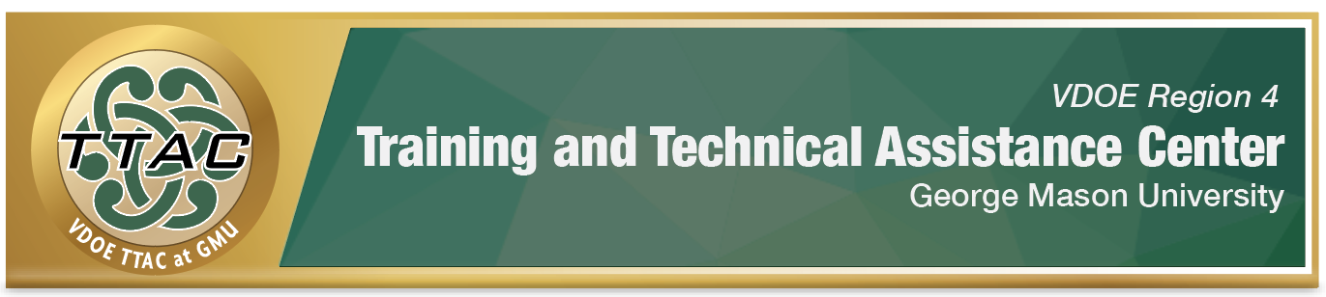

HLP Highlight Tool

HLP 21: Teach Students to Maintain and Generalize New Learning Across

Time and Settings

Here’s What It Is:
- Utilizing numerous examples for designing and delivering instruction
- Systematic planning for instruction and review of content
- Maintaining successful behavior by reinforcing schedules
- Strategies to help students maintain their learning in multiple settings
- Applying successful behavior strategies in more than one setting
- Teaching learners to regulate/manage their behavior

When Do I Use It?
- When students need to use successful learned skills in different settings (academic, behavioral, social)
- When trying to maintain desired behaviors to new settings and people
- When trying to reinforce the desired behavior

Here’s What It Looks Like:
- ABA Autism Training – Chapter 4 – Generalization (6:02)
- Promoting Generalization (9:34)
- Schedules of Reinforcement (4:44)

Resources to Extend Learning:
- The Iris Center
- High Leverage Practices
- National Center on Intensive Intervention
- The National Clearinghouse on Autism Evidence and Practice (NCAEP) and UNC-Chapel Hill

Here Are My Work Plans:
Refer to the video for the categories below: ABA Autism Training – Chapter 4 – Generalization (6:02)
- Definition of Generalization, (Video 00:36-1:27)
- Areas of Generalization, (Video 1:28-4:52)
- Generalization Tips, (Video 5:05-6:02)

Suggested Activities:
- Promote behavior maintenance using a reinforcement schedule
- Use the suggestions on the Leadership Guide to help promote active engagement
- Map out opportunities for incremental rehearsal to lead to mastery.

HLP 21 In Action!

Generalization Techniques to Get You Started
Each of the generalization techniques suggested below can be used individually or in combination to strengthen generalization.
Directions: Read about each technique below and practice applying one within your instructional setting.
Name of Technique | Description | Explanation
Sequential Modification | Teacher applies the same techniques that were successful in changing the behavior in one setting to all settings where the behavior is desirable. | Generalization in ABA: Sequential Modification (18:07)
Train Sufficient Exemplars | Teacher should train the student in a variety of settings with different people. | Generalization Overview (view video segment 16:45-21:30)
Program Common Stimuli | Teacher replicates the setting where the behavior should be generalized by bringing elements of the training setting. | Promoting Generalization (view video segment 3:16-6:40)
Train to Generalize | Teacher instructs the student a new behavior and reinforces the learned behavior in a new setting until generalization occurs. | Promoting Generalization (view video segment 6:43-8:30)

References
Hashey, A. I., Kaczorowski, T. L., & DiCesare, D. M. (2020). High-Leverage Practices in Special Education, Guide 6. Council for Exceptional Children.
McLeskey, J. (Ed.). (2019). High leverage practices for inclusive classrooms. New York: Routledge.
Find additional HLP Highlight Tools on TTAC Online. For additional information about TTAC Region 4, go to https://ttac.gmu.edu/.

