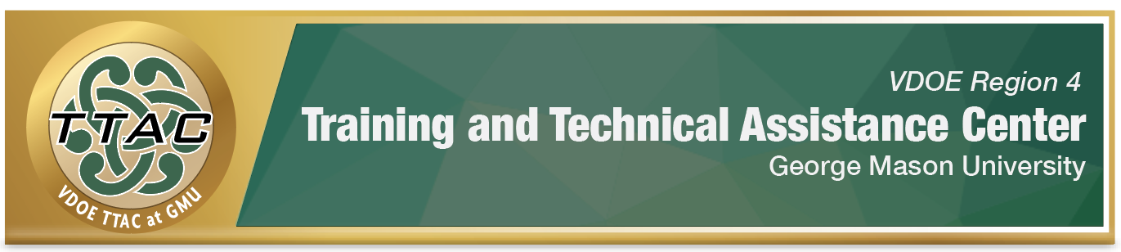
HLP Highlight Tool
HLP 14: Teach Cognitive and Metacognitive Strategies to
Support Learning and Independence

Here’s What It Is:
- Explicit instruction of a specific strategy with structured, task analyzed, sequenced lessons
- Teacher modeled/student monitored with guided and independent practice
- Teaching students to “learn how to learn”

When Do I Use It?
- When students are having difficulties remembering steps
- When students need a meta-cognitive strategy to enhance comprehension and self-monitoring
- When promoting problem-solving in reading and math

Here’s What It Looks Like:
- HLP #14 Video (19:08)
- Virtual Teaching Example of Explicit Strategy Instruction at the High School Level (14:50)
- Virtual Teaching Example of Guided Independent Practice at the High School Level (16:00)

Resources to Extend Learning
- The Iris Center
- National Center on Intensive Interventions
- High Leverage Practices
- VDOE K-12 Inclusive Practices Guide

Here Are My Work Plans:
- Select purposeful strategies:
  - Math: Solve It! Strategy, View HLP #14 video: 5:19-6:14
  - R.U. Asking Strategy in Virtual Classroom, View HLP #14 video: 9:52-13:38
- Use Explicit Instruction
- Teacher models Think-Aloud Strategy, View HLP #14 video: 13:01-16:05
- Provide guided and independent opportunities for students to practice using strategy,
View HLP #14: 16:12-16:57
Click here for full HLP #14 Video

Suggested Activities:
- Think-Alouds
- Reciprocal Teaching
- Pre- and post-tests to help students self-monitor their progress
- Record videos that model metacognitive strategies for students and parents/caregivers to reference

HLP 14 in Action!

Question-Answer Relationships (QARs) Strategy
This strategy is designed to help readers arrive at answers by thinking about where the answer to the question is found in the text (Raphael, 1984.)

Directions: Guide students through this graphic organizer after they have read a passage.

In the Book | In My Head
Right There  (The answer can be found right in the text.) | Think and Search  (The answer is in the text, but it may not use the same language that is used in the question, and I may have to look in some different places to find it!)
Author and Me  (The answer is not in the text. I will need to use my schema, i.e., background knowledge, and what the author has told me to arrive at my answer.) | On My Own  (The answer is not in the text. I need to use my own schema, i.e., background knowledge. I can even answer the question without reading the text. The question must stand alone.)
Adapted from: High-Leverage Practices in Special Education, Guide #4, 2020.

References

Hashey, A. I., Kaczorowski, T. L., & DiCesare, D. M. (2020). High-Leverage Practices in Special Education, Guide 4. Council for Exceptional Children.
Raphael, T. (1986). Teaching children question-answer relationships, revisited. The Reading Teacher, 39, 516-522.
McLeskey, J. (Ed.). (2019). High leverage practices for inclusive classrooms. New York: Routledge.

Find additional HLP Highlight Tools on TTAC Online.
For additional information about TTAC Region 4, go to https://ttac.gmu.edu/.

