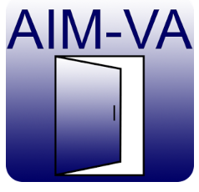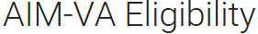
Published on Google Play: https://play.google.com/store/apps/details?id=com.kihdapps.aimvaeligibility&hl=en
or http://tinyurl.com/zhoabfc

Published on iTunes:
https://itunes.apple.com/us/app/aim-va-eligibility/id1090490770?ls=1&mt=8
or http://tinyurl.com/gpsu2oe

This app is used to determine if a student is eligible to receive and use accessible instructional materials created by AIM-Virginia. It is designed to work independently or as an extension of the AT Consideration Guide app developed by KIHd (Kellar Institute for Human disAbilities). 